Earth Sciences 089G
Short Practical Assignment #4
Working in Three Dimensions

Introduction
Maps are 2-D representations of 3-D features, the developers of topographic maps needed to devise a method for showing not only horizontal distances but vertical distances (height) also. The map-reader wants to know the height of hills and how their height related to the surrounding area.
To present height values in an efficient and readily interpretable manner, contour lines are used. Contour lines are lines along which there is a constant elevation above sea level. These facilitate interpretation of the height and shape of various landforms at a glance. To read contour lines, knowing the interval at which the contours are drawn is important. This contour interval is constant throughout the map area. It is added to (or subtracted from the most adjacent contour lines. If the interval is 20 metres, the values of each contour line will increase by 20 m as you go uphill. An isolated contour line may be either a hill or a depression; if it is a depression, it is marked by hatchure lines (figure 1).

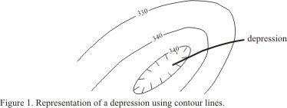

The following rules are used when interpreting contours.
1) All contours close somewhere, though the closure may not show on the map.
2) On a gentle slope the contours are widely spaced whereas on a steep slope they are closely spaced.
3) Contours NEVER cross each other, unless there is an overhanging cliff.
4) On a vertical cliff 2 or more contours may be superimposed.
5) Contours NEVER split.
6) A contour near the top of a ridge, or the bottom of a valley will be repeated on the other side of the ridge or valley.
7) Where contours cross a stream valley they must bend upstream in order to maintain the same elevation.
8) An isolated closed contour that indicates an elevation has the same elevation as that of the higher of the two adjacent contours.
9) An isolated closed contour that indicates a depression has the same elevation as that of the lower of the two adjacent contours.

Topographic Profiles
In maps we see the land surface as viewed from vertically above. In profile sections and cross-sections, we see the earth’s crust from the side, much like looking at a slice through a cake. A topographic profile consists of four lines.
1) the profile line
2) the base line
3) two vertical end lines.
The profile line marks the intersection of the land surface, with a vertical plane. So the profile represents the heights on the map, along the line of the section. The base line is horizontal at the height of the contour below the lowest contour on the profile. Note that it does not have to be at sea level. The vertical end lines mark the end of the profile section. It is essential to mark, with compass directions, the ends of the section to distinguish one from the other.

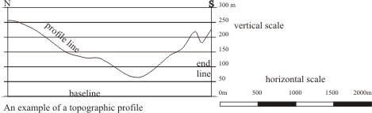

Drawing Profile Sections

Figures 2 and 3 show the method for constructing a topographic profile.
1) Take a long piece of paper and lay it with an edge along the section line on the map. At the end of the profile, mark two lines and label them with geographical letters (N, S, W or E). Along the edge of the paper mark the intersection of each contour with the section line and record their elevation directly below.
2) On a separate sheet, construct a frame for the profile section (base and end lines). The height of the profile section depends on the vertical scale. Construct a grid for the profile section. Its horizontal scale is the same as that on the map but the vertical scale may differ.
3) Lay the marked edge of the slip of paper along the line of the height you wish to plot and plot the point at the appropriate distance along the line (see figure 2). Move to other heights ensuring that the end of the profile on your transfer paper is at the corresponding end line of the frame.
4) Join the dots with smooth lines as in figure 3. Note that a smooth curved line joins two adjacent points of the same elevation. Straight horizontal lines imply that the height along the section is constant. This is a rare situation. For the most part, the profile line will make a crest or trough between such points.
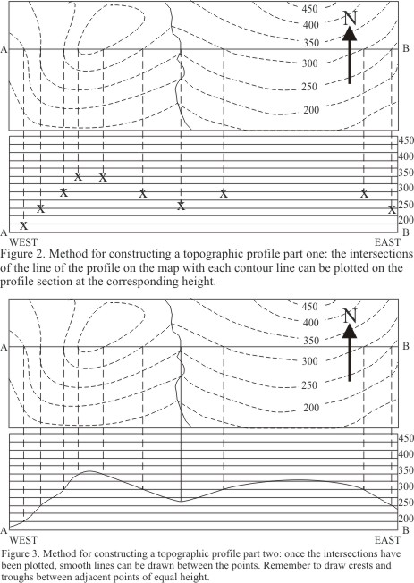

It is especially important for Earth scientists to be able to deduce what is happening below surface. By gathering information from seismic surveys, ground penetrating radar and other geophysical techniques as well as surface mapping, it is possible make these deductions.
As we’ve seen, topographic contours are lines of constant height. When a structure appears on a map, there will almost always be places where it crosses such a line. When two points on a planar feature are at the same height, a line drawn between them will be both straight and horizontal. Such a line may be called a contour line, but it is pertinent to the structure rather than the surface topography. Figure 4 shows the relationship between a geological boundary, topographic contours and structural contours. Notice that where the topographic contour meets the geologic boundary, the structural contour passes through as well. The important thing here is that all three pass through the same points where the elevation is the same.

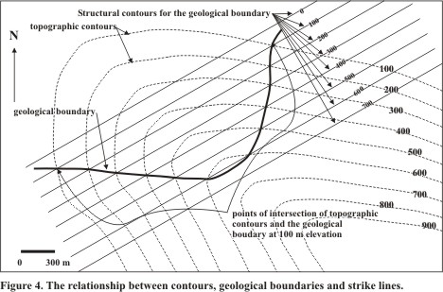

We can treat the information gathered from structural contours in the same way that we treated topographic information. It is important to keep the sets of data discrete from each other. Plot the information for one line and then draw it before proceeding to the next line.

ES089 Working in 3-D Exercises NAME ___________________________

STUDENT #_______________________

A group of archaeologists have found a partially exposed statue of colossal proportions in a desert region of Mexico. Wind is exhuming the top of it from under a sand dune. Ground penetrating radar has been used to establish the general shape that is still buried. It is believed to look something like the Olmec statue illustrated below.

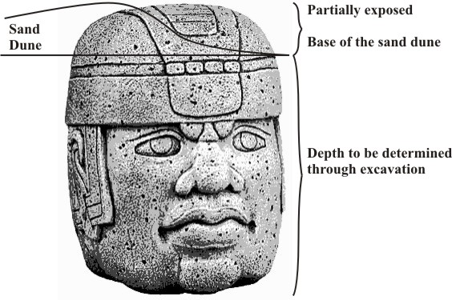
You are given two map figures that contain topographic contours so that the following things can be established:

1) Using figure 1, Plot the topographic profile of the sand dune along the “X-Y” line in the space provided beneath the map.
a) Establish vertical end lines to represent the position of “X” and “Y” (2).
b) Label the “X” and “Y” ends of the profile. (2)
c) Plot the topographic information and draw the profile. (14)
d) How deep would you have to dig at point “Z” to get to the surface of the statue?
_______________________________________________________ (2)

A fracture in the rock of the statue appears on both maps (the bold line). In order to minimise the possibility of the top sliding away, repairs are being proposed.

2) Establish a structural cross-section along the line “A-B” that will include both the topography and the slope of the crack. Use the space prepared for you.
a) Establish vertical end lines to represent the position of “A” and “B” (2).
b) Label the “A” and “B” ends of the profile. (2)
c) Plot the topographic information and draw the profile. (14)
d) Plot the structural information and draw the profile. (24)


