Detour Lake: Discovery of a world class gold deposit in Ontario, Canada
Gerald Panneton, Roger Aubertin, Pat Donovan
Detour Gold Corporation, 200 Bay St., Suite 2040, Box #23, Toronto, Ontario, Canada, M5J 2J1
James Siddorn, Jean-François Couture, Dominic Chartier
SRK Consulting (Canada) Inc., 25 Adelaide St. East, Suite 2100, Toronto, Ontario, Canada, M5C 3A1

Publication
2009 NewGenGold Conference, 23-24 November 2009

Contact
Detour Gold Corporation
200 Bay St., Suite 2040, Box #23
Toronto, Ontario, M5J 2J1
Canada
Phone: (416) 304-0800
Contact person: Laurie Gaborit, Director Investor Relations (lgaborit@detourgold.com)

Detour Lake: Discovery of a world class gold deposit in Ontario, Canada

Abstract
The Detour Lake gold project is located in northeastern Ontario, approximately 300 km northeast of Timmins, within the northwestern portion of the Archean Abitibi greenstone belt, Superior Province. Historically the Abitibi greenstone belt has produced approximately 180 million ounces of gold, largely from narrow vein underground mining.

The Detour Lake project is a site of extensive past exploration since 1974, as well as underground and limited open pit mining activity (1983-1999), during which it produced 1.8 million ounces of gold. Underground mining focused on narrow vein conventional shrinkage and mechanized longhole stoping. After acquiring the property in January 2007, Detour Gold Corporation initiated a comprehensive drill campaign to define the potential for a large, open pitable, low-grade gold deposit.

Gold mineralization at Detour Lake is associated with a large scale deformation zone (Sunday Lake Deformation Zone; “SLDZ”) that occurs at the contact between 2.72 Ga Detour Lake Formation mafic metavolcanics and 2.69 Ga Porcupine Assemblage metasediments.

The bulk of the gold mineralization is found in the hanging wall of the SLDZ (“Quartz Hanging Wall Zone”), which is associated with a stockwork of auriferous quartz veins that splay from a flexure along the deformation corridor. The Quartz Hanging Wall Zone forms a 200-350 metre wide auriferous corridor defined over 3 kilometres along the strike of the mafic metavolcanic assemblage from surface to at least 1,000 metres depth. The richest gold mineralized zones are commonly associated with quartz veins with a strong biotite alteration and local zones of pyrrhotite-chalcopyrite-pyrite-gold enrichment formed during the deformation of the quartz vein system.

From 2007 to present, Detour Gold has completed over 300,000 metres of diamond drilling that has resulted in the discovery of a large low-grade, open pitable gold deposit in the Abitibi greenstone belt, representing a paradigm shift from the typical narrow vein underground deposits found on the belt. The pre-feasibility study completed in September 2009 defined an open pit mineral reserve of 8.8 million ounces of gold, which is Canada’s largest undeveloped gold reserve. In the short-term, Detour Gold is continuing with a feasibility study and development of the project.

Introduction
The Detour Lake gold deposit is located in northeastern Ontario, approximately 300 kilometres northeast of Timmins in close proximity to the Québec border (Figure 1). Situated in the northwestern portion of the Abitibi greenstone belt of the Superior Province, Detour Lake was originally discovered in 1974 as a result of airborne and ground geophysical surveys. The property now consists of a 265 square kilometre land package including the former Detour Lake mine, which saw underground and open pit mining activities from 1983 to 1999. With a combined average head grade of 3.82 g/t gold, the Detour Lake mine produced 1.8 million ounces of gold.

Since Detour Gold Corporation (“Detour Gold”) acquired the project in January 2007, an aggressive exploration programme commenced focusing on the open pit potential of the deposit. In just over two years, over 300,000 metres of drilling was completed and a recent pre-feasibility study estimated proven and probable open pit reserves at 8.8 million ounces of gold within a global measured and indicated resource of 17.3 million ounces (BBA by Patrice Live, 2009 NI43-101 Technical Report).

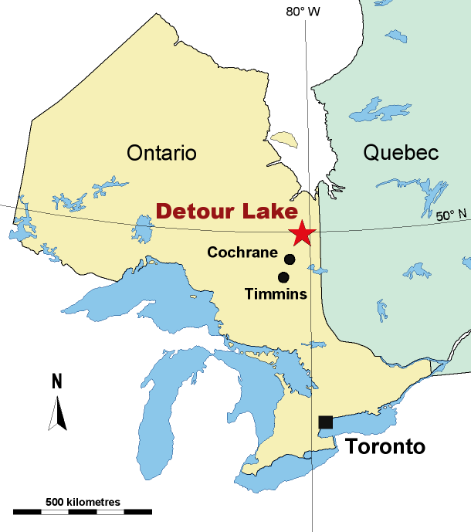

Figure 1. Location of the Detour Lake Gold project, northeastern Ontario, Canada.

This paper provides a case study of the rejuvenation of the Detour Lake gold project following aggressive surface exploration around a former underground mine, focusing on exploring the potential of a large gold corridor that was previously only sporadically explored and the discovery of a world class, bulk tonnage gold deposit in the Abitibi greenstone belt.

Exploration history

The Initial Discovery, 1974-1982
In 1974, Amoco Petroleum Ltd. (“Amoco”) commenced exploration on the Detour Lake property with regional airborne and ground geophysical surveys. These surveys achieved immediate success with the identification of a 2 kilometre long input anomaly with strong magnetic coincidence, which was originally named the “Detour 38 Anomaly”. In October 1974, Amoco drilled the first hole into the central portion of the anomaly and intersected several interesting mineralized zones, including a 9 metre intersection containing 10-15% pyrrhotite and up to 1% chalcopyrite within a quartz vein system that would eventually be called the Main Zone.

Starting in 1975, a major exploration program was undertaken, including over 47,000 metres of surface drilling, construction of a decline to the 120 metre level and underground drilling and sampling. A winter road was also built from La Sarre, Québec. The results of this work successfully confirmed the presence of a significant gold deposit, which was estimated by Amoco to host 8.6 million tonnes at 7.1 g/t (cut to 31.1 g/t), or 9.1 g/t (uncut), to a depth of 545 metres (note: this resource estimate was prepared prior to implementation of National Instrument 43-101 and this information should not be relied upon). Subsequently, a feasibility study carried out by Lummus Company of Canada Limited between 1976 and 1978 indicated pessimistic results. The property was optioned in 1978 to Campbell Red Lake Mines (“Campbell”) and Dome Mines Ltd. (“Dome”). To 1979, 341 boreholes (58,000 metres) were drilled.

Between 1979 and 1982, Campbell completed an additional 419 surface and underground boreholes (31,600 metres). As with Amoco, most of the drilling focused on the Main Zone but a substantial amount was directed towards other quartz vein zones to the west. In 1982, the combined underground and open pit mineral resources were estimated at 27.7 million tonnes grading 3.88 g/t Au. A decision was taken to commence open pit mining at a rate of 2,000 tonnes per day and gradually phasing in underground production over a five year period.

Underground and open pit mining, 1983-1999
In 1983, open pit mining started (Campbell open pit), and until 1987, 3.0 million tonnes grading 3.25 g/t Au (313,070 ounces) were mined. Approximately 1.6 million tonnes grading 1.40 g/t Au (70,652 ounces) was blended with underground ore between 1986 and 1998. In 1987, underground mining commenced, coinciding with a merger between Campbell, Dome and Placer Development to form Placer Dome Inc (“Placer”). Less than a year later, Placer acquired the remaining 50% of the property from Amoco. From 1987 to 1998, 9.1 million tonnes grading 4.98 g/t Au (1,464,431 contained ounces gold) were extracted from underground mining using longhole, cut and fill, shrinkage stoping and level development.

In 1995, the operation was expanded to 3,750 tonnes per day to improve the economics of the deposit. In 1998, the open pit mining resumed for a short time, extracting 644,000 tonnes grading 2.20 g/t Au. In July 1999, Placer halted mining at Detour Lake due to low gold prices and declining economics and reclamation of the mine was initiated.

Between 1983 and 1999, the total production (open pit and underground) is estimated at 1,765,000 ounces of gold from 14.3 million tonnes of rock at an average head grade of 3.82 g/t Au and an average mill recovery of 93.1%. Over that period, 4,219 drill holes (435,002 metres) were drilled from both underground and surface. After 1990, the bulk of the drilling tested the western extensions of the gold mineralization (i.e. QK Zone).

Rejuvenation of exploration, 1999-2006
In December 1998, predecessors to PDX Resources Inc. (“Pelangio”) and Franco-Nevada Corporation (“Franco-Nevada”) (the “Detour Lake Joint Venture”) acquired from Placer an option to acquire the mine property pursuant to an option and access agreement between the Detour Lake Joint Venture and Placer. In 2002, Pelangio completed the purchase of all of Franco-Nevada’s interest in the property subject to a 2% NSR.

From 2004 to 2006, Pelangio drilled 127 drill holes (29,780 metres) directed towards a variety of exploration targets located mainly west of the former Campbell open pit, including the M Zone near the west boundary with Block A (now 50% Detour Gold Corporation), and the area north of Walter Lake. Pelangio completed a mineral resource estimate in May 2005 with the concept of a combined underground and open pit mining scenario utilizing mainly the historical data from the mine property and the adjacent Block A property. The near surface resource was estimated at 2.5 million tonnes grading 2.00 g/t (160,000 ounces contained gold) in the Indicated category and 15.3 million tonnes grading 1.73 g/t (849,000 ounces contained gold) in the Inferred category, located in the former pit area and to the west (“Calcite Zone”). The deeper Inferred resource of 8.1 million tonnes grading 3.37 g/t (879,000 ounces contained gold) was located in eight zones distributed over several kilometres between approximately 200 to 800 metres below surface (Eric A. Kallio, 2005 NI 43-101 Technical Report).

Revitalization of the Detour Lake deposit, 2006 - present
Detour Gold was incorporated on July 19, 2006 to acquire the Detour Lake property and on August 21, 2006, Detour Gold executed a purchase agreement with Pelangio, whereby Detour Gold agreed to acquire the assets constituting the Detour Lake property from Pelangio. The motivation for the formation of Detour Gold and the acquisition of Pelangio’s stake in the property was the recognition that a large auriferous corridor (>200 metres wide and over 3 kilometres in length) existed on the property that, at that time, only had been tested with sporadically spaced drilling. The due diligence work by Detour Gold led to the re-evaluation of the mineral resources of the project with a bulk mining concept for the Detour Lake project. The near surface mineral resources were estimated at 20 million tonnes at an average grade of 2.14 g/t (1.4 million ounces contained gold) in the Indicated category with an additional 35.4 million tonnes at an average grade of 1.80 g/t (2.0 million ounces contained gold) in the Inferred category (Eric A. Kallio, 2006 NI 43-101 Technical Report).

Upon the acquisition of the property in January 2007, Detour Gold quickly initiated an aggressive exploration programme of nearly 50,000 metres on a 80 by 80 m spacing to target the gold mineralized corridor. This eventually lead to the drilling 850 bore holes (>300,000 metres) over the next three years. The bulk of this drilling was aimed at expanding and proving up the size of the gold deposit, which now extends over a strike length of 2.5 km. The drilling programme targeted the Detour Lake deposit as a whole instead of investigating separate gold mineralized zones, with a view of evaluating the open pit potential of this large gold deposit. The programme strategy included:

- Initially define the auriferous corridor over a 1.5 km strike length with 80 by 80 metre drill spacing;
- In-fill drill on a 40 by 40 metre drill spacing to support a Measured and Indicated resource; and
- Expand to the west by drilling on a 80 by 80 metre spacing and in-fill drill on a 40 by 40 metre spacing.

Detour Gold’s first phase drilling programme targeted mainly the area between the former Campbell pit area and the Calcite Zone, which had received very limited drilling in the past (referred to as the Gap Zone). The drilling focused between surface to 350 metres depth over a strike length of 1.6 kilometres on a pattern of 40 metres east-west by 80 metres north-south. 134 NQ core holes (49,320 metres) were drilled between January and June of 2007.

By the end of June 2008, an additional 324 core boreholes (129,170 metres) had been drilled in a second phase on a 40 by 40 metre spacing testing a strike length of nearly 3.0 kilometres to a depth of 500 metres.

Drilling continued in the second half of 2008 to now to infill the deposit on a 40 metre by 40 metre grid and to expand the deposit to the west. In addition, a small area of the eastern side of the deposit was drilled at 20 metre by 20 metre centres with the objective of verifying the continuity of the gold mineralization at close drill spacing. This exercise proved to be very positive by confirming the grade and the same number of ounces. With already +300,000 metres of drilling completed on the Detour Lake deposit, the Company plans to continue its drilling campaigns to extend the deposit to the west (Figure 2).

The results of a pre-feasibility study were released publically in September 2009 defining an open pit mineral reserve estimated at 8.8 million ounces of gold at a cut off grade of 0.6 g/t (see press release September 9, 2009), making Detour Lake Canada’s largest undeveloped gold reserve. Detour Gold is continuing with a feasibility study and development of the project.

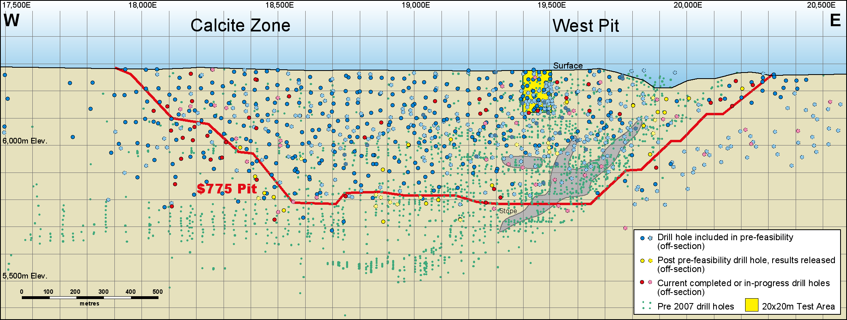

Figure 2. Over 300,000 metres of drilling have been completed by Detour Gold from early 2007 to September 2009 (open pit outline is in red).

Regional geological setting
The Detour Lake gold deposit is located within the northwestern portion of the Abitibi greenstone belt (“AGB”) in the Superior Province of the Canadian Shield. The AGB is the world’s largest greenstone belt covering a large area of northeastern Ontario and northwestern Québec. The AGB has had a total mineral production valued at approximately $120 billion as of 2005, derived from world-class volcanogenic massive sulphide (VMS) deposits, such as in Rouyn-Noranda (Gibson and Watkinson, 1990) and at Kidd Creek (Bleeker et al., 1999); gold-rich VMS deposits, such as Bousquet or Laronde Penna (Mercier-Langevin et al., 2007); and epigenetic gold deposits, such as the Hollinger-McIntyre and Dome mines (Bateman et al., 2008), the Kirkland Lake “main break” deposits (Ispolatov et al, 2008) and the Sigma-Lamaque complex (Robert and Brown, 1986). Gold production in AGB epigenetic gold deposits (such as Detour Lake) has largely been derived from narrow vein underground mining.

The AGB comprises east-trending synclines of largely volcanic rocks (ultramafic to felsic in composition) and intervening domes cored by synvolcanic plutonic rocks (tonalite and gabbro-diorite) alternating with east-trending bands of late tectonic turbiditic and conglomeratic metasedimentary rocks (Ayer et al. 2002; Daigneault et al. 2004). Most of the volcanic and sedimentary strata dip vertically and are commonly bound by abrupt, east-trending faults with variable dip (Figure 3). Some of these faults, such as the Porcupine-Destor Fault, display evidence for overprinting deformation events including early thrusting with later strike-slip and extension events (Benn and Peschler, 2005; Bateman et al., 2008). Two ages of unconformable successor sedimentary basins occur: early widely distributed “Porcupine-style” basins of fine-grained clastic rocks and minor volcanic rocks, followed by “Timiskaming-style” basins of coarser clastic and minor volcanic rocks, which are largely proximal to major strike-slip faults (Destor-Porcupine, Larder-Cadillac and similar faults in the northern AGB; Ayer et al. 2002). In addition, the AGB is cut by numerous syn to late-tectonic intrusions (ranging from gabbro to granite and syenite with lesser dikes of diabase, lamprophyre and carbonatite composition).

Field and geochronological data indicates that the AGB developed autochthonously based on widespread evidence of isotopic inheritance in younger supracrustal assemblages (Ayer et al., 2005; Thurston et al. 2008). The AGB has been subdivided into six early volcanic stratigraphic episodes (i.e. assemblages) on the basis of groupings of numerous U-Pb zircon ages: a) 2770-2736 Ma Pacaud assemblage, b) 2730-2724 Ma Deloro assemblage, c) 2723-2720 Ma Stoughon-Roquemaure assemblage, d) 2719-2711 Ma Kidd-Munro assemblage, e) 2710-2704 Ma Tisdale assemblage, and f) 2704-2695 Ma Blake River assemblage; all unconformably overlain by two late sedimentary assemblages: g) 2690-2685 Ma Porcupine assemblage and h) 2676-2670 Ma Timiskaming assemblage (Ayer et al. 2005; Thurston et al, 2008).

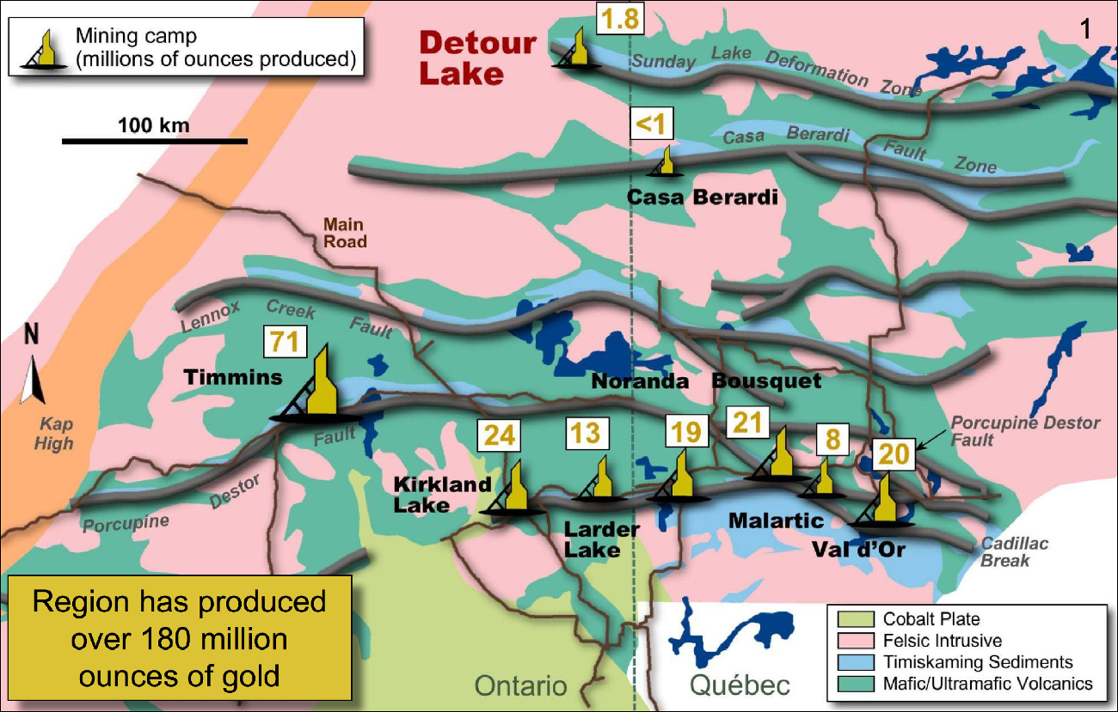

Figure 3. Regional Geology Map of the Abitibi Greenstone Belt (AGB) and the associated major faults.

Deposit geology
The Detour Lake gold deposit is an Archean greenstone-hosted orogenic lode gold deposit, typical of the AGB and in particular similar to gold deposits found along the Destor-Porcupine Fault Zone (Pressaco, 1999).

Supracrustal rocks within the Detour Lake area comprise a thick 2730-2724 Ma sequence of mafic to ultramafic volcanic rocks, referred to as the Deloro Group, in structural contact to the south with the younger 2690-2685 Ma Porcupine sedimentary rock assemblage (Oliver et al. in prep; Figure 4). The supracrustal rocks are bounded to the north, east and west by weakly foliated granodioritic to tonalitic intrusions and cut by smaller mafic and felsic dikes and sills.

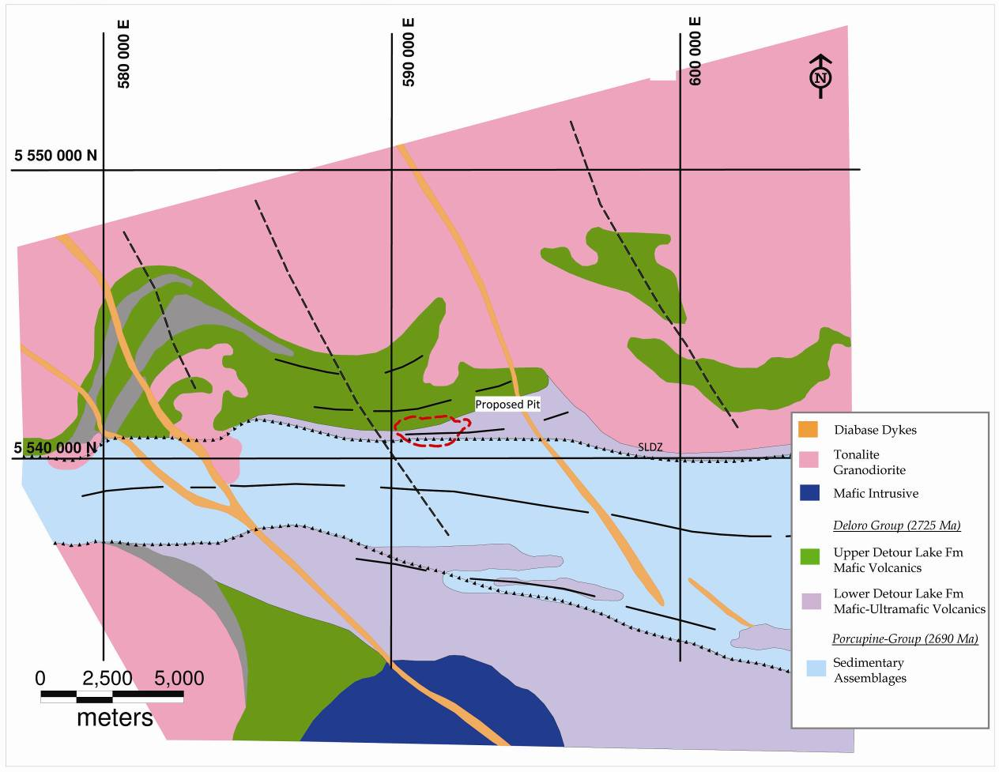

Figure 4. Detour Lake gold project regional geological map (modified from Oliver et al. in prep).

In the Detour Lake area, the Deloro Group is further sub-divided into the Upper and Lower Detour Lake Formations. The Upper Detour Lake Formation is a thick sequence of tholeiitic mafic volcanic massive and pillowed flows. At the base of the Deloro Group, the Lower Detour Lake Formation is dominated by ultramafic (komatiitic) flows, mafic flows and lesser tuffaceous-volcaniclastic horizons. The lower contact of the Upper Detour Lake Formation is marked by a mylonitized, auriferous, silicified felsic unit, locally referred to as the Chert Marker Horizon (CMH) (Figure 5). The CMH commonly ranges between 0.5 and 2.0 metres in thickness and is associated with elevated gold and sulphide content.

The volcanic flows have a general east-west strike, from east-northeast in the eastern part of the deposit, to west-northwest at the western end of the Detour Lake deposit. All rock units generally dip steeply 75° to 90° to the north (Figure 5).

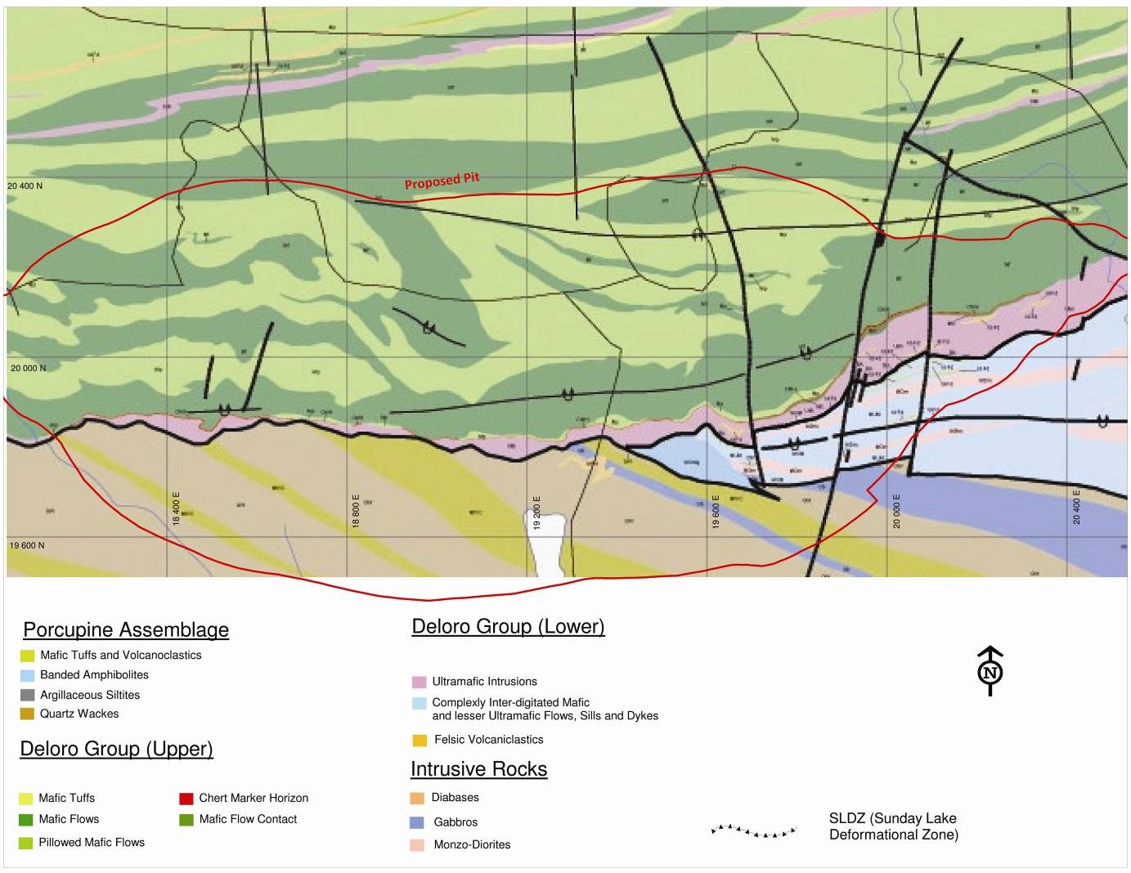

Figure 5. Detour Lake Gold project deposit geological map (modified from Oliver et al. in prep).

The Porcupine sedimentary rock assemblage is characterized by a stratified sequence of argillaceous siltite, quartz wacke, banded amphibolite and mafic volcaniclastic rock.

The contact to the south between the Deloro Group and the Porcupine Assemblage is defined by the Sunday Lake Deformation Zone (“SLDZ”), a regional scale deformation zone traced over a distance greater than 20 kilometres (Figure 5). This deformation zone is spatially related with the gold mineralization at Detour Lake.

Within the SLDZ, the Deloro Group ultramafic and mafic volcanic rocks are strongly altered and deformed to talc-chlorite and chlorite schist, and the CMH is strongly mylonitized and silica altered. A penetrative foliation is well developed within the SLDZ, shown in the alignment of biotite, chlorite, talc, quartz and sulphide. A moderately west plunging (~40°) stretching lineation is associated with the foliation, indicating oblique slip displacement. Kinematic indicators suggest a reverse-dextral component of oblique slip along the SLDZ, north side (hanging wall) south and east relative to the south side (footwall).

Gold mineralization
Gold mineralization is hosted within all rock types at Detour Lake, although principally within the Deloro Group mafic and ultramafic volcanic rocks associated spatially with the trace of the SLDZ and subsidiary shear zones. Historically, gold mineralization was sub-divided into the Main Zone (focused on the CMH), the Quartz Hanging Wall Zone within the Upper Detour Lake Formation, and the Talc Zone within the Lower Detour Lake Formation. Historical gold production largely centred on the Main Zone where gold mineralization is associated with the CMH.
Gold mineralization covers a large volume at Detour Lake, forming a zone 200-350 metre wide, extending east-west over at least 3 kilometres along strike and from surface to a depth of at least 1,000 metres. Gold mineralization is intimately associated within a broad large scale stockwork of quartz-carbonate veins that occurs in talc schist, biotite schist, massive and pillowed mafic volcanics, and the CMH. The bulk of the gold mineralization is associated with high strain zones exhibiting strong potassic alteration and containing the quartz stockwork, crosscutting massive mafic flows and at the contact between massive and pillowed flows. The richest gold mineralized zones are associated with quartz veins with a strong biotite alteration and local zones of pyrrhotite-chalcopyrite-pyrite-gold enrichment developed in low-pressure sites during the deformation of the quartz vein system (Figure 6). Visible gold is usually found as specks, clusters or fracture coatings within quartz veins.
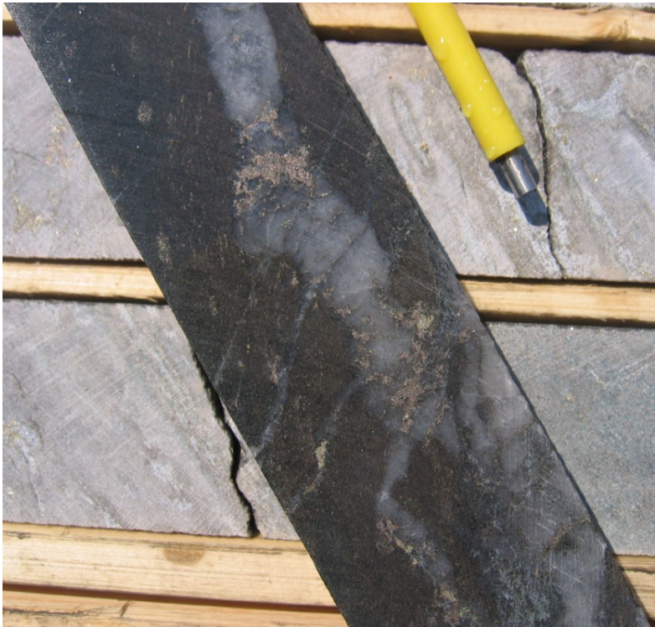

Figure 6. Boudinaged quartz vein with biotite alteration halo and with pyrrhotite and chalcopyrite infilling boudin necks, and associated extensional quartz veins. Drill hole DG-09-630, 29.125 g/t Au.

Historical gold production largely came from quartz-calcite veins, silicified zones and sulphide-rich gold mineralization associated with the CMH (Main Zone), centred on a flexure in the CMH where it shallows in dip in cross-section (Barclay, 1993; Marmont, 1986). The former Campbell open pit is located at the surface expression of this flexure. The overall shape of the flexure is defined by a distinct zone of shearing and hydrothermal alteration associated with the SLDZ. The flexure plunges west varying from approximately 40º near surface to about 20º farther at depth and to the west (Figure 7).
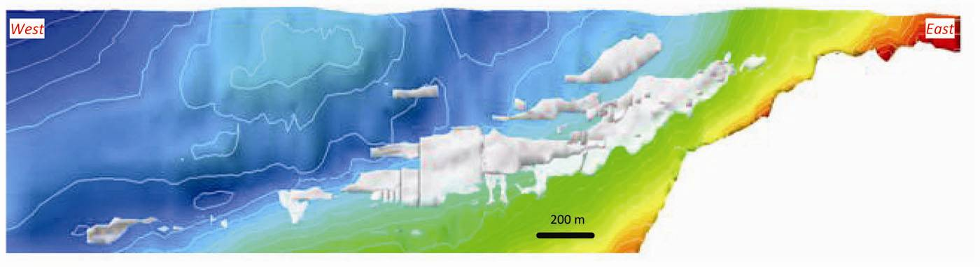
Figure 7. Schematic long section of the CMH and historical stope development (white) at Detour Lake looking north (Leapfrog software). CMH is represented by the green/blue boundary depicting the shallow west plunge of the flexure in the CMH coinciding with the mined out stopes.

Additional gold mineralization is associated with a stockwork of quartz veins splaying off the CMH in the Upper Detour Lake Formation (historically termed the “Q” series veins or Quartz Hanging Wall Zone). These auriferous quartz veins are associated with east-west trending, biotite schist shear zones often developed along lithological contacts. The gold zones form two dominant trends, west-southwest and west-northwest. In the eastern portion of the deposit, gold occurs in a quartz stockwork splaying off the CMH into overlying massive flows trending 260º. In the western part of the deposit, the auriferous quartz vein stockwork trends 275º to 285º, mainly within the pillowed flow sequence and along its contact with a more massive flow sub-unit. Most quartz veins have sub-vertical north or south dips and are parallel to a series of sub-vertically dipping east-west trending deformation zones. These auriferous quartz veins are typically only a few centimetres in thickness and occur at a frequency of greater than one vein per metre. In plan view, these veins are commonly noted as a series of sheeted sub-parallel veins which meet or intersect the CMH at 30º to 35º angles in plan view (Figure 8). These veins are commonly deformed, strongly boudinaged and folded.
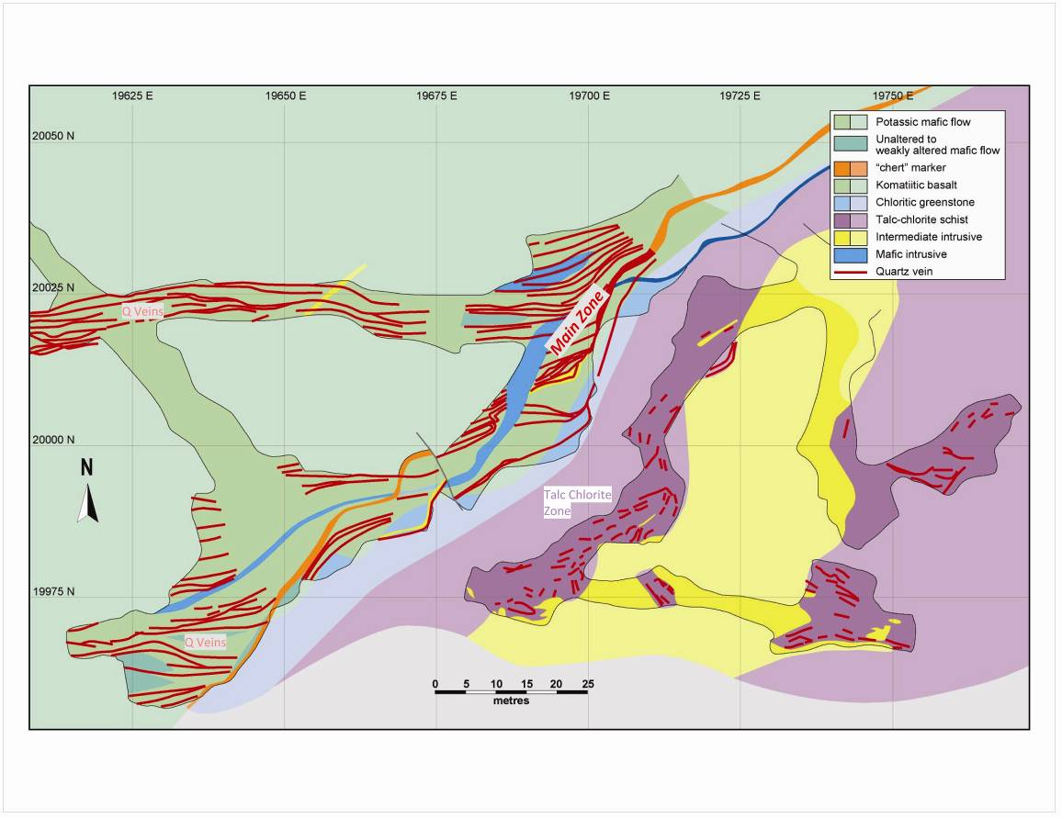
Figure 8. Main and Talc Chlorite zones: Plan view, 360m Level. Note the ~35° angle between the CMH (orange) and the splaying quartz veins (red). Photoreduced from 1:250 scale geology plans (modified from Barclay, 1993).

Broader gold zones associated with a weaker quartz stockwork and deformation zones developed along lithology controlled dilatant sites in pillowed flows, hyaloclastite sequences or at pillowed/massive flow contacts also occur within the Upper Detour Lake Formation. In the western end of the deposit, gold mineralization is associated with a stronger calcite alteration and weaker potassic alteration, often containing calcite in veinlets and quartz veins. Gold mineralization appears to be closely associated with pillow selvages and pods of volcanic breccia. Sulphides and visible gold occur locally within quartz veining. Although pillow selvages and vesicles are preferentially sulphide altered and locally contain visible gold, the sulphide and gold alteration is clearly epigenetic and coeval with development of high strain zones.

Gold mineralization also occurs within the Lower Detour Formation (Talc Chlorite Zone) hosted in highly altered ultramafic flows below the CMH and along the contact with barren mafic volcanic rocks. Gold occurs dominantly with pyrite-pyrrhotite and minor chalcopyrite along foliation planes, narrow discrete shear zones and in irregular lenses. The gold mineralized zones also contain short deformed lenses or boudinaged quartz veins. In some cases, the gold mineralization is controlled by strong brittle fault structures containing several centimetres of gouge material. Gold mineralization is preferentially concentrated in talc-chlorite schist near the contacts of intermediate to felsic dikes.

Realization of world class potential
Detour Gold acquired the Detour Lake project on January 31, 2007 with the sole focus on delineating and putting into production a world-class, large scale, open pit gold deposit in the AGB. This represents a paradigm shift for the AGB and for the Detour Lake deposit where historical gold production has largely been from narrow vein underground mining. The motivation driving Detour Gold’s revitalization of the Detour Lake project was:

- Indication from previous underground operation and drilling of near-surface low-grade gold mineralization;
- Potential existed for a broader auriferous vein system, covering a large area outside of the historical mine footprint;
- The deposit remained open at depth and along strike; and
- Possibility to develop a large scale bulk tonnage open pit operation on these assumptions.

An aggressive exploration programme was quickly initiated that has now lead to the drilling of over 850 bore holes (over 300,000 metres) to expand and delineate the gold deposit. The exploration programme targeted the Detour Lake deposit as whole instead of investigating separate gold zones with a view of evaluating the open pit potential of this large gold deposit. The goal was to determine a strategy to achieve the full potential of the project in a timely and cost effective manner. The programme strategy included:

- Elevating key areas to Measured and Indicated resources;
- Further delineate poorly defined zones to Inferred category to expand resource inventory; and
- Methodical grid drilling to quantify maximum size, extent and potential upside of the deposit.

The size of the Detour Lake gold deposit has grown considerably since Detour Gold acquired the property in January 2007. Pelangio had defined a near surface resource of nearly 1 million ounces prior to selling its asset to Detour Gold. During the due diligence period in mid-2006, Detour Gold estimated the mineral resources at 20 million tonnes grading an average of 2.14 g/t Au containing 1.4 million ounces of gold in the Indicated category with an additional 35.4 million tonnes at an average grade of 1.80 g/t Au containing 2.0 million ounces of gold in the Inferred category (Eric A. Kallio, 2006 NI 43-101 Technical Report).

By mid-2008, the mineral resources increased fourfold with 262 million tonnes grading an average of 1.40 g/t Au containing 11.75 million ounces of gold in the Measured and Indicated category with an additional 70.7 million tonnes at an average grade of 1.22 g/t Au containing 2.8 million ounces of gold in the Inferred category (prior to detailed engineered pit design) (Risto et al. 2008; Figure 9).

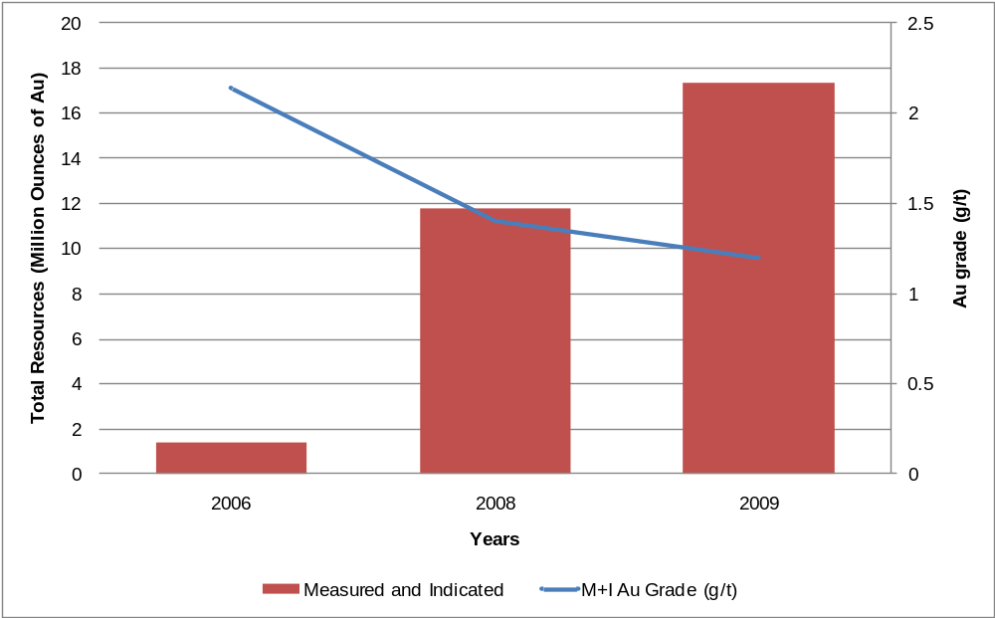

Figure 9. Growth through time of the Detour Lake Gold deposit resource (Note: 2006 Resource only included Indicated Resources and not Measured; 2009 Resource is a global resource and not within a LG pit shell).
The global mineral resources were further increased in September 2009 with 445 million tonnes grading an average of 1.2 g/t Au containing 17.3 million ounces of gold in the Measured and Indicated category and an additional 151 million tonnes grading an average of 1.1 g/t Au containing 5 million ounces of gold in the Inferred category (SGS Geostat by Michel Dagbert, 2009 NI 43-101 Technical Report; Figure 9). Detour Gold’s drilling has demonstrated the continuity of gold mineralization within and beyond the limit of the current conceptual open pit shell indicating the Detour Lake deposit still has room to expand, especially to the west.

Pre-Feasibility study

Based on the successful growth of the resource resulting from the 2007-2009 exploration campaigns, a Pre-Feasibility study was completed on Detour Lake in September 2009 (Met Chem by Rock Gagnon, 2009 NI 43-101 Technical Report). The aim of the study was to develop various mine optimization strategies to provide a basis for advancing towards a Feasibility Study during 2009-2010.

The September 2009 measured and indicated resource includes a Proven and Probable open pit reserve of 239 million tonnes grading an average of 1.15 g/t Au containing 8.8 million ounces or 281 tonnes of gold, based on a gold price of US$775 per ounce (BBA by Patrice Live, 2009 NI43-101 Technical Report; Figure 10). Detour Lake now represents a world class (>100 t Au) gold deposit that is the largest undeveloped gold reserve in Canada and the 6th largest undeveloped gold reserve in North America.

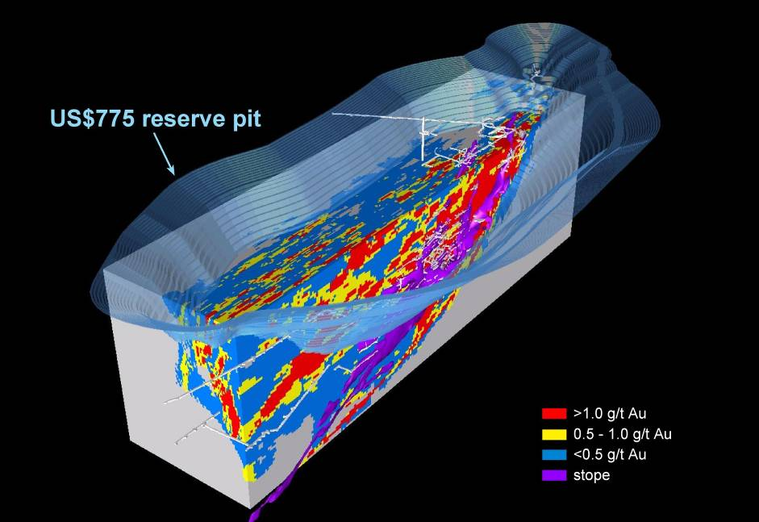

Figure 10. The Detour Lake deposit contains a Proven and Probable open pit reserve of 239 million tonnes grading an average of 1.15 g/t Au containing 8.8 million ounces, based on a gold price of US$775 per ounce (Looking approx. northeast).

The main highlights of the Pre-Feasibility study are:

- Detour Lake will be mined as a phased, multi-stage large open pit, 2.5 kilometres in length and 490 metres deep; strip ratio 3.8:1;

- 14.5 years mine life at 45,000 tonnes per day mill throughput to produce an average of 560,000 ounces of gold per year at a cash cost of US$404 per ounce;

- Overall gold recovery of 91.5% (gravity recovery estimated at 30-50%);

- Operating costs are expected to average US$1.29/tonne mining and US$6.26/tonne milling;

- At US$775 per ounce gold price, a pre-tax NPV of 5% or US$621 million, IRR 13.5%, and 6.2 year payback;

- At US$900 per ounce gold price, a pre-tax NPV of 5% or US$1.2 billion, IRR 20.1% and 4.0 year payback; and

- Opportunities to improve project economics: further increase in reserves, optimizing mill throughput (coarser grind), and stockpiling and processing low-grade material.

Acknowledgements
Detour Gold would like to acknowledge and thank the following persons who have made the completion of this paper possible: Jim Oliver for his contribution to the Detour Lake project, the geological team on site for their contribution, and Laurie Gaborit, Director Investor Relations, for providing suggestions and edits to this paper.

References

Ayer, J.; Amelin, Y.; Corfu, F., Kamo, S.; Ketchem, J.; Kwok, K.; and Trowell, N., 2002, Evolution of the southern Abitibi greenstone belt based on U – Pb geochronology: autocthononous volcanic construction followed by plutonism, regional deformation and sedimentation, Precambrian Research, 115, p. 63 – 95.

Ayer, J.A., Thurston, P.C., Batemen, R., Dube, B., Gibson, H.L., Hamilton, M.A., Hathway, B., Hocker, S.M., Houle, M.G., Hudak, G., Ispolatov, V.O., Lafrance, B.; Lesher, C.M., MacDonald, P.J., Peloquin, A.S., Piercey, S.J., Reed, L.E., Thompson, P.H., 2005, Overview of results from the Greenstone Architecture Project: Discover Abitibi Initiative: Ontario Geological Survey, Open File Report 6154, 146 p.

Barclay, W., 1993, Aspects of structural geology at the Detour Lake Mine. Internal Report for Placer Dome Inc.

Bateman, R. , Ayer, J.A., and Dube. B., 2008, The Timmins-Porcupine Gold Camp, Ontario: Anatomy of an Archean Greenstone Belt and Ontogeny of Gold Mineralization, Economic Geology, 103, 1285 - 1308.

Benn, K., and Peschler, A.P., 2005, A detachment fold model for fault zones in the Late Archaean Abitibi greenstone belt: Tectonophysics, 400, p. 85 – 104.

Bleeker, W., 1999, Structure, stratigraphy, and primary setting of the Kidd Creek volcanogenic massive sulphide deposits : a semiquantitative reconstruction. In: Hannington, M.D. & Barrie, C.T. (eds) The Giant Kidd Creek Volcanogenic Massive Sulfide Deposit, Western Abitibi Subprovince, Canada. Economic Geology Monograph, 10, 71-121.

Daigneault, R., Mueller W.U., and Chown, E.H., 2004. Abitibi greenstone belt plate tectonics: the diachronous history of arc development, accretion and collision. Pat Eriksson, Wlady Altermann, David Nelson, Wulf U Mueller, and Octavian Catuneanu (editors). The Precambrian Earth: tempos and events. In: Developments in Precambrian Geology 12, Elsevier, 88-103 pages.

Gibson, H.L. and Watkinson, D.H., 1990, Volcanogenic massive sulphide deposits of the Noranda Cauldron and Shield Volcano, Quebec, in Rive, M., Verpaelst P., Gagnon, Y., Lulin, L.M., Riverin, G., and Simard, A., eds., The Northwestern Quebec Polymetallic Belt: A summary of 60 years of mining exploration, Canadian Institute of Mining and Metallurgy, Special Volume 43, p. 119-132

Ispolatov, V., LaFrance, B., Dube, B., Creaser, R., and Hamilton, M., 2008, Geologic and Structural setting of gold mineralization in the Kirkland Lake-Larder Lake Gold belt, Ontario. Economic Geology, 103, 1309-1340.

Kallio, E.A., 2006, Technical Report for the Detour Lake Mine option property, Detour Lake Project, District of Cochrane, Ontario. Prepared for Detour Gold Corporation.

Kallio, E.A., 2005, Technical Report for the Detour Lake Mine Option Property, Detour Lake Project, District of Cochrane, Ontario. Prepared for Pelangio Mines Inc.

Marmont, S., 1986, The geological setting of the Detour Lake gold mine, Ontario, Canada, In Gold '86: An International Symposium on the Geology of Gold Deposits, Edited by Macdonald, p. 81 – 96.

Mercier-Langevin, P., Dubé, B., Hannington, M.D., Davis, D.W., Lafrance, B., and Gosselin, G., 2007,
The LaRonde Penna Au-Rich Volcanogenic Massive Sulfide Deposit, Abitibi Greenstone Belt, Quebec: Part I. Geology and Geochronology, Economic Geology, 102, 585 - 609.

Oliver, J., Ayer, J.A., Dube, B., Aubertin, R., Burson, M., and Panneton, G., In Prep, Structural, Chronologic, Lithologic and Alteration Characteristics of Gold mineralization: The Detour Lake Gold Deposit, Ontario, Canada.

Pressacco, R., 1999, Economic Geology and Mineralization at the Detour Lake Mine, Ontario Geological Survey Open File Report 5985, p. 52 – 76.

Risto, R., Breede, K., Live, P., Castro, L., and Melis, L., 2008, Technical Report and Mineral Resource estimate update for the Detour Lake mine option property, Ontario. Prepared for Detour Gold Corporation by Watts Griffis and McOuat Consulting Engineers.

Robert, F., and Brown, A.C., 1986, Archean gold-bearing quartz veins at the Sigma mine, Abitibi greenstone belt, Quebec. Part I, Economic Geology, 81, 578-592.

Thurston, P.C., Ayer, J.A., Goutier, J., and Hamilton, M.A., 2008, Depositional Gaps in Abitibi Greenstone Belt Stratigraphy: A Key to Exploration for Syngenetic Mineralization, Economic Geology, 103, 1097 – 1134.

