Genesis of Chah-Talkh nonsulfide Zn-Pb deposit (south of Iran): Evidence from Geology, Mineralogy, Geochemistry and Stable Isotope (C, O) data

Abdolkarim rezaeian^{1*}, Iraj Rasa², Ali Amiri³, Mohammad Reza Jafari⁴
¹ Sciences and Research Branch, Islamic Azad University, Department of geology, Tehran, Iran
² Faculty of Earth sciences, Shahid Beheshti University, Tehran, Iran
³ Zarand Branch, Islamic Azad University, Zarand, Kerman, Iran
⁴ North Tehran Branch, Islamic Azad University, Department of geology, Tehran, Iran

Abstract
Chah-Talkh nonsulfide Zn-Pb deposit with about more than 720000 t at 15% Zn in the form of Zn carbonates and silicates is a target resource in the south of Iran. In this preliminary study, some cases likes geology, mineralogy and geochemistry (major and trace element data and stable Isotope) of this deposit in surface and depth are investigated for determine of genesis. The analyses carried out on samples from 14 drill cores and 15 surface profiles (vertical to veins strike). Mineralization occurs in 3 main veins with thickness about 0.5 to 3 meters in the length about 900 m that in (resent) exploration this length increases. Main ore minerals are hydrozincite, hemimorphite and smithsonite. The mineralogical and geochemical evidences indicate that Chah-Talkh deposit is a typical supergene nonsulfide Zn-Pb deposit in carbonate rocks that primary sulfide ores almost has been affected by deeply weathered. Mineralization in Chah-Talkh is generally associated with fracture zones and dolomitization. It seems that distribution of hemimorphite, smithsonite and hydrozincite is reflection of existing of clay minerals in host rocks. In presence of clay minerals (in marly limestone) main ore mineral is hemimorphite and in absence of clay minerals (micritic limestone) main ore mineral is hydrozincite and smithsonite. The δ18O_{vsmow} value of hydrozincite ranges from 7.57 to 15.15 per mil that is very lower than this value in other nonsulfide deposits and has extent range. C and O isotopes and fluid inclusion data indicate that Zn oxide minerals were formed at temperatures ˷ 80° to 100°C by meteoric and metamorphic waters. There are evidences of both direct replacement and wallrock replacement in mineralization. EPMA analyzes and map elements of minerals show that in first stage of weathering fO₂ was very high then gradually fCO₂ increases. It seems that primary source of Zn and Pb could be Permian metamorphic unites (essentially shale and shiest).
Chah-Talkh nonsulfide Zn-Pb deposit with about more than 720000 t at 15% Zn in the form of Zn carbonates
and silicates is a target resource in the south of Iran. A study of the geology, mineralogy and geochemistry (major and trace element data and stable Isotope) of this deposit in surface and depth was made to determine the origin of the ores. Analyses were carried out on samples from 14 drill cores and 15 surface profiles (vertical to veins strike).
The main mineralization occurs in 3 veins with (total? or individual?) thickness of about 0.5 to 3 meters, currently traceable over lengths of about 900 m. The principal ore minerals are hydrozincite, hemimorphite and smithsonite. The mineralization is generally associated with the formation of fracture zones accompanied by dolomitization. In the presence of clay minerals (e.g. in marly limestone) the main ore mineral is hemimorphite, whereas in the absence of clay minerals (micritic limestone) the main ore mineral is hydrozincite and smithsonite. The sigma18Ovsmow value of hydrozincite ranges from 7.57 to 15.15 per mil, a range of values very much lower than in other nonsulfide deposits. C and O isotopes and fluid inclusion data indicate that the Zn oxide minerals were formed at temperatures c. 80° to 100°C by meteoric and metamorphic waters. There is evidence of both direct replacement and wallrock replacement in the mineralization process. EPMA analyzes and element distribution maps of minerals show that fO2 was very high in the first stage of weathering , with gradually increasing fCO2 in the later stages.
It is concluded that the Chah-Talkh deposit is a typical supergene nonsulfide Zn-Pb deposit in carbonate rocks formed from primary sulfide ores as a result of deep weathering. It is possible that the primary Zn and Pb was derived from Permian metamorphic units (essentially shale and schist). .

Keywords: Chah-Talkh deposit, nonsulfide Zn mineralization, supergene, stable isotope
*Corresponding author: Abdolkarim Rezaeian, Email: krrezaeian@gmail.com

Introduction
Nonsulfide Zn deposits have experienced a significant revival over the recent years, as a consequence of new developments in hydrometallurgical acid-leaching, solvent extraction, and electro winning techniques (Large, 2001).
Iran is host to more than 600 deposits and indexes showings of Zn and Pb (Ehya et al., 2010); many of them of the non-sulfide type. Some deposits, such as Angouran and Mehdiabad have a large tonnage and are renowned in the world. Other deposits are small to medium size, such as the nonsulfide bodies of the Kuhbanan-Bahabad area. Some of them have sulfide ore (sphalerite and galena) at depth, but others such as Chah-Talkh display only relict sulfides. The Chah-Talkh deposit is situated in the Kerman Province (southern Iran), about 45 km southwest of Sirjan (980 km south of Tehran). Some old mining activities have been observed at Chah-Talkh, but it is not clear when ores really were first mined. More recently. the non_sulfide ores at Chah-talkh, which consist mainly of smithsonite, hydrozincite and hemimorphite, were exploited from 1958 until 1971. In this period about 200,000 ton of ore, grading 23% Zn and minor lead was exploited, and a concentrate with 45% Zn was exported to the USSR. The deposit resource has been estimated (Sabzehei and Afrooz, 1989) to be more than 720000 tons.

Regional geology
The Chah-talkh deposit is located in the southern Sanandaj-Sirjan Zone of the Zagros orogenic belt, close to the Urumieh-Dokhtar Magmatic Arc (Fig. 1). The Zagros Belt formed as a consequence of Tertiary continental collision between the Afro-Arabian plate and smaller Gondwana-derived microplates, following subduction of the Neotethys ocean during the Cretaceous (Boni et al., 2007). This north west - south east trending zone (Sanandaj-Sirjan) is divided into a northern and southern section (Aghanabati, 2004): the Chah-Talkh deposit is situated in the southern section. The geology of Sanandaj-Sirjan Zone in the Chah-Talkh area is dominated by uppermost Paleozoic/lowermost Mesozoic (Permian-Trias) rocks consisting of slate, phyllite, black schist, quartzite, mica schist, amphibolite, gneiss, metarhyolite and green schist, covered by Cretaceous limestone. The non-sulfide mineralization in the Chah-Talkh deposit is hosted by a late Cretaceous limestone sequence overlying a calcareous sandstone unit.

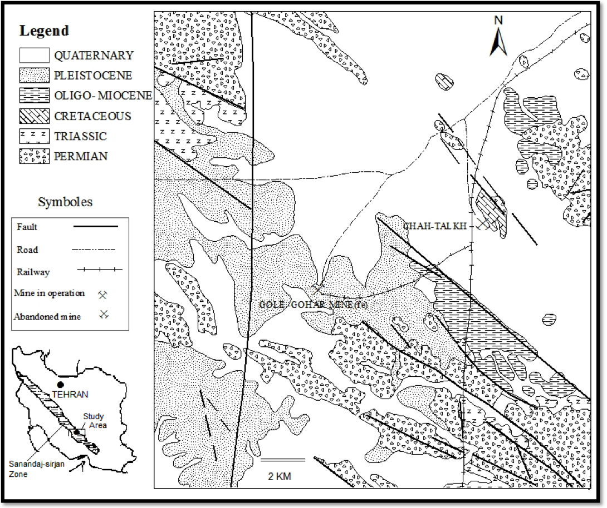
Fig.1. Geological map of the Sanandag-Sirjan zone in Chah-Talkh area (modified from Sabzeheiet al.,1997).

The Cretaceous limestone is a variable sequence of thin to medium bedded, gray biomicrites or oomicrites, and limestones with marly interbeds. Both rock units (limestone and marly limestone) are dolomitized. These units have been deposited in a shallow marine environment.

Deposit Geology
The Chah-Talkh orebody lies in a NW-striking structural belt in the Upper Cretaceous dolomitic limestone. The host rock appears as a syncline whose axis strikes NW-SE and plunges southward at 15-20°. North - south oriented faults cut the syncline at several points. The western limb of the syncline dips about 65° to the east and eastern limb dips 60° to the west. Three main faults are located in this deposit. The Said Abad fault in the east, and the Chah-Talkh fault in the center and in the west. The Chah-Talkh fault in the west of the syncline is parallel to sub- parallel to the axis of syncline. Mineralization occurs along a minor fault, which lies between the separates dolomitic limestone (k^{ld}₂) and the from lower marly limestone (k^{lm}₁) in on the west limb of syncline, near of west Chah-Talkh fault. This is a permeable zone, which is believed to have acted as conduit for the hydrothermal fluids. The age of host rock in the Chah-Talkh ore deposit is different from the other Zn-Pb deposits in the Sanandag-Sirjan zone such as Irankouh (hosted in Lower Cretaceous) and Angouran (hosted in Cambrian). The host rock limestone of the Chah-Talkh deposit (Upper Cretaceous) lie unconformably on a sandy conglomerate unit, and is considered to have been sedimented deposited in a shallow shelf to marginal marine environment. Limestone includesshows high-energy (oolitic unit) to moderate energy (bioclastic unit) strata and low energy micritic wackestone with sparse bioclasts. The host rock limestone has been subdivided into five units, which from the bottom to top includes: lower dolomitic limestone (k^{ld}₁), lower marly limestone (k^{lm}₁), middle dolomitic limestone (k^{ld}₂), upper marly limestone (k^{lm}₂) and upper dolomitic limestone (k^{ld}₃) (Fig. 2). The main part of the mineralization is located in a fault zone between the k^{lm}₁ and k^{ld}₂ units. For simplicity, in the geological map of Fig. XX, k^{ld}₂, k^{lm}₂ and k^{ld}₃ are represented as the kldm unit.

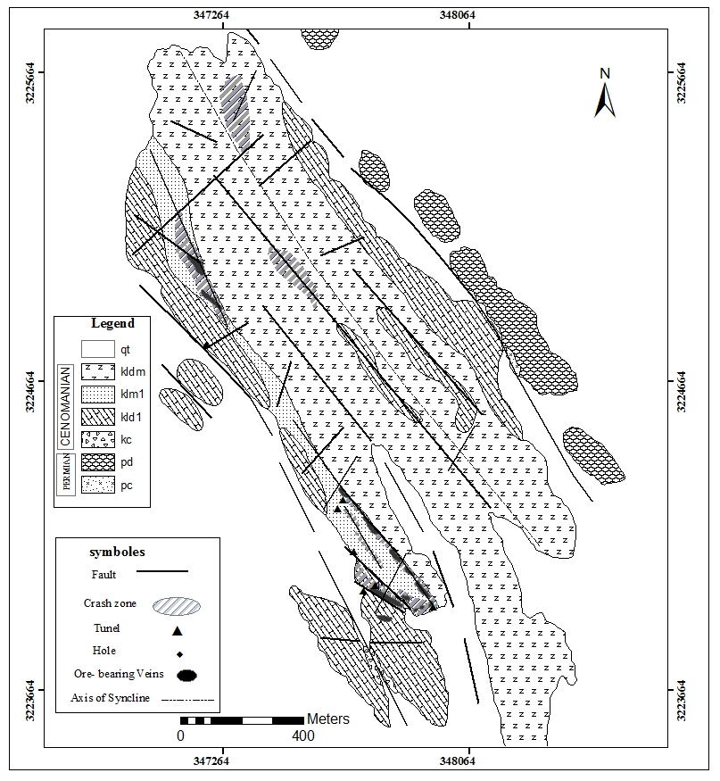

Fig 2: Simplified geological map of Chah-Talkh (modified from IMIDRO, 2010). The Chah-Talkh orebody is located in the hanging wall of an NW-SE trending fault; the ore body is stratabound and composed of multiple veins. Maximum throw of the fault is about 500 m. The mineralization is considered to be epigenetic. The strike of the veins is parallel to that of the bedding of the host limestone (k^{lm}₁ and k^{ld}₂).
The hypogene ore comprises galena, sphalerite and pyrite as remnants in the supergene ore. The epigenetic mineralization took place during dolomitization (main alteration)and the precipitation of calcite and dolomite in veins and cavities. The main association of nonsulfide minerals at Chah-Talkh consists of smithsonite, hemimorphite and hydrozincite. Sabzehei and Afrooz (1989) estimated the ore resource of Chah-Talkh at about 720,000 tons at 15% Zn and 8% Pb, but the results of recent exploration have raised these evaluations.

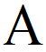


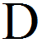
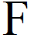

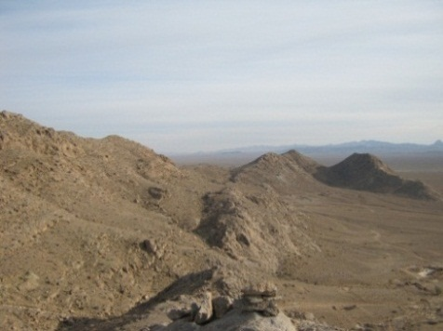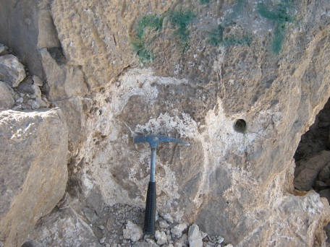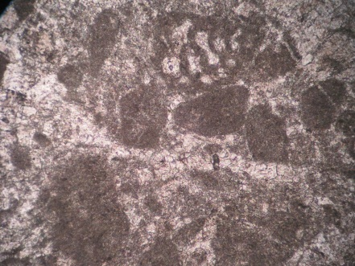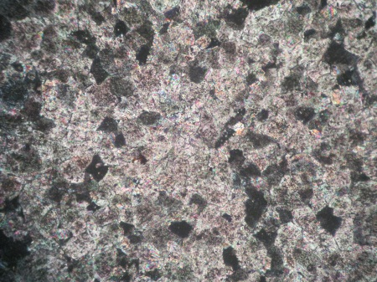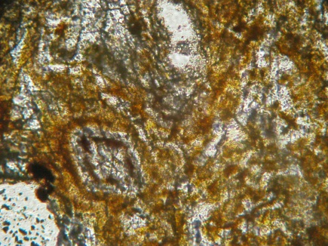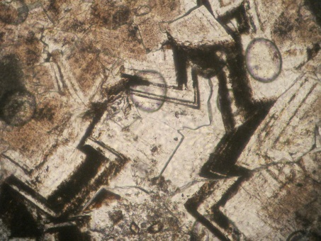
Hem
Dol

Fig. 3: A: West limb of the Chah-Talkh syncline and location of nonsulfide mineralization; B: fracture filled by nonsulfide Zn ores (hydrozincite and smithsonite) in the lower dolomitic limestone (k^{ld}₁); C: k^{ld}₁ (host rock) in thin section (rounded spaces of micrite in the sparite matrix) (PPL). D: first stage dolomitization that has no relation to mineralization (PPL); E: second stage dolomitization, which is related to the nonsulfide mineralization and fracture zones (PPL); F: third stage dolomitization that occurred together with mineralization (PPL).

Dolomitization
The host rock of the Chah- Talkh nonsulfide Zn-Pb deposit is dolomitized (Rezaeian et al., 2010). At least three dolomitization stages can be distinguished in the Chah-Talkh mine (Fig. 3). Early nonferroan dolomite in the micritic limestoneis widespread throughout rocks in the Chah-Talkh syncline. This dolomitization stage is not related to mineralization.
The dolomite precipitated in the second stage of dolomitization is weakly ferroan, and is coeval with both brecciation and primary Pb-Zn sulphide mineralization. D
Third stageferroan coarse grained dolomite occurs along fractures, filling cavities and breccia zones. This dolomitization stage was synchronous with the replacement of Pb-Zn sulphide minerals by non-sulfide Pb-Zn minerals.

Sampling and analytical methods:
To investigate the distribution of secondary Zn- and Pb-bearing minerals, Iranian Mines & Mining Industries Development & Renovation Organization (IMIDRO) carried out fourteen drilled fourteen sites along the main veins in the southern part of the Chah-Talkh deposit. The mineralization sites are covered locally by recent alluvial sediments. The holes were drilled to a maximum depth of 134 m (N.2 hole), and clear evidence of the presence of supergene minerals was found down to maximum depth of 82 m (hole N.8). From the fourteen diamond drill cores 536 samples were prepared for this study. All samples are from the non-sulfide section: in the drill cores the sulfide zone is not represented. One hundred and twenty seven samples were collected from selected outcrops and from the carbonate host rocks at the surface at Chah-Thalkh, 3 samples from the slags, and 8 samples from the veins. Ore minerals are detected in thin-section ,and XRD (table 1) and EPMA analysis.
Optical microscopy (OM) and powder X-ray diffraction (XRD) were used to examine the samples. Thin sections of smithsonite, hemimorphite, hydrozincite and cerussite-bearing assemblages were analyzed by electron microprobe at the Iran Mineral Processing Research Center (IMPRC). Selected major, minor and trace elements of the Chah-Talkh ore have been measured at ALS Chemex laboratories in Vancouver, Canada with ME-ICP61a.
O and C isotopes were measured on hydrozincites at the Cornell Isotope Laboratory (COIL, USA).

Mineralization
The main Chah-Talkh orebody contains supergene zinc minerals with some remnants of sulfides disseminated in the supergene ore. Mineralization occurs in a main vein and in two minor veins. The main vein is at least 900 m in length at the surface. This vein is situated in the upper part of the k^{lm}₁ unit in the adjacent of k^{ld}₂ unit. Other smaller veins have a maximum length of 65 m. Nons-sulfide zinc minerals are dominated by smithsonite (ZnCO3), hemimorphite [Zn4Si2O₇(OH)₂·H₂O)] and hydrozincite [Zn5(CO3)₂(OH)₆]. Zincite [(Zn,Mn)O] , willemite and rare sweetite [Zn(OH)2] also occur. In aAlmost all samples these minerals occur together. The Zn-carbonates Smithsonite and hydrozincite are more common in the lower dolomitic limestone (k^{ld}₁) whereas the siliceous hemimorphite is more common in the lower marly limestone (k^{lm}₁). Non-sulfide zinc minerals display many different textures:earthy masses, breccia cement, replacement and open space filling in fractures and karstic cavities. Hydrozincite shows exhibits a colloform texture and seems to be last phase of mineralization. Willemite was only found by XRD in one sample (64-D) from the tunnel no.6 (in k^{lm}₁ unit). Sweetite occurs as traces in sample CT-55 (in the main vein at klm1 unit). Lead occurs as cerussite (PbCO₃) and rare massicot (PbO): the latter is found only by XRD.
Among the clay minerals montmorillonite is predominant in the K^{lm}₁ unit. Kaolinite was a few samples. Rarely, iron oxides and hydroxides were found with other manganese minerals in weathered zones. The mean Fe value both at depth and in surface samples (657 samples) is 0.42%. The main gangue minerals consist of dolomite and calcite and rare quartz.

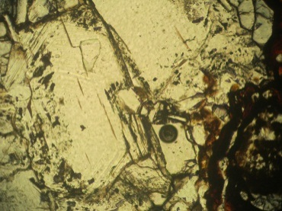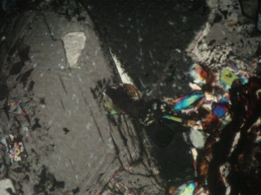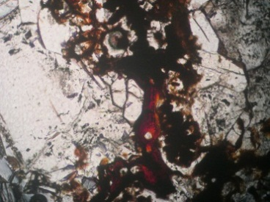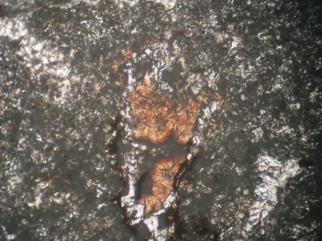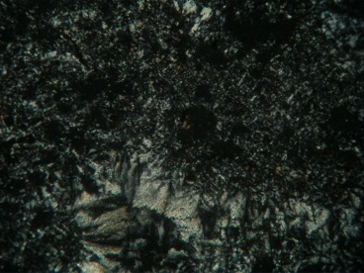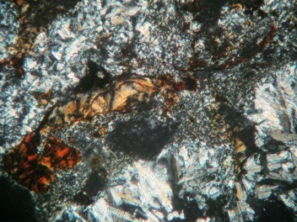
hyz
Hem
Sph
Sph
Hem
Hem
Hem
Hem
Hem
hyz
Sph

Fig.4. Microphotographs taken of Zn and Pb nonsulfide minerals from the mineralization of Chah-Talkh; A: direct replacement of sphalerite to hemimorphite (PPL); B: direct conversion of sphalerite to hemimorphite (XPL); C: residual sphalerite adjacent to hemimorphite (PPL); D: aggregates of fine radiating crystals of hydrozincite in the matrix of hemimorphite (PPL); E: aggregates of fine radiating crystals of hemimorphite adjacent to cerussite (XPL); F: aggregates of fine radiating crystals of hydrozincite and aggregates of tabular crystals of hemimorphite replacing the carbonate host rock (PPL).

Hemimorphite

Hemimorphite is more abundant than smithsonite in many samples from the lower marly limestone (k^{lm}₁) unit. In this unit sphalerite is directly replaced by hemimorphite: in fact the sphalerite form has been kept during this process (Fig. 4). In turn, Hydrozincite replaces hemimorphite. The latter mineral occurs as tabular crystals with radiating texture (under the microscope) and as massive cryptocrystalline aggregates
Smithsonite
Smithsonite is the most important supergene ore mineral in the veins in the lower dolomitic limestone (k^{ld}₁) unit; it is always found together with hydrozincite. The color of smithsonite ranges from milky white to beige. In many

Table 1

XRD qualitative analysis of the samples from the Chah-Talkh mine (S Iran)

sample | Mineral(s) | Host rock unit | sample | Mineral(s) | Host rock unit
CT-10-D | cc, qz | Klm1 | CT-83-D | cc, qz | Kld2
CT-17-D | qz, san, mont,cc | Klm1 | CT-84-D | cc, non,clc, qz | Klm1
CT-19-D | cc, qz, mont | Klm1 | CT-85-D | cc, qz, clc, mos, rot | Klm1
CT-20-D | cc, hem, pir, clc | Kld1 | CT-86-D | cc | Kld1
CT-22-D | sm, hyz | Kld1 | CT-112-D | qz, mos, clc,cc | Kld1
CT-25-D | cc, qz, kaol | Klm1 | CT-115-D | ce, sm, cc | Kld1
CT-42-D | cc, qz, mont | Klm1 | CT-201-D | ce, qz, mas | Kld1
CT-55-D | sm, swe | Klm1 | CT-202-D | hyz, sm | Kld1
CT-61-D | cc, mont | Klm1 | CT-203-D | hyz, sm, cc | Kld1
CT-64-D | wi, hyz, cc | Klm1 | CT-204-D | hyz, ce, qz, hem | Kld1
CT-79-D | cc, dol | Kld1 | CT-205-D | hem, ce, hyz | Kld1
CT-81-D | cc, qz | Klm1 | CT-206-D | hyz, sm | Kld1
CT-82-D | cc, qz, non | Klm1 | CT-207-D | sm, ce, clc | Kld1

Mineral symbols are in order of abundance: cc calcite, ce cerussite, dol dolomite, sm smithsonite, hem hemimorphite, hyz hydrozincite, qz quartz, wi willemite, mont montmorilonite, kaol kaolinite, swe sweetit, pir pirophillite, clc clinochlore , mos moscovite, rot rotil, non nontronite, san sanidin, mas massicot.

samples this mineral occurs as a cement of breccia clasts in micritic limestone. Other textures of smithsonite are earthy aggregates, carbonate replacements, and open space, combed veins filling in fractures and karstic cavities. Smithsonite in aggregates is never completely pure and always occurs with hemimorphite and gangue minerals. In contrary smithsonite cements are more pure

Geochemistry
Zinc in non-sulfide ore at Chah-Talkh is present preferentially in smithsonite, hemimorphite and hydrozincite. Lead occurs in cerussite and minor massicot. Some galena and sphalerite remnants are disseminated in the matrix of nonsulfide ore. Chemical analyses of some non-sulfide minerals are shown in tables 2, 3 and 4.
The most important hole, among the 14 drilled in the Chah-Talkh mine, is hole N. 8. In this hole the maximum amount of zinc is about 41%, found at a depth of 28 m in depth (sample BH8-15). The highest lead value is about 16% at 27 m in depth (sample BH8-14). The Ag content is below detection limit. The maximum value of As is greater than 10000 ppm in the sample BH8-14. However, in the metallographic analysis, no As minerals have been detected. The maximum Cd value is 2000 ppm in samples BH8-3 and 4 about 8 m below the surface. The Fe and Zn contents decrease with depth, while the Mn content increases with depth. The mineralized section of this drillhole goes from 8.5 m below surface 82.5 m in depth. The Zn and Pb grades at the depth of 82.5 m are 12.5% and 3% respectively. The total thickness of the ore interval is about 38 m (with more than 1% zinc). This drillhole reached a maximum depth of 119 m and did not reach the water table. The Pb/Zn ratio and the Fe content in this hole decrease with depth (Fig. 5).

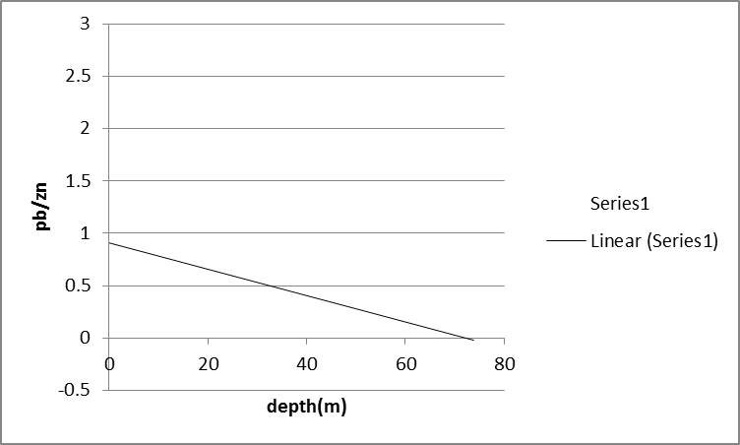
Fig.5: Inverse correspondence between Pb/Zn ratio and depth

The chemical analyses of the samples from drillhole N. 8 are shown in Fig. 6.
Another interesting drillhole at Chah-Talkh is hole N. 5. In this hole the highest Zn grade is about 37% at a depth of 22 m (sample BH5-13) and the highest Pb grade is about 8% in the same sample. The maximum As value is 1339 ppm in sample BH5-16 at a depth of 24 m, and the maximum Mn value is 2393 ppm in sample BH5-18 at the depth of 27 m below the surface. The Fe, Cd and Zn contents decrease with depth.
The results of total chemical analyses (657 samples from depth and surface) show a direct correspondence between Zn and Pb contents and the Mg/Ca ratio and Al content. With an increase in Ca and Mg, the Zn, Pb and Cd values decrease (Fig.11).
The Late Cretaceous limestone equivalent of the host rock of Chah-Talkh deposit, was sampled in the north of Chah-Talkh area and analyzed. The average Zn and Pb content in the samples from this outcrop is about 11 ppm and about 5 ppm respectively. These values are lower than the general content of these elements in carbonate rocks (Zn 20 ppm and Pb 9 ppm) (Krauskopf, 1976).
An EPMA study carried out on some ore-bearing samples revealed a few element maps (shown in Fig. 12, 13), and corresponding chemical analyses (Table 2, 3, 4). In these pictures zincite occurs as a cavity fills in the center of the image and around the cavity, and the host rock (dolomitic limestone) is replaced by Zn carbonates and hemimorphite. In the next stage Pb and Mn minerals replace the edges of zincite (Fig. 12 D, F). In the other stage the host rock (dolomitic limestone) is replaced by Zn carbonates and silicates. Part of Zn carbonates in the cavity filling are replaced in the late stage by Zn carbonates and silicates similar to the host rock but this replacement does not change the Pb and Zn minerals on the margin of zincite. The Zn content in the cavity is more than in the wall rock. Fig. 13 shows a galena cube that is present with the Zn minerals texture. Microprobe analyses of some minerals from the Chah-Talkh mine are reported in table 2. Zn content of type1 smithsonite is about 42% but Zn content of type 2 is about 50%. Pb content of type 1 smithsonite is higher than in type 2. Ag and Mn content of type 1 and 2 smithsonite are low.

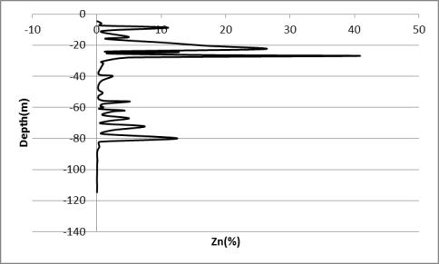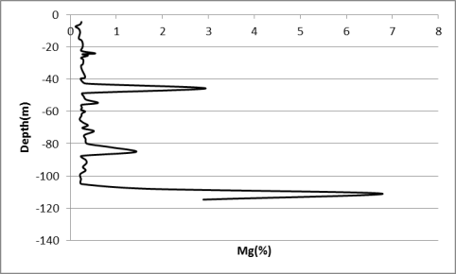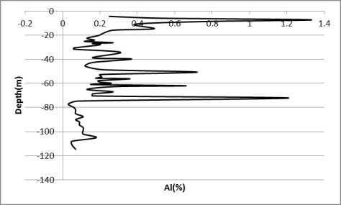
A
B
C
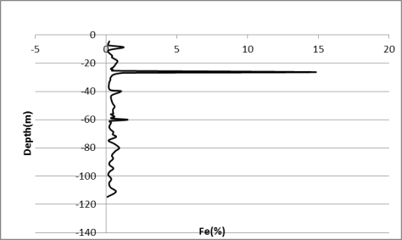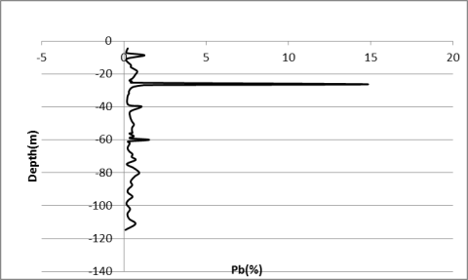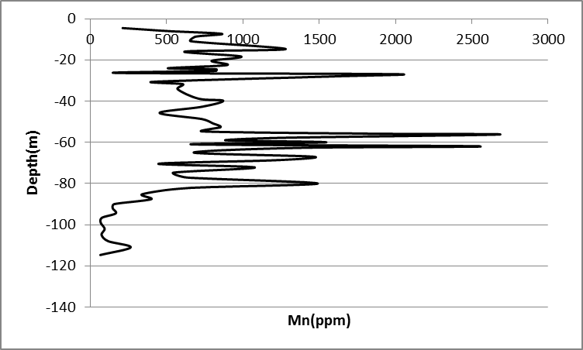
D
E
F

Fig.6. Variations of elements with depth in drillhole N. 8.

Table 2: Chemical analyses (EPMA) of smithsonite from the Chah-Talkh deposit.
 | smithsonite
 | CT-231 |  |  | CT-264 |  |  |  | CT-231
Element (%) | Type 1 |  |  | Type 1 |  |  | Elements | Type 2
Mg | 0.41 | 0.44 | 0.36 | 0.38 | 0.42 | 0.36 | Mg | 0.5 | 1.98
Al | 0.68 | 1.19 | 1.38 | 1.4 | 1.44 | 1.47 | Ca | 0.24 | 0.02
Si | 0.07 | 0.07 | 0.07 | 0.08 | 0.08 | 0.1 | Mn | 0 | 0
S | 0 | 0.1 | 0.1 | 0.15 | 0.18 | 0.13 | Fe | 0.04 | 0
Ca | 0.08 | 0.32 | 0.33 | 0.34 | 0.34 | 0.35 | Cu | 2.33 | 0.16
Ti | 0 | 0.33 | 0 | 0 | 0 | 0 | Zn | 50.58 | 50.03
Mn | 1 | 0 | 0 | 0 | 0 | 0 | As | 0 | 0
Cu | 1.31 | 0.19 | 0.07 | 0 | 3.44 | 2.33 | Ag | 0 | 0
Zn | 40.09 | 40 | 42.14 | 40.31 | 42.65 | 40.88 | Cd | 0.33 | 0.23
Ag | 0.03 | 0 | 0 | 0 | 0 | 0 | Au | 0.5 | 0.06
Ba | 0 | 0.32 | 0 | 0 | 0 | 0 | Pb | 0.07 | 0.02
Pb | 2.95 | 1.09 | 1.18 | 1.22 | 1.14 | 1.31 | S | 0 | 0.02
Total | 46.62 | 44.07 | 45.62 | 43.9 | 49.68 | 46.94 | Total | 54.6 | 52.54

Table 3: Chemical analyses (EPMA) of hemimorphite and hydrozincite from Chah-Talkh deposit.

 | hemimorphite |  |  | Hydrozincite |  |  |  |  |  | hydrozincite
Element (%) | CT-231 |  |  | CT-231 |  |  | CT-231 |  |  | CT-264
Mg | 1.64 | 0.24 | 0.52 | 0.38 | 0.38 | 0.61 | 0.58 | 0.52 | 1.51 | 0.8 | 0.72 | 0.61 | 0.62 | 0.59
Ca | 0.02 | 0.58 | 0.03 | 0.01 | 0.02 | 0.02 | 0.02 | 0.08 | 0.06 | 0.09 | 0 | 0.03 | 0.02 | 0.02
Mn | 1.41 | 0.58 | 0 | 4.5 | 0 | 0.22 | 0.92 | 5.9 | 0.75 | 0 | 0 | 0 | 0 | 0
Fe | 0.07 | 0.09 | 0.13 | 0.17 | 0 | 0.03 | 0.12 | 0.87 | 0.04 | 0 | 0 | 0 | 0 | 0
Cu | 1.92 | 0 | 0 | 1.25 | 1.07 | 0.01 | 0 | 0 | 0 | 0.15 | 0.06 | 0 | 0.15 | 0.29
Zn | 53.97 | 54 | 54.05 | 61.67 | 59.77 | 61.35 | 56.94 | 56.19 | 56.67 | 64.24 | 63.15 | 62.87 | 60.63 | 60.27
Ag | 0 | 0.01 | 0.03 | 0 | 0 | 0 | 0 | 0 | 0.01 | 0 | 0.03 | 0.02 | 0 | 0.02
Cd | 0.19 | 0.21 | 0.2 | 0.12 | 0.13 | 0.22 | 0.22 | 0.42 | 0.26 | 0.25 | 0.18 | 0.28 | 0.14 | 0.11
Au | 0.61 | 0.53 | 0.02 | 0.3 | 0.43 | 0.26 | 0.11 | 0 | 0.02 | 0.35 | 0.17 | 0.12 | 0.2 | 0.28
Pb | 0 | 0.05 | 0.09 | 0.04 | 0.11 | 0.02 | 0 | 0.05 | 0 | 0.11 | 0.18 | 0.05 | 0.17 | 0.2
S | 0 | 0.11 | 0.01 | 0 | 0 | 0.02 | 0.02 | 0 | 0.02 | 0 | 0 | 0 | 0 | 0
Total | 59.84 | 56.4 | 55.08 | 68.44 | 61.91 | 62.74 | 58.94 | 64.02 | 59.35 | 65.99 | 64.5 | 63.98 | 61.93 | 61.77

Table 4: Chemical analyses (EPMA) of zincite from Chah-Talkh deposit.

Elements (%) | zincite |  |  | Zincite |  |  | Zincite |  |  | zincite |  |  | zincite
 | CT-231 |  |  | CT-231 |  |  | CT-231 |  |  | CT-231 |  |  | CT-231
Mg | 0.13 | 0.09 | 0.13 | 0.08 | 0.14 | 0.13 | 0.11 | 0.4 | 0.13 | 0.13 | 0.11 | 0.12 | 0.11 | 0.08 | 0.13
Ca | 0.02 | 0.02 | 0.01 | 0.03 | 0.03 | 0.02 | 0.02 | 0.03 | 0.01 | 0.04 | 0.03 | 0.02 | 0.02 | 0.02 | 0.03
Mn | 0.98 | 0.2 | 3.74 | 0.1 | 0.05 | 4.34 | 0.46 | 0.54 | 0.07 | 1.57 | 0.33 | 0.08 | 5.19 | 0.9 | 0
Fe | 0.14 | 0.02 | 0.21 | 0.03 | 0.01 | 0.18 | 0 | 0.01 | 0.01 | 0.12 | 0.02 | 0 | 0.22 | 0.03 | 0
Cu | 0 | 0 | 0 | 0.07 | 0.13 | 0.02 | 0.05 | 0 | 0.04 | 0 | 0.01 | 0.21 | 0 | 0.33 | 0.04
Zn | 68.7 | 69.13 | 70.78 | 68.24 | 67.73 | 71.81 | 68.49 | 65.91 | 66.96 | 69.1 | 68.77 | 68.72 | 70.82 | 68.79 | 69.45
As | 0 | 0 | 0 | 0 | 0 | 0 | 0 | 0 | 0 | 0 | 0 | 0 | 0 | 0 | 0
Ag | 0 | 0 | 0.01 | 0 | 0.02 | 0.03 | 0.02 | 0 | 0 | 0 | 0.03 | 0.01 | 0.04 | 0.01 | 0.05
Cd | 0 | 0 | 0.06 | 0.02 | 0.01 | 0 | 0 | 0.01 | 0 | 0.02 | 0 | 0 | 0 | 0 | 0
Au | 0.15 | 0.27 | 0.3 | 0.25 | 0.23 | 0.25 | 0.24 | 0.24 | 0.25 | 0.15 | 0.22 | 0.28 | 0.33 | 0.36 | 0.29
Pb | 1.45 | 1.54 | 1.39 | 1.49 | 1.47 | 1.28 | 1.45 | 2.27 | 1.4 | 1.19 | 1.5 | 1.44 | 1.19 | 1.44 | 1.47
S | 0 | 0 | 0 | 0 | 0 | 0 | 0 | 0 | 0 | 0 | 0 | 0 | 0 | 0 | 0
Total | 71.56 | 71.27 | 76.64 | 70.32 | 69.82 | 78.06 | 70.85 | 69.41 | 68.87 | 72.32 | 71.03 | 70.87 | 77.92 | 71.95 | 71.46

Zn content of hemimorphite from sample number 231 is quite close to ideal hemimorphite (which contains about 54% Zn). Au content of hemimorphite is higher than other minerals (up to 0.61%). Ca, Mg and Mn content are low. Zn content of hydrozincite from sample number 264 (about 60% to 64%) is more than sample number 231 but hydrozincite from sample number 231 shows high Mn and Fe content. Au, Cd and Ag in hydrozincites occurs only as trace elements. Zincite occurs as cavity and fracture fill (Fig. 12) and shows high Zn content in the range from 67 to 72 wt. %. Mn content can reach up to 5.2 wt% and Pb content can reach to 2.27% with traces of Ca, Mg, Cd and Au.
To evaluate the Zn and Pb content of Permian metamorphic units (shale and schist) that are located below the carbonate host rock in Chah-Talkh, 4 samples (CT-33, 34, 35, 36) were sampled in the nearest outcrops of these units 4 km east of ChahTalkh mine. The average Zn and Pb contents in the metamorphic rocks are about 320 ppm and 215 ppm respectively.

Isotopic Geochemistry

The results of the carbon and oxygen isotope measurements in metallic carbonate minerals has been used to investigate the approximate temperatures and genesis of non-sulfide Zn ores (Gilg et al., 2008). Smithsonite in Chah- Talkh deposit occurs as disseminated grains intergrown with other minerals such as hydrozincite and hemimorphite: a condition that renders separation very difficult. For this reason hydrozincite, that is very similar to smithsonite in its isotopic characteristics (Boni et al. 2003), was sampled for measurement of carbon and oxygen isotopes. However, even though the published data on hydrozincites (Gilg et al., 2008) suggest that the oxygen isotope fractionation factors for this mineral and water are similar to those of smithsonite, further studies are still required.

Table 5: Carbon and Oxygen isotope data of hydrozincite samples from Chah-Talkh deposit

Sample ID | normalized δ¹³C vs. VPDB | normalized δ¹⁸O vs. NSMOW
CT-2221 | -7.03 | 9.65
CT-2261 | -8.57 | 14.99
CT-2211 | -4.91 | 15.15
CT-2232 | -7.95 | 10.66
CT-2262 | -8.68 | 7.57
CT-2233 | -7.79 | 14.60
CT-2212 | -4.88 | 7.80
CT-2222 | -6.84 | 11.65
CT-2231 | -9.32 | 14.27
CT-2213 | -5.25 | 14.19

The results of the oxygen and carbon isotope measurements on 10 hydrozincite samples are presented in table 5. The δ18O values range from 7.57 to 15.15 per mil (SMOW) and the δ13C values between -4.88 and -9.33 per mil. This range in δ18O and δ13C values point to multiple sources for the fluids that had been responsible for oxidation of the primary sulfides (Gilg et al. 2008). Comparing the results of the oxygen and carbon isotope measurements in Chah-Talkh to the published parameters of rocks and waters from different geological environments (Fig. 7), it can be observed that the δ18O values of our hydrozincites is located in the range of detrital rocks, metamorphic rocks and metamorphic waters (Hofez, 2004). Since to locating of Chah-Talkh deposit in Sanandaj-Sirjan zone and Given the abundance of metamorphic rocks in the vicinity of the Chah-Talkh deposit in the Sanandaj-Sirjan zone (fig. 1), we can suggest that metamorphic water has been effective in nonsulfide mineralization. On the other hand, high temperature can reduce δ18O value too. Therefore this a reduction in oxygen isotope values may be the result of increasing temperature during formation or crystallization of hydrozincite during metamorphism.

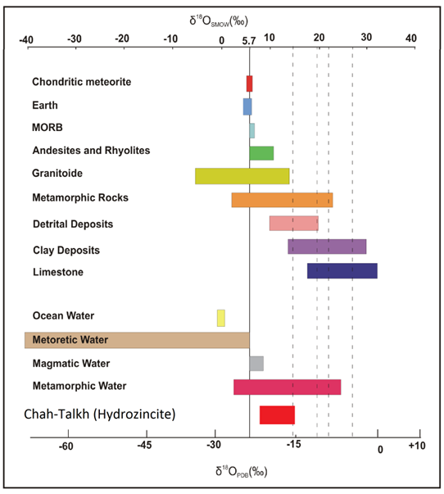
Fig 7: δ18O value of Chah-Talkh hydrozincite in comparison with δ18O values in different geological environments (Amiri and Rasa, 2006).
The δ¹³C values of hydrozincite samples in Chah-Talkh range from -9.32 to -4.88 per mil and have an average value of -7.12 per mil. In fig. 8 the δ¹³C values of Chah-Talkh are compared to δ13C in different geological environments. As shown in fig. 8, δ13C value of hydrozincite in Chah-Talkh fall within the range of atmospheric CO₂ and limestone attending the deposition of shallow marine??? carbonate rocks These values are comparable to the range of δ¹³C values in the deposits of Sardinia.

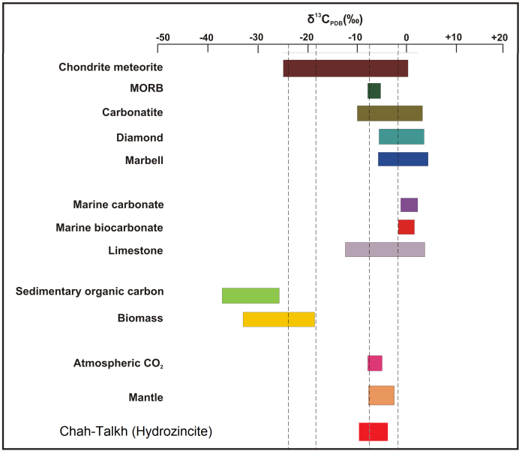
Fig 8: δ13C value of Chah-Talkh hydrozincite in comparison with δ13C values in different geological environments (Amiri and Rasa, 2006).

Fig.9: Stable oxygen and carbon isotope composition of hydrozincite from Chah-Talkh in compare to the values in Ravar-Bafgh area (Amiri and Rasa, 2008), Angouran, Sardinia (Gilg et al. 2003) and Silesia (Coppola et al. 2009).

In fig. 9 the oxygen and carbon isotopic values in Chah-Talkh are compared with the values in Angouran and Sardinia. As shown in fig. 10, δ¹⁸O values in Chah-Talkh were compared with different deposits across the world. If we consider that each unit per mil decrease in δ¹⁸O value indicates a 4°C increase in the temperature of crystallization (Ghasemi et al. 2004), and given that there is an average 18 per mil decreases in δ¹⁸O values in the Chah-Talkh deposits relative to those of Sardinia and Angouran, this points to 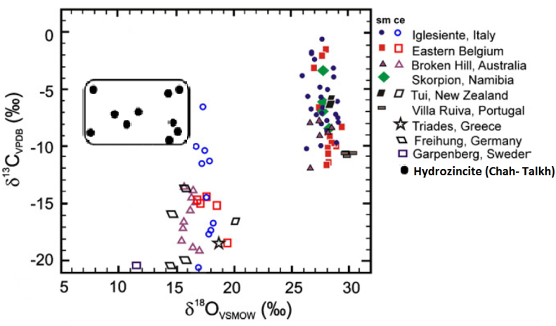
Fig.10:Carbon and oxygen isotope composition of smithsonites (sm)
and cerussites (ce) from supergene oxidation zones of several Pb–Zn
deposits in compre with these values in Chah-Talkh hydrozincite (Gilg et al. 2008).

a temperature formation of hydrozincite in Chah-Talkh about 70°C higher than hydrozincite in the Sardinia district. Therefore, we suggest that the temperature formation of hydrozincite in Chah- Talkh was about 80 to 100° C, which in turn indicates that both meteoric water and metamorphic water had a role in the oxidation of the primary sulfide.

Discussion

The non-sulfide Zn-Pb mineralization of the Chah-Talkh deposit has many characteristics of typical supergene carbonate hosted non-sulfide Zn-Pb deposits. In the Chah-Talkh deposit there is no sulfide zone at depth, and none of the holes recently drilled to a depth of as much as 134 m cut any sulfide zone. Nor did the drillholes reach the water table. Sulfide minerals (sphalerite, galena & pyrite) do occur as relict fine grains
It would seem that the depth of the water table is a significant factor in the generation of high Eh conditions allowing intensive weathering of entire sulfides. Arid climates, the limited availability of meteoric water, and deep to very deep water tables provide the best conditions for the preservation of non-sulfide deposits and the protection of non-sulfide ores from subsequent dissolution (Reichert, 2007). Boni (2003) believed that many of the oxide deposits of supergene type, are located between latitudes 15° and 40° N and this may reflect particularly favorable climatic conditions conducive to the formation of secondary zinc minerals. Therefore the latitude of Chah-Talkh deposit location (about 29° N) could be having a role in formation of non-sulfide mineralization.
The host rock in Chah-Talkh is dolomitic limestone and dolomitic marly limestone, and the ore minerals in these units is not the same. The results of XRD analyses (table 1) show that the main minerals in the selected samples from the marly limestone unit (k^{lm}₁) are calcite and clay minerals (kaolinite and montmorillonite) and the main ore in this unit is hemimorphite. The main ore mineral in dolomitic limestone unit (k^{ld}₁) is however hydrozincite. This suggests that probably some of SiO₂ employed in generation of hemimorphite was derived from clay minerals in marly limestone units. Takahashi believes that changes in pH are the principal control on the precipitation of secondary zinc minerals from the metal bearing solution. In waters with average pH values between 7 and 8 percolating through carbonate rocks, smithsonite is the least soluble zinc mineral, followed by hydrozincite, and then by hemimorphite (Boni & Large, 2003). Therefore the abundance of hemimorphite in marly limestone may be reflect differences in pH value in these two units. Non-sulfide mineralization at Chah-Talkh corresponds with the development of fracture zones acting as channels for dolomitizing solutions.

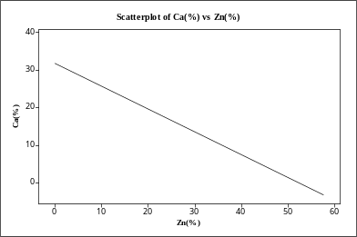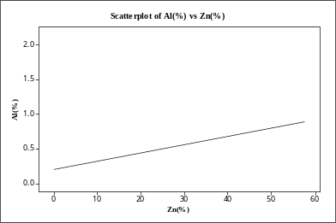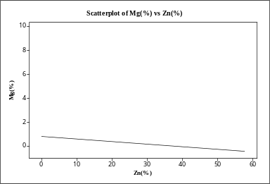
A
D
E
F
B
C

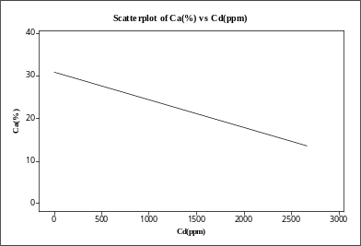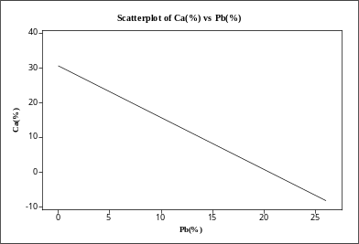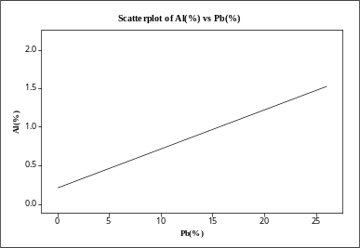

Fig. 11: Relationship between elements contents in total geochemical analyses.

In addition the Zn and Pb content in total geochemical analyses (from surface and depth samples) show an inverse correlation with Ca and Mg content (Fig. 11). Balassone et al. (2007) believed that this might be due to the replacement of dolomitic host rock first by primary and then by secondary Zn minerals. However with increases of Zn and Pb minerals in each sample (in high grade) the host rock volume (dolomitic limestone) decreases. Cd content is followed of by Zn and Pb content too. There is a direct correspondence between Al and Zn content that may be due to of the occurrence of part of the mineralization in marly limestone units (klm1). However in many non-sulfide Zn deposits such as Mehdi-Abad (Ghasemi et al. 2008), and Dare-Zangir (Iran), Zn mineralization (non-sulfide) occurs in shale or marly units. Thus probably clay minerals play a role in precipitation of non-sulfide or primary sulfide Zn minerals. In the Chah-Talkh deposit the main mineralization is hosted by marly limestone too.
Results of chemical analyses of samples taken from depth (drill hole number 8, (Fig.6)) show that the distribution of some elements such as Mn and Mg follow mineralization zones. The direct correspondence between Zn mineralization and Mg content is due to the Zn non-sulfide minerals occurring in dolomitization zones. In addition the Fe content at Chah-Talkh is lower than other Zn non-sulfide deposits. Inverse correspondence between Pb/Zn ratio and depth is due to the greater mobility of Zn compared to Pb in supergene zones and the downward leaching of Zn in veins near the surface. Therefore in the veins near the surface cerussite is the main ore and the proportion of Zn minerals increases with depth.
EPMA map elements of zinc sample (Fig.12) indicate that prior to mineralization cavities formed due to dolomitization and/or dissolution of host rock. Initially those solutions that start to precipitate in these cavities have been high fO2 (Fig. 12-B) and precipitate Zn oxide minerals (zincite). Precipitation of Mn oxides on the margins of zincite in the next stage of mineralization shows that high fO2 conditions prevailed (Balassone et al., 2007). Presence of Pb together with Mn at this stage is probably due to negative charge of manganese sols and absorption of Pb ions in sols (Krauskopf, 1976). Mn values in zincite is lower than that of the standard level ofabout 6% Mn, thus indicating that fO2 is high and Mn oxides are stable.Mn concentration is commensurately very low in the circulating fluids and consequently in the precipitated zincite as well. Production of zincite at this stage is probably due to absence of carbonate ions and the lowering of fCO₂ in the fluids. In the subsequent stage of dolomitisation the host rock is replaced by smithsonite and hemimorphite, withpart of the zincite in the cavity replaced by smithsonite. However,Mn and Pb minerals around the primary zincite are unchanged. Replacement of zincite by smithsonite shows that fCO₂ in fluids increases (due to dissolving of carbonate host rock). Fig 6 show an EPMA elements map of a galena that is surrounded by zinc minerals protecting the primary shape of a galena cube. Arsenic content in the galena is more than Zn, the Zn content of galena being below 1% (table 6). However, part of the mineralization in this deposit is a direct replacement type whereas the other part is a wall rock replacement type involving the filling of karstic cavities. As such it is comparable to non-sulfide mineralization in southwest Sardinia (Boni et al., 2003).

Table 6: Chemical analyses (EPMA) of galena crystal in Zn ores.

Elements | Galena
S | 11.39 | 12.63 | 12.24
Fe | 0 | 0 | 0
Cu | 0.66 | 0 | 0.73
Zn | 0.95 | 0.5 | 0.81
Pb | 86.86 | 84.96 | 86.45
V | 0.01 | 0 | 0.01
Al | 0.28 | 0.94 | 0.03
Total | 100.15 | 99.03 | 100.27

Hitzman et al. (2003) believe that in the absence of pyrite and marcasite large amounts of acidic solutions are not formed and zinc cannot migrate long distances. Therefore distal supergene wall-rock replacement deposits cannot form by weathering processes. In the Chah-Talkh deposit under conditions of low Fe (about 0.4 % Fe in total analyses), Zn minerals precipitated as a direct replacement of primary sulfide veins.

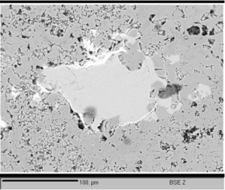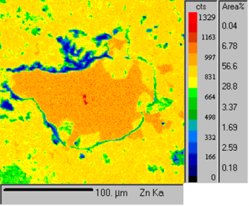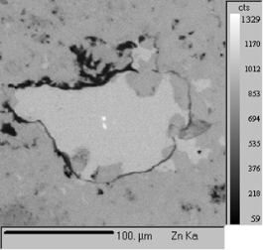
zincite
sm
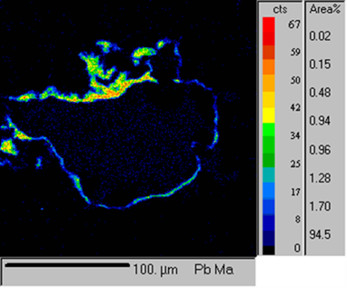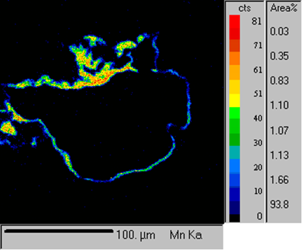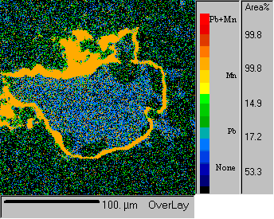

Fig. 12: EPMA element maps of ore bearing sample; A: electron microscope image (BSE) of Zn mineral; B , C: distribution of Zn in center of cavity and matrix; D, E, F: distribution of Pb and Mn in section and overlay of these elements.

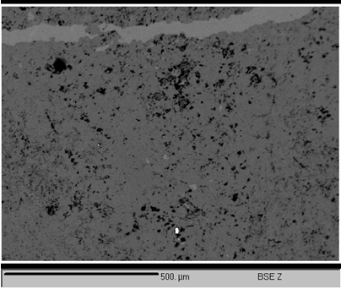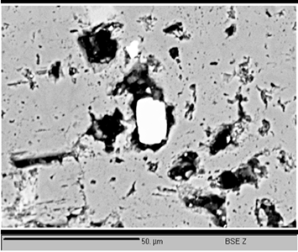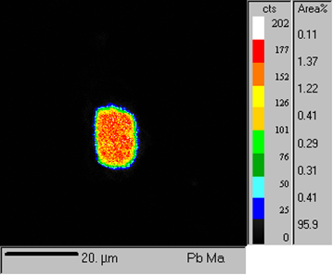
gln
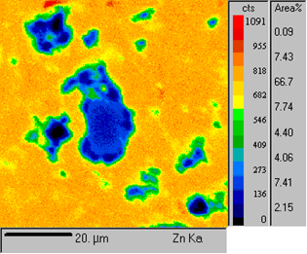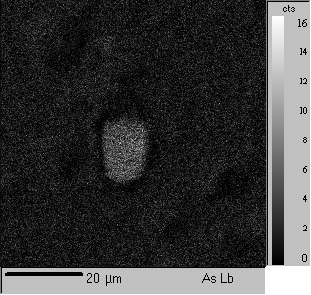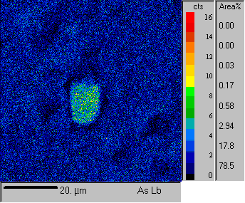

Fig.13: EPMA element maps of ore bearing sample. A, B: electron microscope image (BSE) of Pb mineral (galena);

Pb content in the smithsonite, measured in only one sample (CT-231), is more than 2%. This may indicate direct replacement of sphalerite by smithsonite (Balassone et al., 2007). The time of weathering and non-sulfide mineralization is unclear, but the Sanandag-Sirgan zone was beyond the influence of the Laramide orogeny during the Paleocene (Agha nabati, 2004). Therefore from Paleocene to recent times conditions may have been more favourable for the weathering of primary sulfide.
With regard to the absence of igneous rocks in the region of the Chah-Talkh deposit, two hypotheses may be evaluated for the primary source of Zn and Pb in the Chah-Talkh deposit: 1- late Cretaceous rocks 2- Permian schist and shale. The results of chemical analyzes from carbonate rocks equivalent to the host rock show that the mean Zn and Pb content is lower than the mean of the Zn and Pb content in carbonate rocks, whereasanalyzes of shale and schist show enrichment of these samples in Zn and Pb. The Zn content is four orders (320 ppm) more than that of the mean Zn content in shales. Given that the metamorphic rocks are more than 500 m thick (Sabzehei et al.,1997), the leaching of 50% of the Zn content in this unit from 4 km² area of shale and schist (2 km³) would provide enough Zn for the generation of this deposit. Therefore it seems that Permian metamorphic rocks could be the Zn source for the Chah-Talkh deposit. To confirm this, lead isotope studies will be necessary.

Conclusions
Epigenetic dolomitization and brecciation of host rock, the morphology and texture of the ores, and the existence of clay minerals in host rocks, suggest that type of primary sulfide ore was probably MVT. Concentration of non-sulfide zinc ores in Chah-Talkh reflects the existence of local fracture systems (NW-SE). The paragenesis of minerals under conditions of high pH and Eh belies the lack or presence of clay minerals. In the presence of clay minerals the main ore is hemimorphite replacing sphaleritedirectly. In absence of clay minerals the main ores are hydrozincite and smithsonite.
The presence of clay minerals did not allow fluids to disperse in the host rock,. Consequently, the fluidsprecipitated their content in cavities and fracture zones. Different types of smithsonite as seen in the deposits of Sardinia and Ireland are not recognized in the Chah-Talkh deposit. Zn and Pb content show an inverse correlation with Ca and Mg. This might be due to the replacement of dolomitic host rock first by primary and then by secondary Zn minerals. Zn and Pb content show direct correlation with Al content reflecting deposition of ore in marly limestone.
The results of EPMA analyses on ore bearing zones suggest that in the first stage of weathering, Zn oxides (zincite) deposit in the center of cavities under conditions of high fO₂ . In the next stage Pb and Mn bearing solutions began to precipite their content along the margin of zincite. In the last stages of mineralization fCO₂ began to increase and the host rock and part of the previously deposited Zn oxides were replaced by Zn carbonates (smithsonite).
It is suggestedthat at first, weathering began under the influence of meteoric water (increase in fO₂ value) and then continued with metamorphic water (increase in fCO₂ value) playing the dominant role. The absence of a sulfide zone even to depths of 134 m below surface is due to the high altitude of the deposit , the depth of the water table, the arid climate of the areaIt is proposed that the source of Zn and Pb are the Permian shale and schist units.
The results of oxygen and carbon measurements on hydrozincite samples indicate that the range of δ¹⁸O value in Chah-Talkh (7.58 per mil) is the result of the mixing of at least two different water sourcesIn addition the average of δ¹⁸O values in Chah-Talkh is ˷ 12 per mil that is much lower than the δ¹⁸O value in other nonsulfide Zn deposits (˷ 27 per mil). This suggests that the ore forming temperature of oxide ores in Chah-Talkh was much higher than in other deposits. The range of δ¹⁸O value in metamorphic water, confirm that both metamorphic and meteoric water act as fluids responsible of weathering. The situation of Chah-Talkh in an arid climate indicates that deep weathering by supergene processes was not permissible, confirming the primacy of metamorphic water in the weathering of primary sulfides.

Acknowledgements
We would like to thank Sajad Ziaadini for supplying geochemical data, and the personnel of Iranian Mines & Mining Industries Development & Renovation Organization (IMIDRO) for financial and logistical support M. Boni is kindly acknowledged for careful reviewing of the manuscript.

References
Agha Nabati, A., 2004,Geology of Iran., Geological Survey of Iran, (inFarsi).
Amiri A, Rasa I (2008) The non-sulfide ore formation conditions of Ravar-Bafgh area, findings of carbon and oxygen stable isotopes (in farsi). Quarterly Applied Geology 3(2): 95–103.
Balassone G, Rossi M, Boni M, Stanley G, McDermott P, 2008, Mineralogical and geochemical characterization of nonsulfide Zn–Pb mineralization at Silvermines and Galmoy (Irish Midlands), Ore GeologyReviews 33: 168–186.
Boni M, 2003, Non-Sulfide Zinc Deposits: a new –(old) type of economic mineralization, SGA News Nr.15 (August2003). Boni M, Gilg HA, Aversa G, Balassone, G., 2003, The calamine of southwest Sardinia (Italy): Geology, mineralogy and stable isotope geochemistry of nonsulfide Zn mineralization, Econ. Geol., Vol. 98:731-748.
BoniM,Gilg,A.,Balassone,G.,Schneider,J.,Allen,C.,Moore,F.,2007, Hypogene Zn carbonate ores in the Angouran deposit,NW Iran, Springer-Verlag 2007,22pp.
Boni, M., Large, D., 2003,Nonsulfide Zinc Mineralization in Europe: An Overview, Economic Geology 98, 715-729.
Coppola, V., Boni, M., Gilg, A., Strzelska-Smakowska, B., 2009, Nonsulfide zinc deposits in the Silesia–Cracow district, Southern Poland, Miner Deposita 44:559–580.
Ehya,F., Lotfi, M., Rasa, I., 2010, Emarat carbonate – hosted Zn- Pb deposit, Markazi province, Iran: A geological, mineralogical and isotopic (S,Pb) study, Journal of Earth sciences : 37: 186-194.
Ghasemi, A., Ghasban, F., Taghipoor, B., 2004, Role of dolomitization in KolahDarvaze deposit, Proceeding of the 11th
Conference of crystallography and mineralogy of Iran, 158-160.
Ghasemi, M., Momenzadeh, M., Yaghubpur A., Mirshokraei .,A.A., 2008, Mineralogy and Textural Studies of Mehdiabad Zinc-Lead Deposit-Yazd, Central Iran, Iranian Journal of Crystallography and Mineralogy, vol. 16, no.3.
Gilg HA, Allen C, Balassone G, Boni M, Moore F (2003) The 3-stage evolution of the Angouran Zn “oxide”-sulphide deposit, Iran. In: Eliopoulos D et al. (eds) Mineral exploration and sustainable development. Millpress, Rotterdam, pp 77–80.
Gilg, H., Boni, M., Hochleitner, R., Struck, U., 2008, Stable isotope geochemistry of carbonate minerals in supergene oxidation zones of Zn-Pb deposits, Ore Geology Reviews 33: 117-133.
Hitzman, M. W., Reynolds, N. A., Sangster, D. F., Allen,C. R. & Carman, C. E., 2003, "Classification, genesis,and exploration guides for nonsulfide zinc deposits",Econ.Geol., Vol. 98 (4): 684-714.
Hoefs, J., 2004, Stable isotope geochemistry, 5th edition, Springer velag, Berlin: 244p.
Iranian Mines & Mining Industries Development & Renovation Organization (IMIDRO), 2010, Exploration of Chah-Talkh deposit (in Farsi).
Krauskopf, K.P., Bird, D, K.,1976,Introduction to Geochemistry, McGraw-Hill.
Large, D., 2001, The Geology of non-sulphide zinc deposits—an overview: Erzmetall, v. 54, p. 264–276.
Reichert, J., 2007, Ametallogenetic model for carbonate- hosted non-sulfide zinc deposits based on observations of Mehdi Abad and Irankuh, central and Southwestern Iran, university of Halle- Wittenberg.
Rezaeian,A.,Rasa,I.,Jafari,M.,Amiri,A.,Khosrowtehrani,Kh.,2010., Epigenetic Dolomitization, as an Exploration key for Nonsulfide Zn-Pb Deposits with Carbonate host Rocks, Journal of Earth & Resources., no. 9.
Sabzehei,M., Afrooz, A., 1989., Geology of Chah-Talkh deposit(Sirjan) and Exploration scheme of this deposit, Geological Survey of Iran,(in Farsi).
Sabzehei, M.,Eshraghi, S.A., RoshanRavan, J., Seraj, M., 1997, geological map of GOLEGOHAR, Geological Survey of Iran (GSI).
Tehran Padir(Co), 1990, Exploration Report of Chah-Talkh Deposit (in Farsi).
DOL
DOL

