**Consumption, Investment and Economic Growth**

**\*Additional Readings and Works for Motivated Students (Not for midterm tests, but may be useful for application questions for the final exam; Some of the Assignment Questions may come from these)**

1. **The portion of national income for labor has decreased for the last two decades while the counterpart of capital has increased. At the same time, income distribution in general has changed towards inequality in most of countries around the world.**

**What could be the ‘theoretical prediction’ for the overall level of consumption in a country?**

1. **One of the most interesting articles about the trends for jobs, income, and distribution is by Andrew McAfee, a MIT professor. He has written numerous articles and some very insightful books. The shortest one is his article at the Harvard Business Review, and reflect on the impact of new employment trends and its implication on income, income distribution, consumption, etc:**

[**https://hbr.org/2015/06/the-great-decoupling**](https://hbr.org/2015/06/the-great-decoupling)

**You may read other papers and books(or their summaries) by him. At a practical level, throughout his books and papers, he predicts millions of jobs will disappear soon, and suggests what kinds of jobs will disappear in the future, and what kind of jobs will remain. He also explain why income distribution will be skewed to some super stars of IT and other new technologies. He suggests that we all cannot be a super star, but we can be useful for those super starts and thereby secure our income.**

**The following graph is from the above paper.**

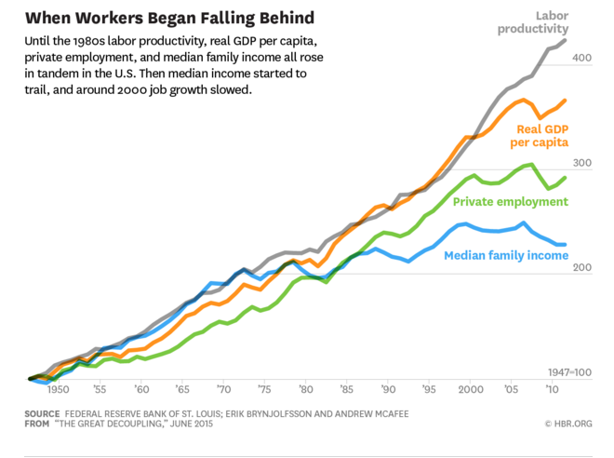

1. **We always talk about creation of income and accumulation of wealth. How about ‘Intergenerational Preservation of Wealth’, which will lead to an increase in income for the future generation of the family.**

**There are a lot of research works done, which feature the degree of difficulties of intergenerational wealth preservation, and some effective ways to better preserve family wealth through generations. For one thing, there are research results indicating that philanthropy or charity helps preserve the family wealth over generation: Families who are actively involved in charity works are more likely to succeed in intergenerational wealth preservation than those who are not actively involved. If this is a robust empirical result, philanthropy is also a good strategy for the family wealth preservation.** [**http://www.economistinsights.com/sites/default/files/Philanthropy%20and%20wealth%20transfer_0.pdf**](http://www.economistinsights.com/sites/default/files/Philanthropy%20and%20wealth%20transfer_0.pdf)

**There are institutions devoted to studies for a better understanding, and to development of strategies for a successful intergenerational transfer of wealth. The Center for Family Wealth and Philanthropy at Boston College is an example.** [**http://www.bc.edu/research/cwp.html**](http://www.bc.edu/research/cwp.html)

**This is particularly relevant for a person who would move further from the current academic programs to the career of wealth management and (long-term) financial or estate planning.**

1. **Investment, and Capital Efficiency.**
2. **v = K/Y = Δ K/ΔY as we have learned in class. How is this related to ‘efficiency of investment’?**

**(Hint: In general, there are two measures of investment efficiency: one is Incremental Capital-Output Requirement(ICOR) or “How much capital do we need to produce one more unit of output?”, and the other is Marginal Product of Capital or “How much does one unit of capital lead to an increase in Output/national income?”. In fact they are the reciprocal of each other. Here v seems to be related to the ICOR. )**

1. **Calculate the (approximate) v or K/Y, we have learned in the class, of China from the following data for China during 2000-2004? Can you relate this v to the efficiency or inefficiency of investment?**

**Hint: The first graph shows the growth rate(ΔY/Y) and the second graph the (gross) capital formation rate (ΔK/Y). v = K/Y = Δ K/ΔY.**





**3) Can you compare the efficiency of capital in China and in other East Asian countries?: compare the above calculated numbers with the Japanese case of ICOR during her rapid economic growth shown in the papers by Kazuo Sato in Kozo Yamamura’s celebrated/famous book on Japanese economic development (on the course website)?**

[**You may click here for the paper by Sato.**](Kazuo%20Sato%20Paper.pdf)

**4)Some authors argue that the apparently higher ICORs for the contemporary China, compared with the Japanese and Korean cases, are not really as bad as they appear. What would be possible explanations for the apparently higher ICORs not necessarily indicating a correspondingly lower efficiency of use of capital in China than in the two other countries? Hint: Recall the Class discussion.**