Planetary Image Interpretation

Mapping Example

The Moon
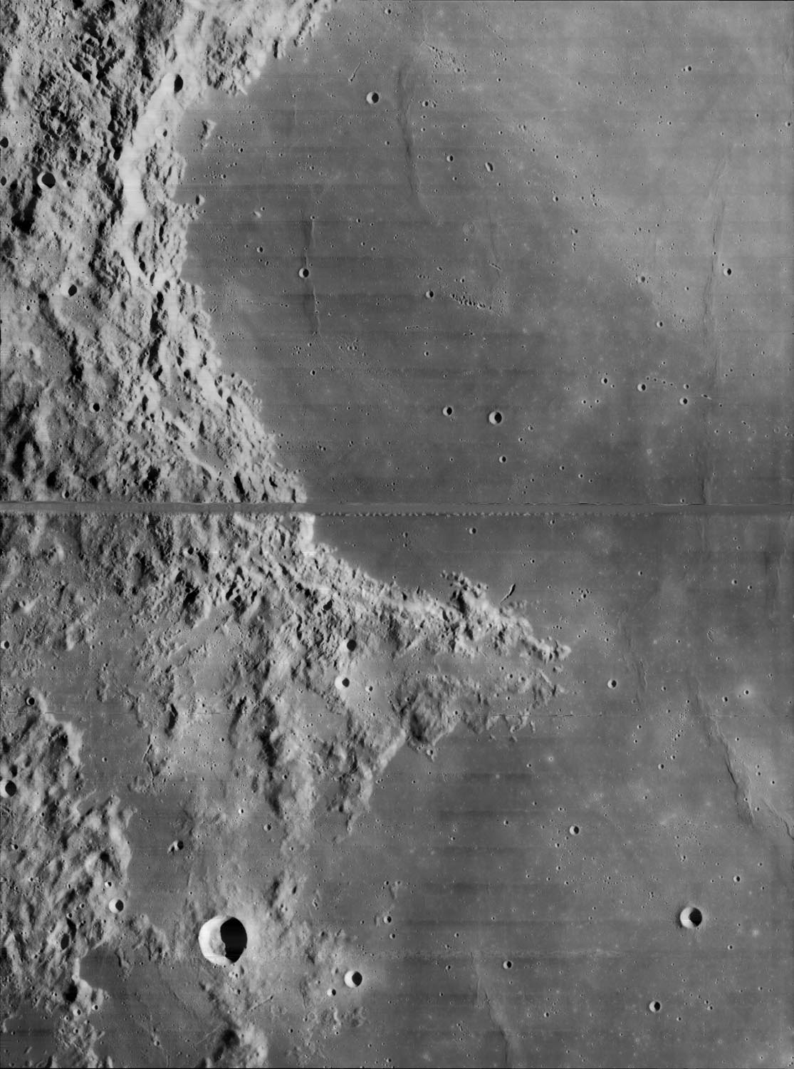

Figure 1. Lunar Orbiter 4 image 4-145-H2

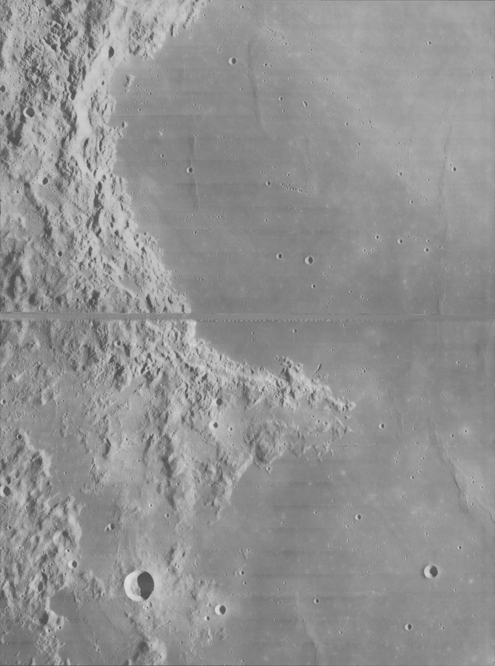

Figure 2 - reduce contrast for mapping.

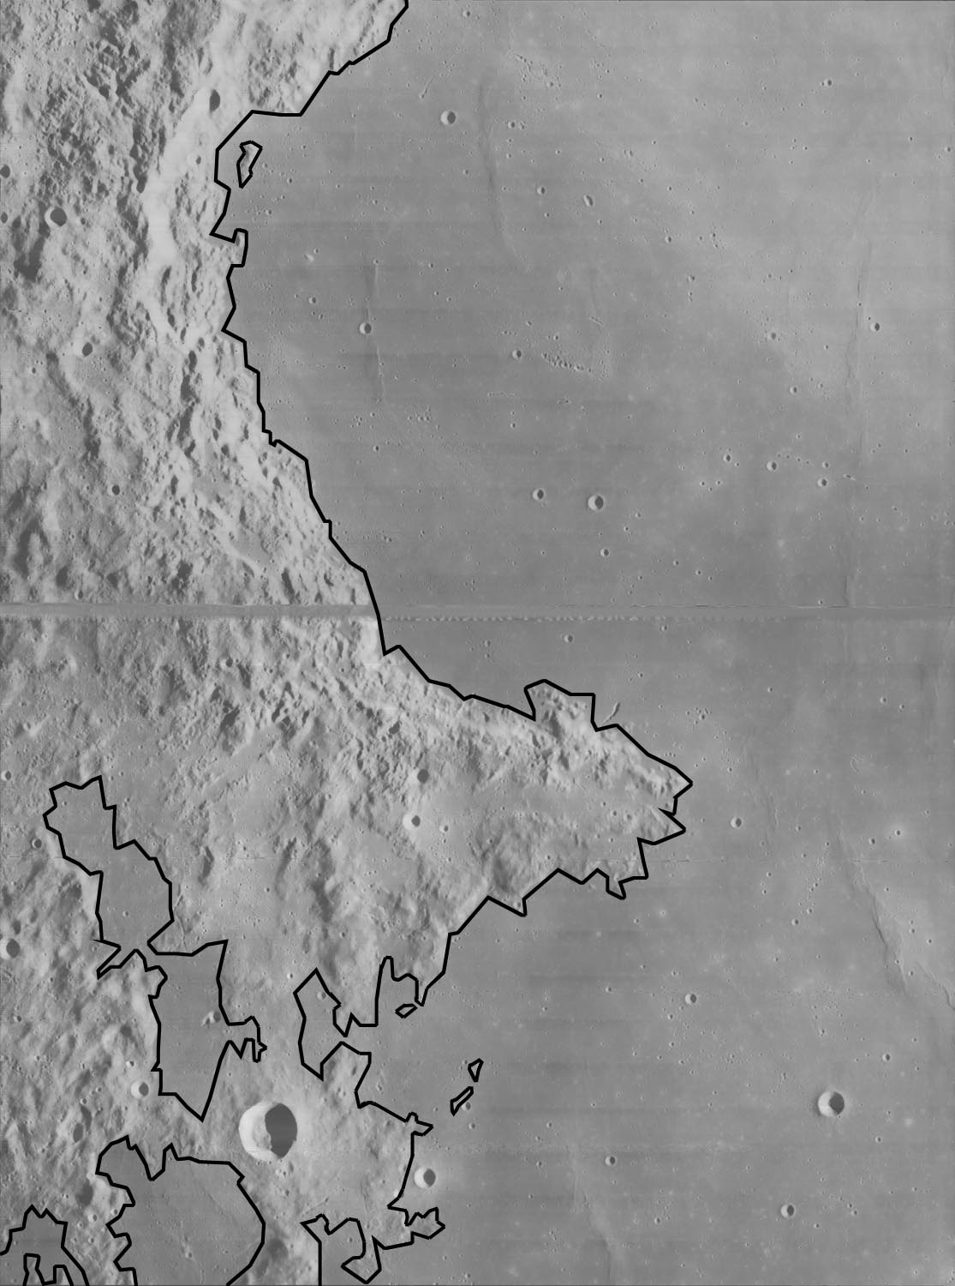

Figure 3. Outline basic units - in this case, mare and highland.

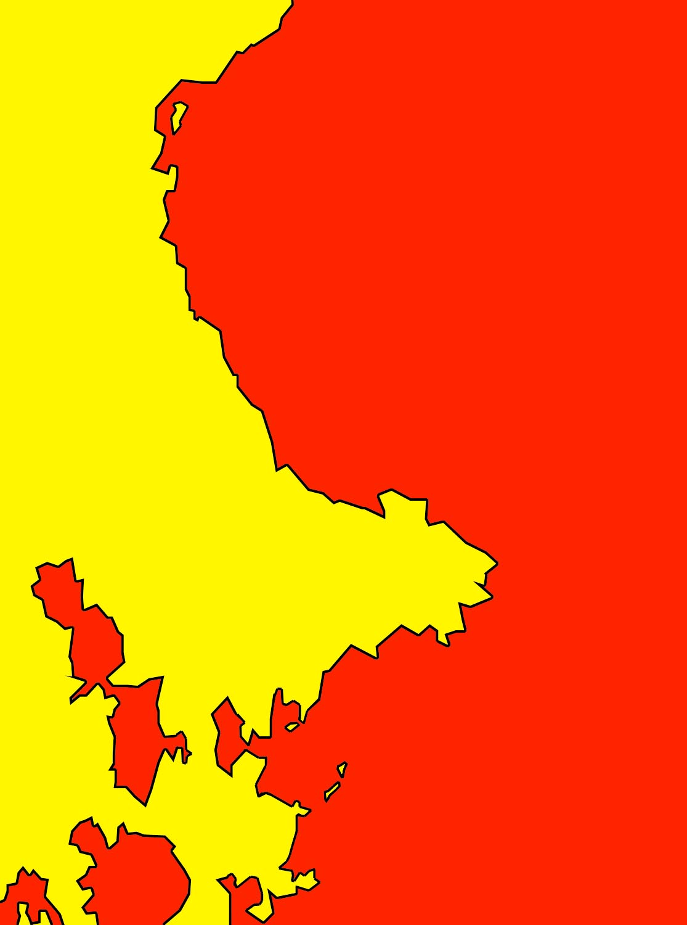

Figure 4 - Apply colour - any way you like.

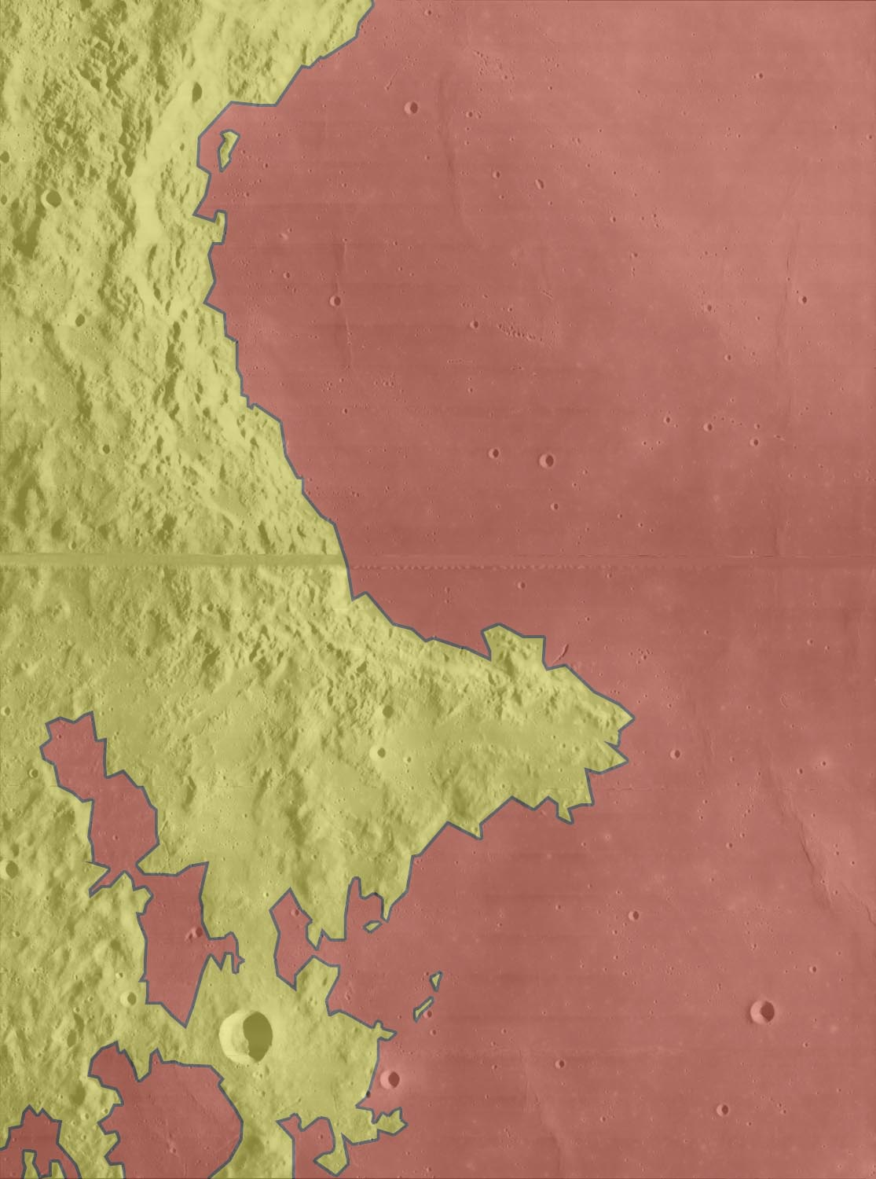

Figure 5 - Subdued colour, or semi-transparent colour, looks better.

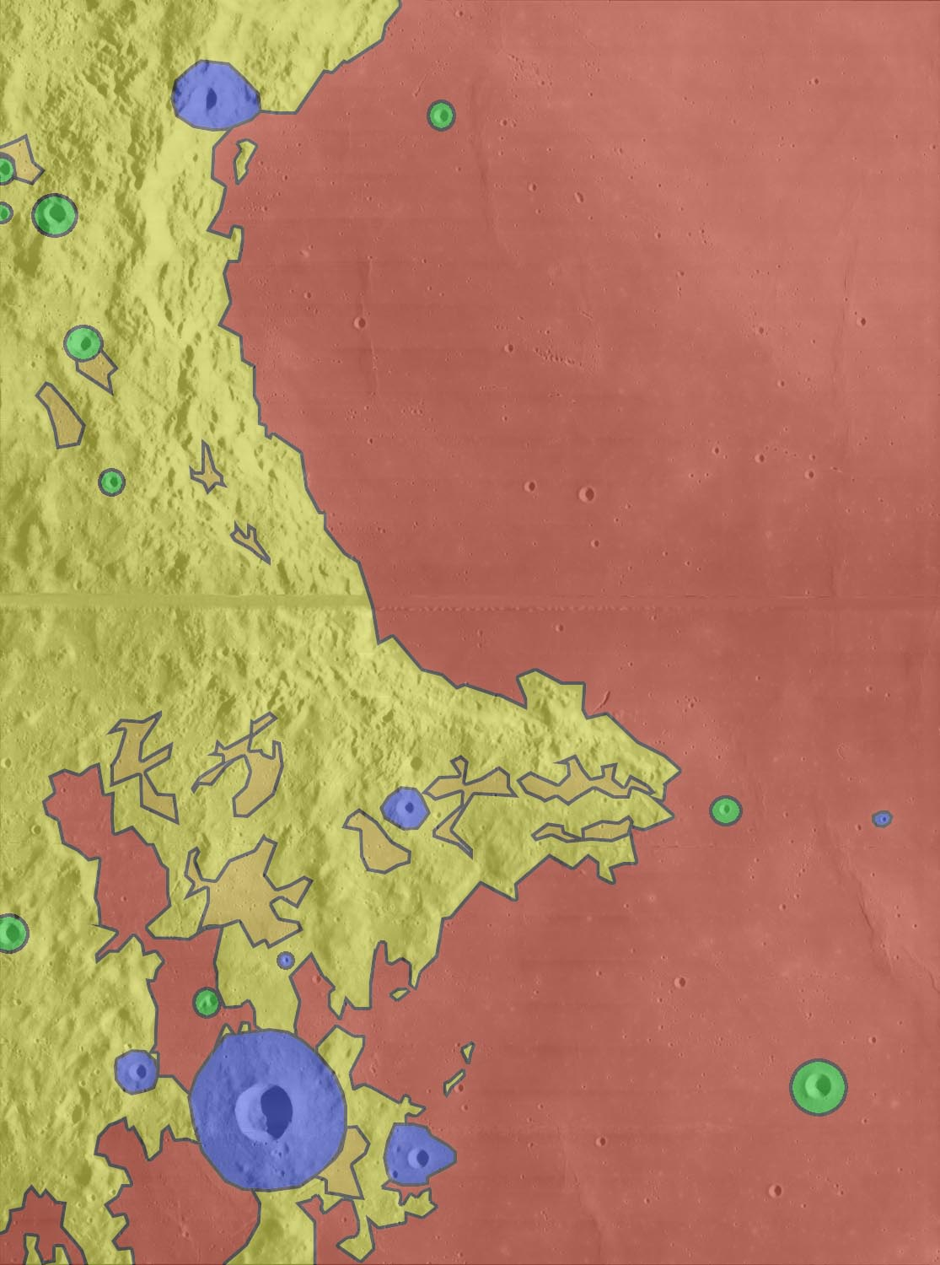

Figure 6 - Add more features - in this case, highland plains unit and some fresher craters.

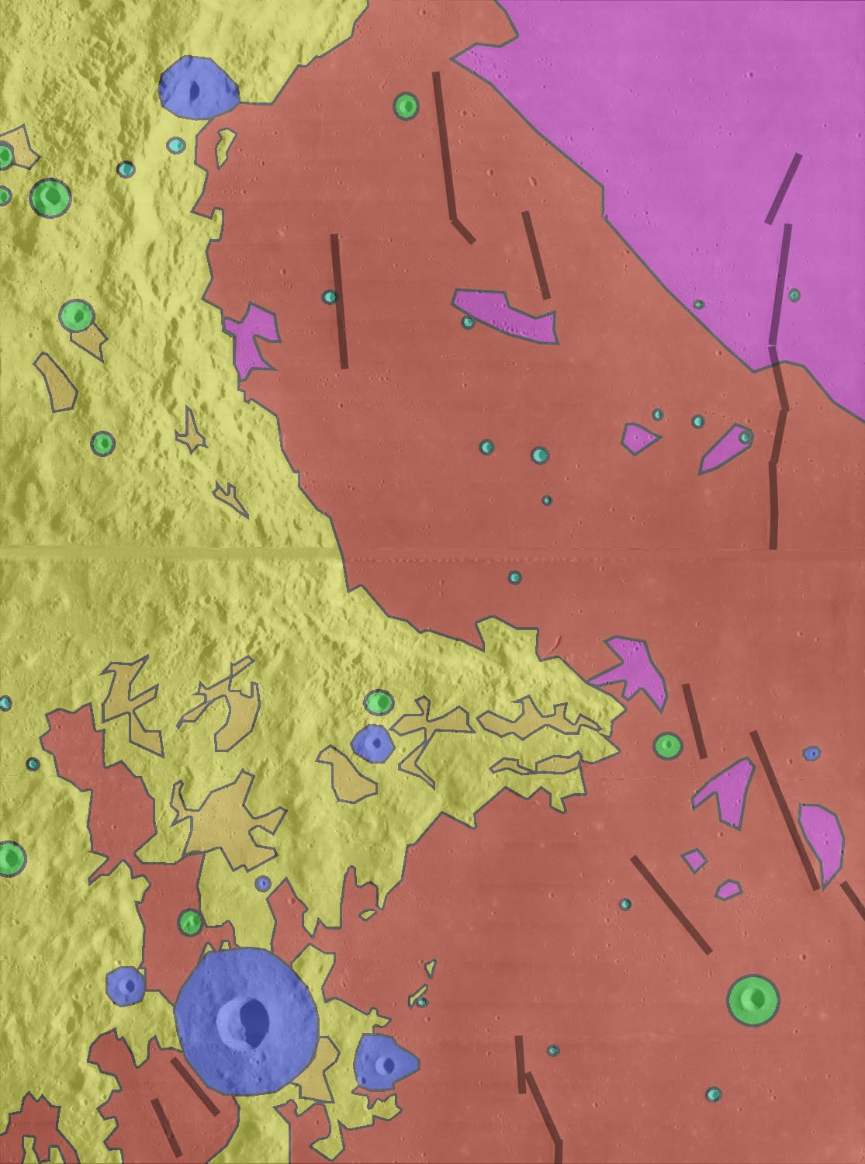

Figure 7 - add more units - ray-covered mare areas, mare ridges, pre-mare craters.

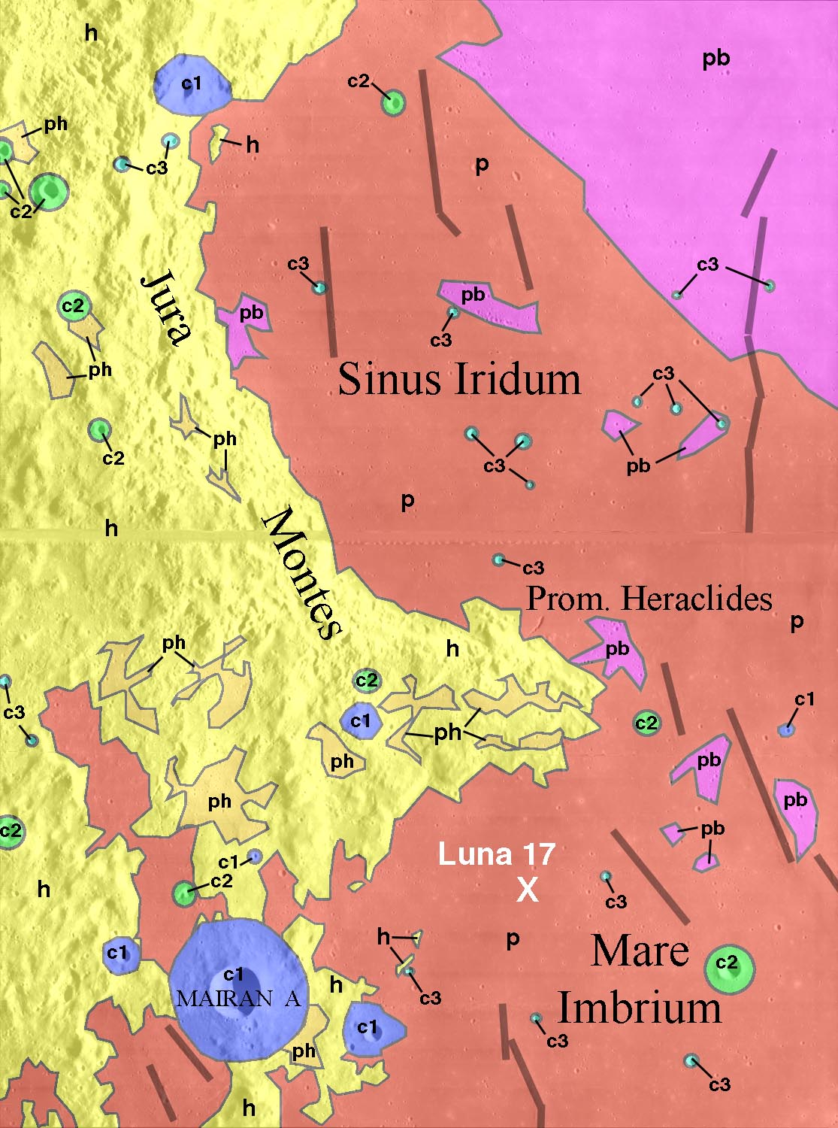

Figure 8 - add labels to identify units

unit | name | description | interpretation
p | plains | Smooth low albedo surfaces with few large craters | Basalt lava flows (mare)
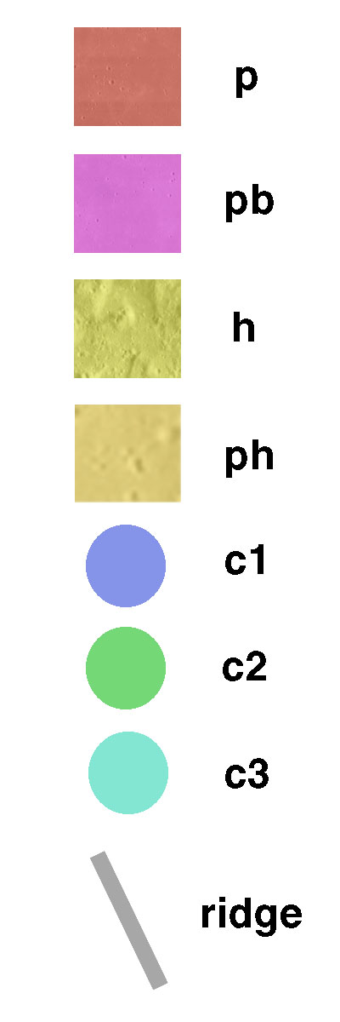  pb | bright plains | Smooth surfaces with higher albedo, often with many small craters | Basalt lava flows covered with fresh crater ray material
h | highlands | Hilly or mountainous regions, topographically higher than plains | Old cratered surfaces consisting of overlapping layers of basin and crater ejecta.
ph | plains in highlands | Local smooth areas in depressions within highlands | Crater ejecta and mass-wasted deposits accumulating in depressions.
c1 | youngest craters | Craters with bright ejecta and sharply defined rims | Youngest craters
c2 | medium age craters | Craters with sharply defined rims but no bright ejecta. On plains, ejecta overlies plains | Craters older than C1 but younger than the youngest plains, or similar craters on highlands.
c3 | older craters | Craters with ejecta apparently covered by plains, or similar craters on highlands | Craters older than the youngest plains

History:

Cratered highlands form everywhere. The Imbrium basin forms, creating the basic pattern of highlands and plains in this area. A large impact creates Sinus Iridum, whose rim and ejecta form the highlands (unit h) here. Some craters form over this area. Crater ejecta and mass wasting collect in depressions (unit hp). Mare Imbrium and Sinus Iridum are filled with many layers of lava, forming the plains (unit p). Ridges are produced on the lava flows. Craters continue to form. Some are partly covered by the last flows of unit p (c3). Others form on top of the last unit (c2), and the most recent still have rays (c1). One or more large impacts outside the map area deposit fresh ejecta across the map area (unit pb).

