FIRST NATIONS

TRACK AND FIELD EXPERIENCE
Table of Contents:

Track and Field Seminars………………………………….…………………………3

Registration Form………………………………………..………………………………4

Consent Form……………………………………………..……………………………….5

Track and Field Day Itinerary………………………………………………………6

Map of the Track…………………………………………………………………………..7

Contact Information……………………………………………………………………..8
Track and Field Seminars

Overview:

Students from the Sport and community service and other volunteers from the University of Western Ontario will visit the four First Nations Schools in the area. The volunteers would like to assist the grade 7 and 8 students in the three disciplines of track and field- running, jumping and throwing. This session is designed to introduce the students to the sport, allow them to try each of them before the field day and experience track and field in a fun and exciting way.

Date: Thursday Feb 23rd, 2006

Time: Volunteers arrive between 12:30pm and 1:00pm
Volunteers depart at 4:00 (or when classes are over)

Format:

The children will given an opening speech after which they will be broken up into three groups. Each group will rotate through the three stations. The three stations are as follows:
Station 1: Running
- Running technique
- Drills
- Starts

Station 2: Jumping
- long jump take off and landing
- high jump take off and landing

Station 3: Throwing
- shot put technique
- throwing technique

When the students have completed all three stations, we will proceed to closing remarks and registration where students will fill out a registration form which will include the events they wish to participate in for the full day event and t-shirt size (See Registration form attached). They will also take home a consent form to be signed by their parents (see consent form attached.)
Registration Form

Name: __________________________________________

School: __________________________________________
Events:
60 m
200 m
800 m
Long Jump
High Jump
Shot Put
Age: _______________

Event #1: _______________

Event #2: _______________

Event #3: _______________

Relay (check one): Yes ___ No ___

Registration Form

Name: __________________________________________

School: __________________________________________
Events:
60 m
200 m
800 m
Long Jump
High Jump
Shot Put
Age: _______________

Event #1: _______________

Event #2: _______________

Event #3: _______________

Relay (check one): Yes ___ No ___

Permission Form

I will allow my child to participate in the Track and Field Field Day at the University of Western Ontario on Wednesday March 22, 2006. …..
???
Parent Release Form for Media Recording
I, the undersigned, do hereby grant or deny permission to [Organization] to use the image of my child, _________________________________, as marked by my selection(s) below. Such use includes the display, distribution, publication, transmission, or otherwise use of photographs, images, and/or video taken of my child for use in materials that include, but may not be limited to, printed materials such as brochures and newsletters, videos, and digital images such as those on the [Organization] Web site.
❑ Deny permission to use my child’s image at all.
❑ Grant permission to use my child’s image in the following ways (mark all that apply):
- Limited usage: I want my child’s image used within the [Organization] setting only (not in the larger community).
- Limited usage: I want my child’s image used for educational materials only (not marketing). This could be either within [Organization] or in the larger community. One example of this could be videos in parent education classes.
- Limited usage: I want my child’s image used on printed materials only (no digital or video use).
- Unrestricted usage: I give unrestricted permission for my child’s image to be used in print, video, and digital media. I agree that these images may be used by [Organization] for a variety of purposes and that these images may be used without further notifying me. I do understand that the child’s last name will not be used in conjunction with any video or digital images.
Parent/guardian signature Date
Track and Field day Itinerary

11:00 – 11:30 Arrival and Registration

11:30 – 12:45 Session A

12:45 – 1:30 Lunch and Pole Vault Demonstration

1:30 – 3:30 Session B

3:30 – 3:45 Closing remarks and departure

Session A Session B
60 m 200 m
Long Jump High Jump
Shot Put Relays
. .
. .

Additional Activies (Available throughout day)
- Tech corner (View Video of self and others)
- Kinesiology/Health Science Info Station
- Western Info Station
Map of the Track
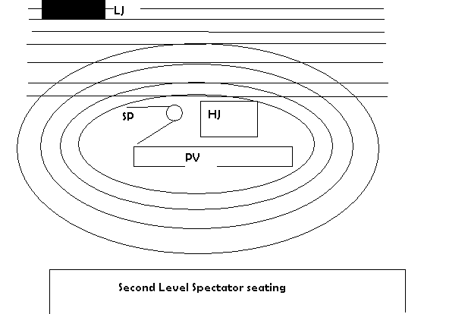
Contact Information

Craig Boydell, Ph.D.
Faculty of Health Sciences
Head Coach, Men’s Basketball
Thames Hall
University of Western Ontario
London, Ontario
Canada N6A 3K7

519-661-3916

Alanna Boudreau

Jacquie Edwards

Randy McAuley

Jen Sulpher

