GULU WALK LOGO

www.guluwalk.com

University of Western Ontario
March 30, 2006

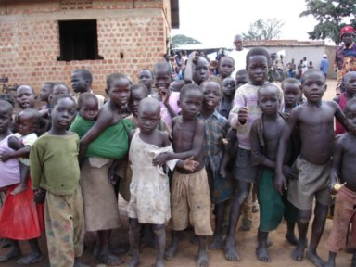
Every night, as many as 40,000 children walk for hours from their rural villages into major urban centres of Gulu, Kitgum and Pader. so that they can sleep in relative safety. With their blankets and straw mats in tow, endless rows of youngsters walk seeking refuge from what should be the safety of their own homes. In the morning, they retrace their steps in hope of returning in time to attend school and do their daily chores. This is their daily routine because to stay home in the countryside is to risk abduction by the rebel army and be forced to fight as child soldiers in northern Uganda’s 19-year civil war. The life of a ‘night commuter’ is their best option.

We meet and walk today to support Athletes for Africa and the GuluWalk movement to bring attention to the plight of these children and ask - what can we do?

The GuluWalk

The GuluWalk started in July of 2005 as an attempt by two average Canadians to better understand the ordeal of the ‘night commuters’ of northern Uganda. It has now grown into an urgent, impassioned worldwide movement for peace.

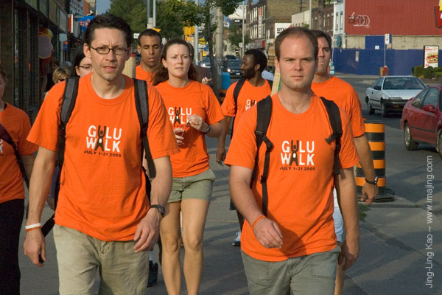
The original GuluWalk, which lasted for 31 days, saw Adrian Bradbury and Kieran Hayward (picture) conduct their own ‘night commute’ in Toronto, Canada. Like everyone who reads the story of the ‘night commuters’ for the first time, Adrian and Kieran were stunned that the plight of these kids was not garnering worldwide outrage. They continued to read reports that it was indeed one the world’s most ignored humanitarian disasters, but that’s where the story seemed to end. Adrian and Kieran did the GuluWalk simply because we would never let this happen to our children, so why would we sit idly by when it’s the children of northern Uganda? So, every night in July they walked 12.5 km into downtown Toronto to sleep in front of city hall. After about fours hours sleep they made the trek home at sunrise, all while continuing to work full-time and attempting to maintain their usual daily routine. The GuluWalk could not possibly replicate the terror, fear and uncertainty of the real ‘night commuters,’ who walk for their lives every single day. Adrian and Kieran walked to simply tell their story and draw attention to their plight. PICTURE OF ADRIAN AN KIERAN integrated in text above

There was a worldwide response to the original GuluWalk that resulted in GuluWalk Day on October 22, 2005 which saw over 15,000 people in 38 cities worldwide take the first international step towards telling the story of the children of northern Uganda. GuluWalk Day attracted people of all nationalities, colours, races and religions in a global show of support for the innocent victims of the world’s most ignored civil war and humanitarian emergency.
PICTURE of Night WALKERS INTEGRATED in text
--------------

Welcome to GuluWalk at Western

We are ten student-athletes and a faculty-coach who are spearheading this event within the context of a special fourth year honours seminar in Kinesiology entitled Sport and Community Service. We begin with the belief that the sports we play are much more than just games. What we have learned through our participation has been an integral part of our education here at Western. We hope to use the profile of the games we play to serve our communities and to bring attention to important social issues everywhere.

The intention of this event is to raise awareness about the plight of children in Northern Uganda who have suffered and died through years of civil conflict. We are proud to align ourselves with Athletes for Africa and The GULUWALK movement co-founded by Adrian Bradbury who is our honored guest and keynote speaker. This all began with a couple of people who believed that individuals can make a difference and has become a worldwide movement that has drawn international attention to the unthinkable suffering of people in this region. They made a difference and you can too.

Karenina Aguilar (Women’s Basketball); Alanna Boudreau (Track
and Field); Jacquie Edwards (Women’s Rugby); Jori Hardin (Women’s
Volleyball);Alana Juzenas (Women’s Basketball); Randy McAuley (Football, Track
and Field); Peter McClelland (Rowing); Allison Oosterhuis (Women’s Soccer);
Jennifer Sulfer (Track and Field); James Yoon (Men’s Basketball); Craig
Boydell(Course Instructor and Head Coach Men’s Basketball); Alan Salmoni (Director,
School of Kinesiology); Mike Lysko (Director, Sport and RecreationServices); Jim
Weese (Dean, Faculty of Health Sciences).
Welcome from the School Boards
As Director of the Thames Valley District School Board, I would like to let you know how proud I am to see our students actively supporting the GuluWalk. The world is full of opportunities for young people to make a difference. By participating in events like this, you are taking the important step of becoming leaders in your community and the world. I applaud you for recognizing both the potential and the obligation you have to speak to world issues and to create positive change. Your participation in the GuluWalk underscores the value that Thames Valley places on compassion, empathy, and respect. Thank you for demonstrating the heart of our Caring, Learning Community. I also want to thank the many partners who have contributed to this important event for giving Thames Valley students this opportunity to become involved, and for the positive influence you have shown our young people.
Bill Bryce - Director of Education
On behalf of the London District Catholic School Board, we extend a warm welcome to all students, athletes and staff participating in the GuluWalk initiative. The plight of children in Northern Uganda is one that cannot be ignored. We commend the Western student athletes who organized this event. Through their role modeling and actions, they have encouraged younger students to participate. It is our hope that after taking part in the GuluWalk today, students will seriously consider what they can do to both raise awareness and have a direct impact on the lives of children. The London District Catholic School Board would like to thank the University of Western Ontario's Faculty of Healthy Sciences, School of Kinesiology, Intercollegiate Athletic Program, and particularly the student athletes for engaging our students as partners in the GuluWalk. This event reinforces one of the Ontario Catholic Graduate Expectations: we are commanded to work for justice and peace by becoming a responsible citizen who contributes to the common good.
Corrie Gicante - Superintendent of Education

THE PROGRAM

On the Campus of the University of Western Ontario

The GuluWalk at Western will begin at 9:30AM at the Stadium. From here participants will walk on two different routes around campus and eventually converge on University College Hill around 10:00 AM where we will do our best to spell out GULU in human form. From here we will walk up to Alumni Hall for the inside portion of the event at 10:45 AM.

At Alumni Hall

Welcoming addresses by representatives of the University, the Thames Valley District School Board, and the London District Catholic School Board.

Craig Boydell Kinesiology Professor and Head Coach Men’s Basketball

Karenina Aguilar Honours Kinesiology and Women’s Basketball
Allison Oosterhuis Honours Medical Sciences and Women’s Soccer

Moses Latigo Odida Social Justice and Peace Studies
King’s University College, University of Western Ontario

Adrian Bradbury Co-Founder of Athlete’s for Africa and
The International GuluWalk Movement

Presentation Jori Hardin, Honours Kinesiology and Women’s Volleyball

National Anthem Tegan Young, Kinesiology, University of Western Ontario

Basketball Games and Contests and Mustang Action Video
James Yoon – Kinesiology and Men’s Basketball
Alana Juzenas – Administrative and Commercial Studies and Women’s Basketball
Dan Durack – The Voice of the Western Mustangs
Western Mustangs Men’s and Women’s Basketball Teams and YOU

Closing Comments: What Now? – Adrian Bradbury

Music and Departure 1:30 PM



ATHLETES FOR AFRICA LOGO –

MUSTANG LOGO
MEN’S AND WOMEN’S BBALL on behalf of all Mustang teams are proud to align ourselves with Athlete’s for Africa to promote this worthwhile cause.

Men’s Basketball Team
Kyle Coatsworth (London, Medway); Jason Milliquet (Sarnia, St. Clair); Andy Wedemire (Sarnia, St. Pat’s); Matt Curtis (Hamilton, St. Thomas More); Guy Ferguson (Vancouver, Sentinel); Jeremy Mitchell (London, South); Adam Ruickbie (Hamilton, Hillfield-Strathallen); Brad Smith (Innisfil, St.Peter’s); Dave Wilson (London, Banting); James Yoon (Thornhill, Vaughan); James Harrison (Hamilton, Cathedral); Alan Paron (Arva, Medway); Greg Ross (Ottawa, Ashbury)
Coaches: Craig Boydell (Head); Brad Campbell; Matt Tweedie; Maria Mountain

Women’s Basketball Team
Karenina Aguilar (London, John Paul II); Amanda Anderson (Chatham, Chatham Kent); Cheryl Atkinson (London, Central); Annelise Beaton (London, Beal); Alana Juzenas (Oakville, St.Thomas Aquinas); Deena Kurilsky (London, South); Allison Lainey (Collingwood, Collingwood); Julie Lamparski (Hamilton, St.Mary’s); Megan Lapointe (Burlington, M.M. Robinson); Bess Lennox (Ottawa, Ashbury); Lauren Parkes (London, Mother Teressa); Nadine Paron (Arva, Medway); Paula Romkey (Ottawa, Ashbury)
Coaches: Mike Milne (Head), Heather Heart, Chelsea Elwood, Brianne Henry,

Academic Advisors: Professors Bill Avison (Men) Jim Olsen, Craig Simpson (Women)

WHAT NOW?
Just knowing about the Night Commuters of Northern Uganda is a good start.
But now that you know, what can you do?
Talk to your teachers and class mates about what you have learned today.
Tell someone who doesn’t know.
Write to someone who might be in a position to make a difference.
Make sure people who read your local news paper know.
Let the children in Northern Uganda know that you know
and that you want it to be better for them.
Make a scrapbook of the pictures you took today and send it to them.
Did you know that thousands of the kids who make the walk
can’t go to school because they don’t have
$40.00 dollars a year
to pay for their books and supplies?
You could do something about that.
Maybe you could start your own GULU walk.
Now that you know that you really can make a difference. Will you?
Get Involved
GuluWalk 2005 was only the beginning. The awareness and fundraising has just begun. To find out more about GuluWalk or to find out how you can get involved please contact GuluWalk co-founder Adrian Bradbury at adrian@guluwalk.com, call 416.426.2787 or visit www.guluwalk.com.

