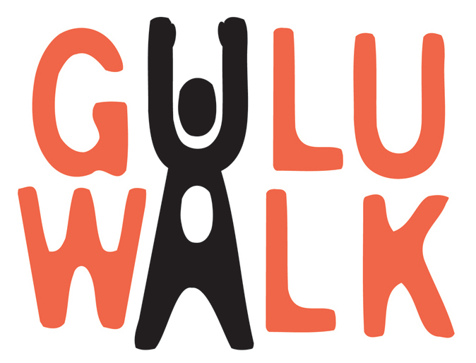
GuluWalk Day – Year in Review

GuluWalk started in July of 2005 as an attempt by two average Canadians to better understand the ordeal of the ‘night commuters’ of northern Uganda. It has now grown into an urgent, impassioned worldwide movement for peace.

The Night Commuters
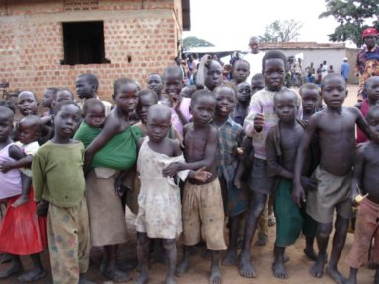
Every night, as many as 40,000 children, some as young as five years old, walk for hours from their rural villages into major urban centres so that they can sleep in relative safety. In the morning, they retrace their steps in hope of returning in time to attend school and do their daily chores. With their blankets and straw mats in tow, endless rows of youngsters walk for hours into Gulu, Kitgum and Pader, seeking refuge from what should be the safety of their own homes. This is their daily routine because to stay home in the countryside is to risk abduction by the rebel army and be forced to fight as child soldiers in northern Uganda’s 19-year civil war. The life of a ‘night commuter’ is their best option.

The GuluWalk
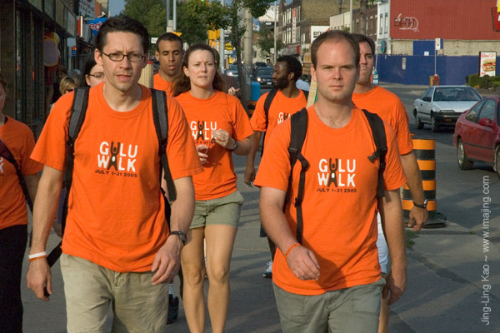
The original GuluWalk, which lasted for 31 days, saw Adrian Bradbury and Kieran Hayward (pictured) conduct their own ‘night commute’ in Toronto, Canada. Like everyone who reads the story of the ‘night commuters’ for the first time, Adrian and Kieran were stunned that the plight of these kids was not garnering worldwide outrage. They continued to read reports that it was indeed one the world’s most ignored humanitarian disasters, but that’s where the story seemed to end. Adrian and Kieran did the GuluWalk simply because we would never let this happen to our children, so why would we sit idly by when it’s the children of northern Uganda? So, every night in July they walked 12.5 km into downtown Toronto to sleep in front of city hall. After about fours hours sleep they made the trek home at sunrise, all while continuing to work full-time and attempting to maintain their usual daily routine. The GuluWalk could not possibly replicate the terror, fear and uncertainty of the real ‘night commuters,’ who walk for their lives every single day. Adrian and Kieran walked to simply tell their story and draw attention to their plight.

GuluWalk Day
There was a worldwide response to the original GuluWalk that resulted in GuluWalk Day on October 22, 2005 which saw over 15,000 people in 38 cities worldwide take the first international step towards telling the story of the children of northern Uganda. GuluWalk Day attracted people of all nationality, colour, race and religion in a global show of support for the innocent victims of the world’s most ignored civil war and humanitarian emergency.

Get Involved
GuluWalk 2005 was only the beginning. The awareness and fundraising has just begun. To find out more about GuluWalk or to find out how you can get involved please contact GuluWalk co-founder Adrian Bradbury at adrian@guluwalk.com, call 416.426.2787 or visit www.guluwalk.com.

