

Did you have a good time today??
Want to wrestle again??

Local High Schools that have wrestling teams include:

Beal, Saunders SS, Lucas HS, CCH, Westminster, Clarke Road & JP II

OR

You can join the London Western Wrestling Club

Check out the link:

http://groups.msn.com/London-WesternWrestlingClub



Sport and Community Service
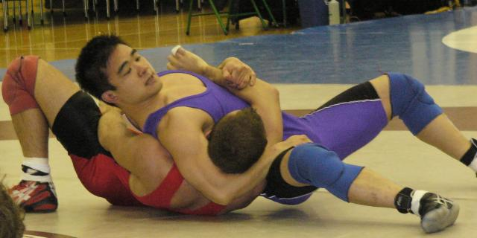

Western Mustang’s
First Nations
Wrestling Clinic


April 4, 2007
Alumni Hall - The University of Western Ontario

You are going to see some Elite Athletes under Wrestling Coach Ray Takahashi do a clinic for you today and also help host you during the day’s events. Several of these athletes have won Medals at the Provincial and National level. But a day like today is not about elite athletic performance. It is about trying out a sport for the first time and having fun. Wrestling is an Olympic sport for both men and women that is practiced in schools (elementary, high school and University) and club programs. Wrestling is one of the oldest sports in the world and requires a high level of technique, strength, endurance as well as discipline and self-control. Not only will you get the chance to participate in a sport that is new to you, but you will also get a chance to take a tour of Western to see what the campus has to offer.

So on behalf of our class and the entire University we hope you have a blast today and enjoy the new sport you have learned. We have worked hard and had a lot of fun in planning this event for you. We have enjoyed getting to know our partners in this event and have learned much in working with them. We especially want to thank our partners at Indigenous Services at The University of Western Ontario -Vivian Peters (Coordinator) Kelly Nicholas, Mike Deleary and Naomi Mishibinijima. We have received encouragement from the University as a whole and more directly from our School of Kinesiology, Faculty of Health Sciences and Intercollegiate Athletic Program in staging this event. Western has a commitment to a broad range of First Nations’ initiatives and we are proud to be a part of this vision.

You are a part of the first ever First Nations Wrestling Clinic at Western. We hope that you have a great day with us as we teach you the basics of a new sport. We encourage everyone who enjoyed the wrestling today to approach the coach at the high school they attend and join the wrestling team. We hope that those who may decide not to pursue wrestling will still have great memories from today and will have enjoyed their time at Western. We really admire the ambition shown by all of you who came out today to try something new on a campus that is foreign to you. We know that whether you continue with wrestling or not, you will all continue to be successful in your athletics because of the initiative you have shown today.

Sincerely,
Craig Boydell and the Sport and Community Service Student Athletes
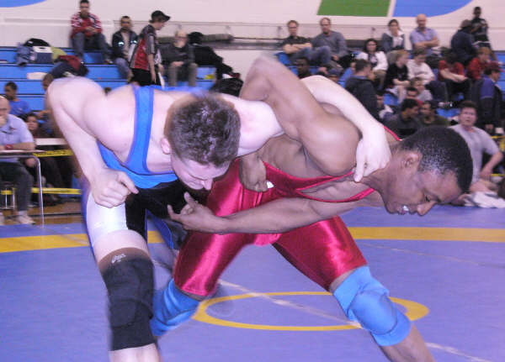

INDIGENOUS SERVICES
(Previously First Nations Services)
On behalf of Indigenous Services students, staff, faculty and the Aboriginal Education and Employment Council of The University of Western Ontario, I would like to welcome all First Nations elementary school students, teachers, and parents to a wonderful and exciting day at Western! It is our sincerest desire that the Wrestling Clinic provides you with a fun day and encourages you to think of Western as your first choice university. There will be other opportunities to participate in different exciting events at Western such as our upcoming summer Science Camps, Health Sciences Camps, and the Medical Schools’ Medquest Camp — all designed to encourage you to explore career opportunities in the health field and one day ‘Come to Western’!
Sincerely, Vivian Peters and the Indigenous Services Staff

ITINERARY
9:30 - Welcome: Craig Boydell and Vivian Peters
Guest Speaker- Albert Doxater
10:00 – Go over rules, learn technique, practice with some drills
11:30 – Pasta Lunch - watch videos of Olympic Wrestling
12:00 – Tour of Western with Indigenous Services Volunteers and Varsity athletes
1:00 – Review technique, play some wrestling specific games, watch a real match
2:15 – Closing Remarks

STUDENT ATHLETES— Jessica Fitzgerald (Women’s Wrestling), Aaron Grainge (Track and Field); Jason Rhodes (Track & Field) Andrew Judge (Track & Field); Shellie McParland (Track & Field); Bethany Janzen (Track & Field); Bess Lennox (Women’s Basketball); Melissa Baer (Women’s Rugby); Alexis Karpacz (Women’s Volleyball); Colin O’Brien (Men’s Volleyball);) as well as Craig Boydell (Course Instructor and former Head coach Men’s Basketball); Earl Noble (Director, School of Kinesiology); Mike Lysko (Director, Sport and Recreation Services); Jim Weese (Dean, Faculty of Health Sciences).

