
First Nations Youth
Wrestling Clinic

April 4, 2007, 9:30am - 2:30 PM

University of Western Ontario

For First Nations Boys and Girls Grades 7 – 9

Demonstrations and live instructions will be conducted by elite competitors and coaches from Western’s Wrestling program. Participants will receive live, small group and
individual instruction.

Wrestling is an Olympic sport for both men and women that is practiced in schools (elementary, high school and university) and club programs. Wrestling is one of the oldest sports and requires a high level of technique, strength, endurance as well as discipline and self-control.

Lunch, drinks and commemorative t-shirts will be provided and a tour of the campus will also be included as a part of the day’s activities.

The day’s events are being hosted and sponsored by student-athletes from the Sport and Community Service Honors Kinesiology class and Western Indigenous Services.

CLINICIANS INCLUDE:

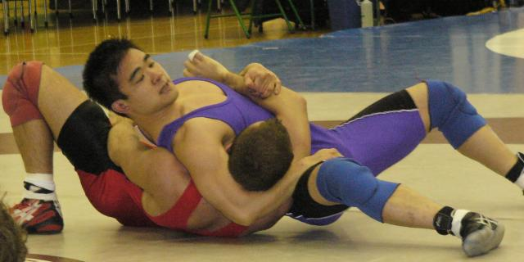
Left: Steven Ko - National bronze
medalist and Provincial silver
medalist in 2007.

Below: Jessica Fitzgerald - National bronze medalist and Provincial silver medalist in 2007.

Left: Steven Ko - National bronze
medalist and Provincial silver
medalist in 2007.

Below: Jessica Fitzgerald - National bronze medalist and Provincial silver medalist in 2007.

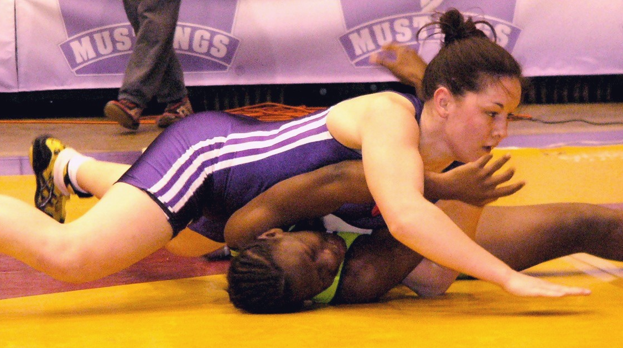
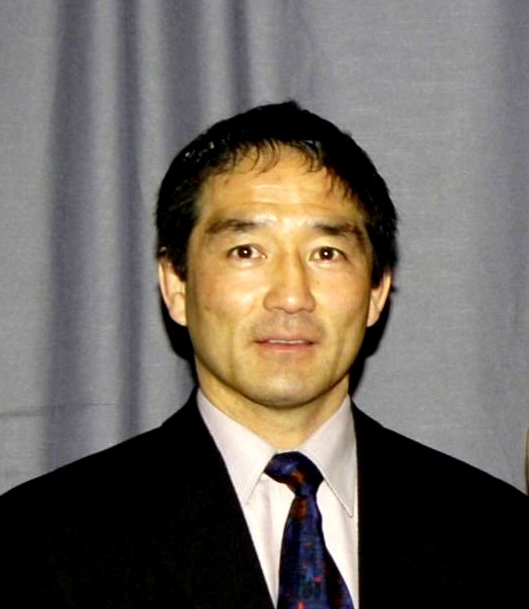
Ray Takahashi –
Head coach of the Western Team,
Former Olympic team member,
National champion and National team coach.

Ray Takahashi –
Head coach of the Western Team,
Former Olympic team member,
National champion and National team coach.



Schedule for the Day

9:15 Arrive at Alumni Hall Western

9:30-10a: The Rules of Wrestling with demonstrations

10a-11:30a: Clinic by the Western Wrestling team. Basic
techniques in small student groups.

11:30a-12p: Complimentary pasta lunch

12p-1p: A campus tour with volunteers from Indigenous
Services and student-athletes.

1p-2:30p: Review techniques followed by live wrestling games.

What to wear: metal free sports shorts or gym pants, t-shirt, running shoes.

Transportation: On own or if you require assistance with transportation, please
contact Kelly Nicholas at 519-661-4095

Registration Form (First 30 Applicants)
For organizing purposes, we would appreciate your registration before FRIDAY, MARCH 23rd thank you!

Student Name: __________________________ School Name: __________________________

Grade: _________ T-Shirt Size: _____________

Email address: ____________________ Phone Number:____________________

Sport background:___________________________________________________

I give permission for my child to participate in the Wrestling Clinic as noted above.
Parent/Guardian Signature: ___________________

Please return this form to Kelly at Indigenous Services kjnichol@uwo.ca
fax 519-661-3357 or for information call 519-661-4095

