Factors influencing the character of Ancient and Medieval Philosophy

- people lived behind an “energy bottleneck”

- travel and contact between cultures was very limited

- the principal practical and scientific questions were taken to have been answered

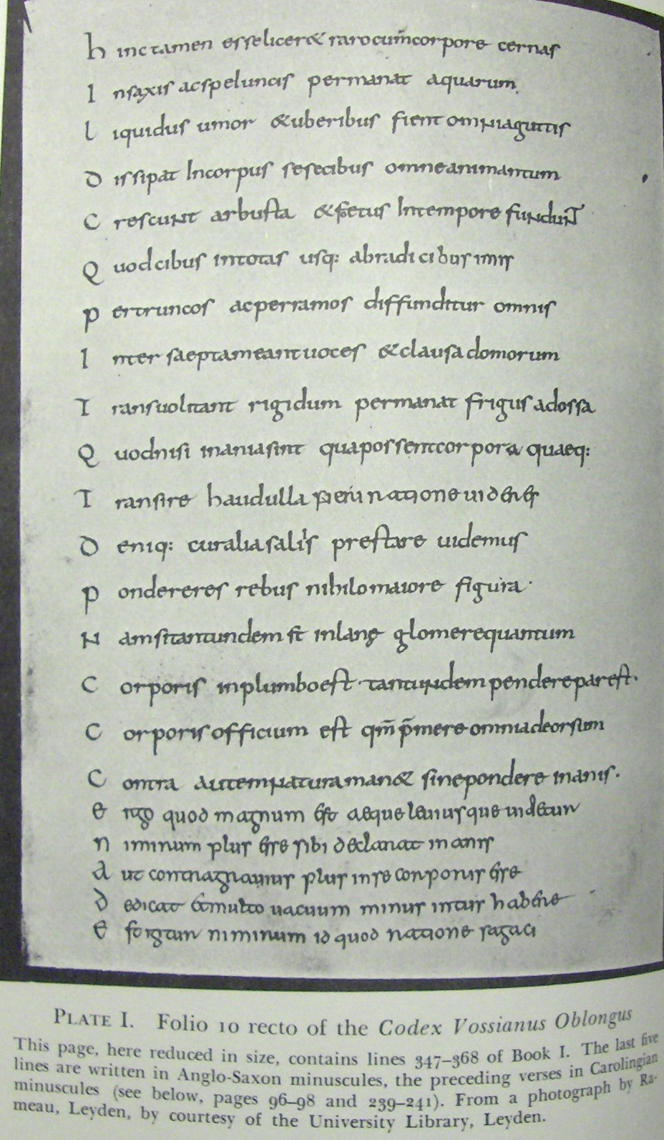
Lucretius (ca 99BCE – ca 55 BCE), De rerum natura II 1095-1099

Quis regere immensi summam, quis habere profundi
indu manu validas potis est moderanter habenas,
quis pariter caelos omnis convertere et omnis
ignibus aetheriis terras suffire feracis,
omnibus inve locis esse omni tempore praesto?

Who could rule the whole of the universe?
Who could hold in coercive hand the strong reins of the unfathomable?
Who could spin the firmament and ferment with the fires of ether all the fruitful earths?
Who could be in all places at all times?

Conceptions of the value of knowledge

Socrates & Plato:

It is impossible to knowingly do wrong, so knowledge will make you a better person

Aristotle:

Human beings are by nature rational animals, so it is only in the exercise of their rationality that they can find happiness.

Epicurus & Lucretius:

Knowledge rids us of groundless fears and superstitious anxieties.

The Stoics:

Knowledge teaches us why it is for the best that all things be as they are, making it easier for us to deal with adversity.

Differences between the medieval and the early modern world

- energy bottleneck has been traversed

- communication and trade with all parts of the world is bringing knowledge of radically different cultures and practices

- dissatisfaction with abuses of power by church authorities has led to a religious revolt and reformation

- the “commentary” tradition on Aristotle’s physics had reached a crisis point. Radical changes to fundamental tenets were needed to grapple with the problems that had emerged

- the texts of “minority” ancient philosophers, esp. sceptics and atomists, had been recovered

Effect of these differences on early modern philosophy

- rejection of received knowledge, particularly received scientific knowledge

- rejection of syllogistic logic, conceived as a “method of demonstration” that does not lead to “discovery”

- a new optimism about our ability to intervene in the course of nature to improve the material conditions of life

    - a consequent new conception of what knowledge is good for

- attempts to formulate a new inductive logic that would serve as a “method of discovery”

- attempts to model the search after knowledge on the manual arts (i.e., “mechanics”)

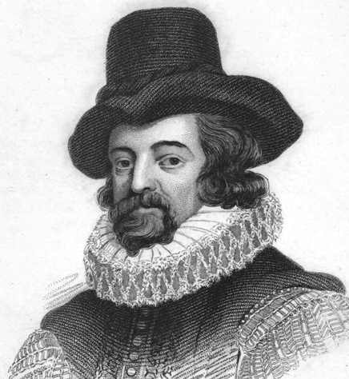
Francis Bacon (1561-1626)

[We] ought on the contrary to be surely persuaded of this; that the artificial does not differ from the natural in form or essence, but only in its efficient [cause]. Since [we] have no power over nature except that of motion, [we] can put natural bodies together and can separate them, and therefore wherever the case admits of the uniting or disuniting of natural bodies by joining (as they say) actives with passives, [we] can do everything. [Works IV 294]

Other Modern features of Bacon’s thought

- the primary purpose of knowledge is not to make you a better, happier, or more contented person, but to gain power over nature in order to improve the material conditions of life

(It was the pursuit of moral knowledge, rather than science, that led to the Biblical “fall.”)

- knowledge ought to be progressive, like the mechanical arts

- the received knowledge of the ancients ought to be rejected on both counts

- the received logic serves only for the presentation of received knowledge and needs to be replaced with a new method of discovery

What Bacon shared with the
Ancient and Medieval tradition

- the causes of change in nature are hidden active “forms” and passive “potencies”

- change occurs as a result of the contact of appropriate pairs of each

- what changes occur as a consequence of the contact of what materials can in the first instance only be discovered by experience

- the proper method for gaining scientific knowledge is the method of reduction and composition (analysis/synthesis, induction/deduction)

    - induction from observation and experience is used to infer first principles and basic theories

    - these principles and theories are then applied to explain why change occurs as it does and predict what will happen next

How Bacon differed from the
Ancient and Medieval tradition

- confidence that knowledge can be made to continually progress, just like mechanics

- if it has not done so, this is because of errors in the application of the method of discovery

    - the induction from observation and experience to first principles has been too hasty

    - observations themselves have not been properly made

- insistence that knowledge is not to be employed for moral purposes (determining how one ought to live) but for practical ones (improving the material conditions of life)

Implications for views on the nature of knowledge

The old sceptical objections are valid.

Our senses are weak and unreliable

they do not tell us everything that is there

what they do tell us is not always correct

(the same object appears differently under different circumstances, making it impossible to say what it is really like)

Our intellects are prejudiced

the intellect “worships” certain “idols” or “false images”

But these weaknesses can be overcome by a properly formulated method of discovery.

We just have to find out what it is.

Bacon’s principal epistemological inventions

- controlled experiment

- induction from a programmed series of observations

- use of crucial experiments (“cross-instances”)

- development of scientific research institutions

Bacon’s proposals
(1)

- Sense experience is not to be implicitly relied upon, but it becomes reliable when used to judge the results of properly controlled experiments.

Where sense experiences of the same phenomenon vary, identify the circumstances in which the variation occurs and try to figure how changes in those circumstances are correlated with changes in the appearances.

While sense experience itself is not reliable, it becomes reliable when you have identified all the circumstances responsible for its variation and controlled for them

And this very project helps you identify hidden causes.

Bacon’s proposals
(2)

- Experiences are not to be collected haphazardly, but as the consequence of a goal-directed search

    - Each phenomenon we desire to know about is to be studied in its natural, preternatural, and artificial states

    - Special attention is to be paid to preternatural and artificial states as they reveal most about causes

(This is an early statement of “Mill’s methods” for the investigation of causes by considering cases of presence, absence, and concomitant variation.)

Bacon’s proposals
(3)

- where studies of natural, preternatural, and artificial phenomena lead to rival causal hypotheses, “crucial experiments” are to be employed to choose between the alternatives

- Knowledge is not to be sought just by individuals but by communities engaged in collaborative research projects within institutions devoted to the advancement of learning

Bacon’s proposals
(4)

Because the intellect worships false idols, its claims are not to be accepted unless confirmed by sensory experience

in particular, its claims regarding “first principles” in the sciences are to be treated with suspicion and put to the test

The idols of the intellect need to be identified and examined so that we can, so far as possible, avoid being seduced by them.

The doctrine of the idols

Idols of the tribe

false inferences grounded in the nature of the human species, for example:

- accepting an explanation or a theory because it is simple, aesthetically pleasing, or analogous to other explanations or theories

- assuming that nature is ordered and regular and only accepting theories and explanations that reflect order and regularity

- refusing to accept a brute fact, so leaping to accept a theory simply because it integrates that brute fact with others on the basis of some specious analogy

examples:

- supposing the motions of the heavenly bodies are perfect circles (circles are easier to grasp)
- supposing that there must be four rather than three elements (making a square of them makes them more analogous to other phenomena)
- arbitrarily fixing the ratio of density the elements at 10 to 1

such theories are easier for our intellects to grasp

— but nature is not necessarily made to be easy for us to grasp; it is not necessarily simple, beautiful, or symmetric

To accept a theory or an explanation simply because it has these features is to worship an idol of the intellect.

The doctrine of the idols, cont.’d

Idols of the cave

false inferences grounded in the circumstances or experiences of the individual thinker, for example:

- supposing that something is true because it is agreeable to you or makes a strong impression on you (it tickles your fancy or engages your attention)
- supposing that something is true because it fits with what you happen to have been taught
- supposing that something is true because it fits with the random and haphazard observations you have so far happened to make
- sticking to opinions you have initially formed regardless of what new evidence comes in (often combined with neglecting or failing to notice or look for contrary evidence)
- preferring affirmative to negative results

The doctrine of the idols, cont.’d

Idols of the market place

false inferences grounded in the modes of human intercourse, notably:

leaping to accept a theory because it is dressed up in fancy (and often unintelligible) jargon

Idols of the theatre

false inferences grounded in the merely “theatrical” manner in which a theory happens to be presented, chiefly:

in the form of a deductive system with many inter-related parts

The combined effect of the idols

The idols induce us to leap to accept grand theories on the basis of inadequate testing and experiment

and then to refuse to change those theories

Rather than induce us to focus on the evidence, they induce us to focus on dressing the theories up in jargon and arranging them into deductive systems.

A comparison of the Baconian
and Aristotelian scientific methods
(according to Bacon)

Bacon  (experimental induction) |  | Aristotle  (resolution & composition)
theories of the  “latent constitution”  of things    crucial experiments to choose between competing hypotheses    hypotheses concerning “latent constitution” and “latent processes”    “natural history” of natural and preternatural occurrences, supplemented by experimental history of artificial occurrences |  General  rules &  principles    means of improving  observations and gaining new knowledge | Speculative  theories of  the forms &  potencies of  things    (hasty  induction)    haphazard observation |  General  rules &  principles    syllogistic  inference    explanations  &  predictions  of natural  phenomena

