Bacon’s hypothesis

Democritus and Epicurus were the Ancient philosophers who came closest to getting things right

The latent constitution responsible for making things behave as they do is not forms and potencies

it is the arrangement of shaped and moving parts constitutive of the thing

And the latent processes going on when change occurs do not involve immutation of form

they involve transmission of motion upon impact

What we see in the great machines produced by human art for the improvement of the conditions of life

the mechanical clock, the printing press, the wind mill, the devices in Agricola’s mines

is an image of the means nature herself employs in bringing about change in nature
Boyle’s “mechanical or corpuscular hypothesis”

“The phenomena of the world are physically produced by the mechanical properties of the parts of matter,

and … they operate upon one another according to mechanical laws”

Boyle’s “mechanical or corpuscular hypothesis”

“The phenomena of the world are physically produced by the mechanical properties of the parts of matter,

and … they operate upon one another according to mechanical laws”

What are the mechanical properties of the parts of matter?

Boyle’s “mechanical or corpuscular hypothesis”

“The phenomena of the world are physically produced by the mechanical properties of the parts of matter,

and … they operate upon one another according to mechanical laws”

What are the mechanical properties of the parts of matter?

just those things that have to do with how matter fills space

“motion, figure, size, posture, rest, order or texture”

not any of those things that we consider to make what is in one space qualitatively different from what is in any other

as if everything was made of exactly the same stuff and all the differences were due to how the stuff is cut up into parts and how the parts are ordered and moving
Boyle’s “mechanical or corpuscular hypothesis”

“The phenomena of the world are physically produced by the mechanical properties of the parts of matter,

and … they operate upon one another according to mechanical laws”

What are mechanical laws?

Boyle’s “mechanical or corpuscular hypothesis”

“The phenomena of the world are physically produced by the mechanical properties of the parts of matter,

and … they operate upon one another according to mechanical laws”

What are mechanical laws?

Not the law of gravitation

Not the laws of magnetism or electrodynamics

Not the laws of chemistry or biology

Just the laws of motion and communication of motion as a consequence of collision

All other laws are presumed to be consequences just of these laws.

Why should we think this hypothesis is true?

The invention of microscopes has led us to realize that apparently solid and uniform things

are actually composed of a variety of differently shaped and sometimes moving parts

Moreover, the only difference between the natural and the artificial is in who made it (God or human inventors)

(because it is the same material that is being employed in both cases

so it can be expected to act in accord with the same laws)

But the grand artefacts of human invention (the windmill, the clock, the printing press)

are all just arrangements of shaped and moving parts that work by communication of motion through collision

So by analogy, natural phenomena may likewise be mechanically produced by insensibly small machines
Why should we think this hypothesis is true? cont.’d

Wishful thinking helps

As long as change is due to the “immutation of form” produced when “actives” are brought into contact with “passives”

(“actives” are things with an active potency to transmit form; passives things with a passive potency to take on a form)

the ultimate reasons for change are “occult” or hidden from human understanding

All we can do is combine all sorts of things in all sorts of ways in the hope of learning what will result from experience

but this leaves us with an impossibly large research project

and in the end we end up being mere spectators of nature’s works, who can only bring about change by identifying and employing secret means that we cannot really understand
Why should we think this hypothesis is true? cont.’d

Wishful thinking helps

But if everything is produced by some machine, then we can abbreviate the research project

by considering what sort of machine we would build to produce the effect, and imagining something similar must be employed by nature

And rather than be spectators to the operation of causes that work in occult and mysterious ways, we would understand exactly how the change is produced

this would put us in the God-like position of being able to alter the operations of causes to suit our purposes
Evidence in favour of Boyle’s thesis

Recent outstanding examples of technological innovations.

- the windmill
- the mechanical clock
- the printing press

Evidence in favour of Boyle’s thesis

Recent outstanding examples of technological innovations.

- the windmill
- the mechanical clock
- the printing press

Challenges to Boyle’s thesis

Recent outstanding examples of technological innovations.

- the magnetic compass
- gunpowder

These are not obviously mechanical devices

And we might add:
- the windmill
- the mechanical clock
- the printing press

because where does the initial force that moves the parts of these machines come from?

what accounts for the winds? Solar heating? the “spring” of metals? the “weight” of plumbs? the motion of animal bodies?

and what accounts for the hardness and internal cohesion of the moving parts of machines?

For mechanist natural philosophers like Boyle, these are things that all to easily fall “out of the picture”
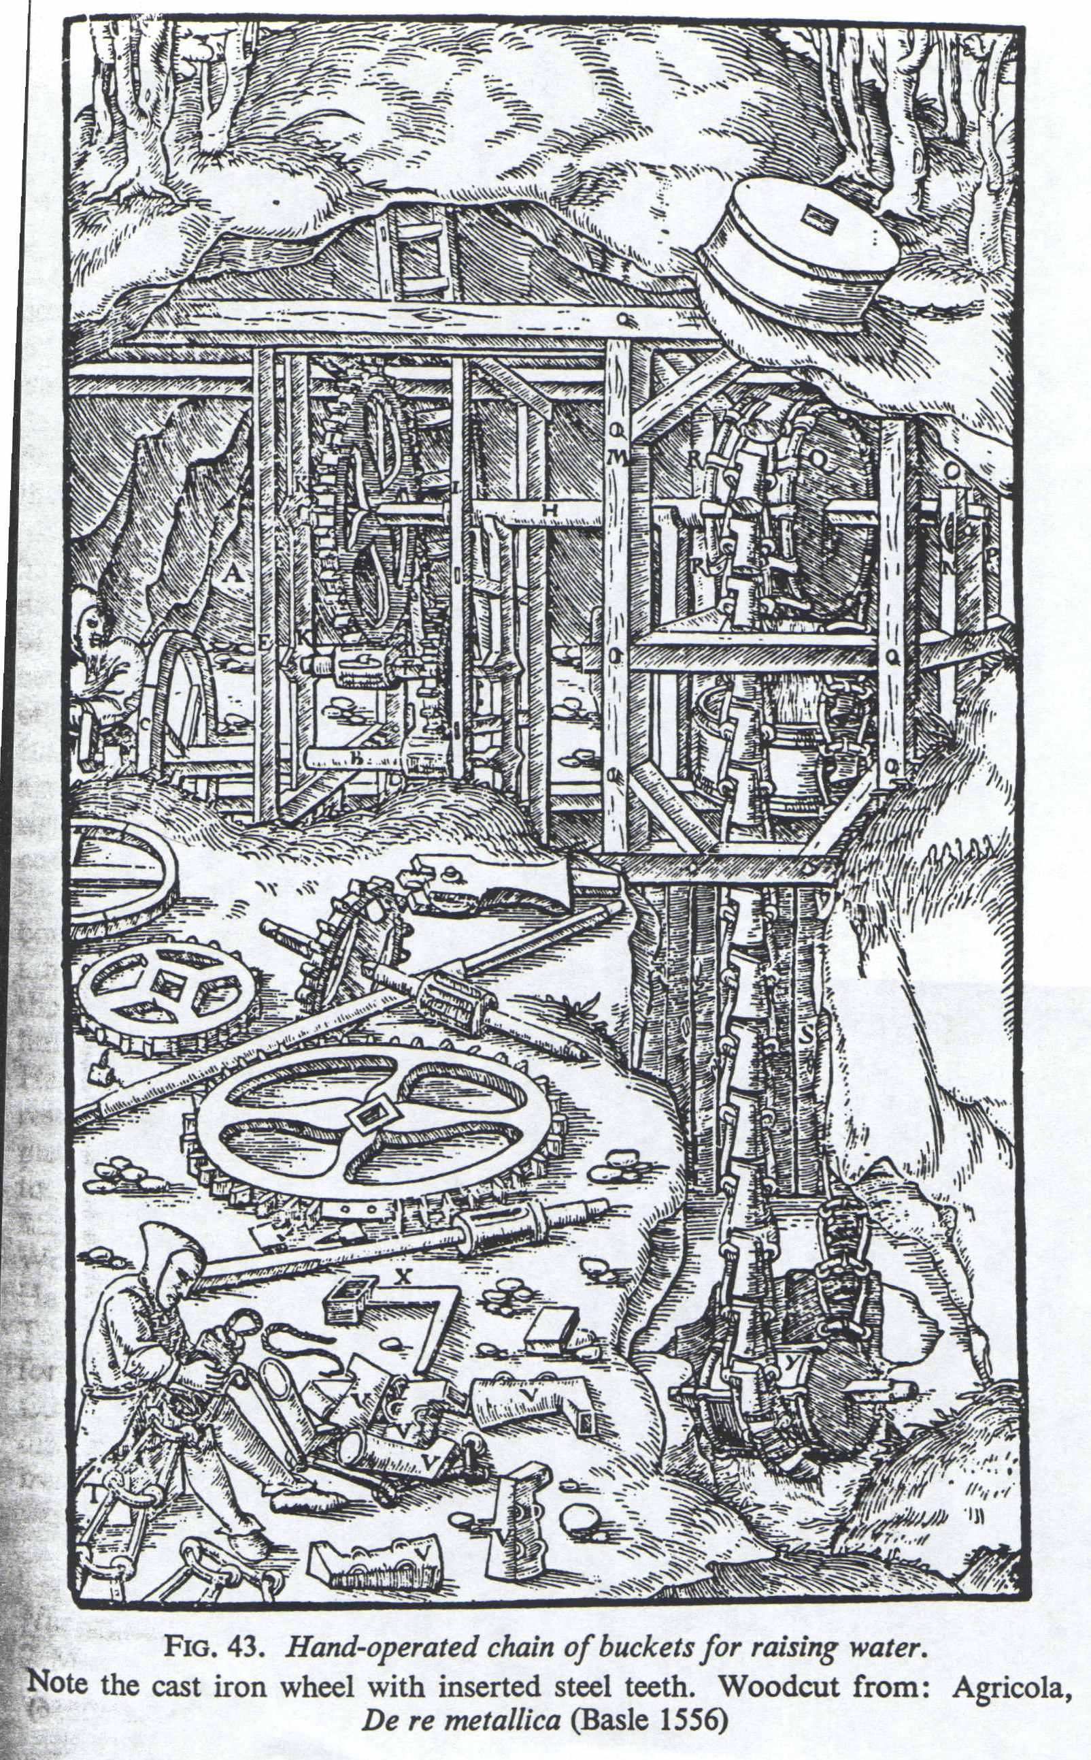
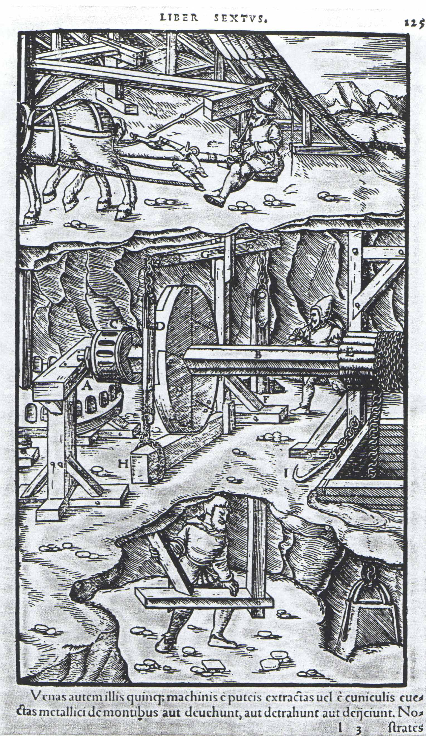
Further Challenges to Boyle’s thesis

The “poverty” of the mechanical philosophy

Qualities that are “read out of existence” by the mechanical philosophy

Sensible qualities: Colour, temperature, smell, taste, sound

Material qualities: Mass, weight, solidity, hardness, softness, ductility, brittleness, fluidity, viscosity, etc

Aristotelian categories: Form, matter, potency

The irreligious tradition of the mechanical philosophy

Boyle’s answer to religious concerns

Insist that mechanism is not able to account either for the origin of worlds or the evolution of life.

Allow that spirits may be causes of motion.

Consequently:

God must have formed the world and planted it with the seeds and embryos of living things

But having once set up the system and instituted the laws of motion, the system runs on its own in accord just with those principles

Even spirits, when they bring about changes in the world, do so by mechanical means
Boyle’s case for accepting the corpuscular
or mechanical hypothesis

The mechanical hypothesis has a number of advantages over rival hypotheses that

- invest the parts of matter with qualities
- attribute change to the agency of spirits or forces

Significant advantages of the mechanical hypothesis:

- its principles and explanations have greater intelligibility and clarity
- it uses fewer explanatory principles
- it uses the most primary explanatory principles
- it uses the simplest explanatory principles
- it has the greatest explanatory power
- its explanations are analogous to those that are operative in machines of human invention, and we have every reason to suppose that the analogy carries down from humanly observable machines to the smallest parts of matter
- it is alone able to satisfy our curiosity
Boyle’s case for accepting the corpuscular
or mechanical hypothesis

The mechanical hypothesis has a number of advantages over rival hypotheses that

- invest the parts of matter with qualities
- attribute change to the agency of spirits or forces

Significant advantages of the mechanical hypothesis:

- its principles and explanations have greater intelligibility and clarity

even those who champion other systems prefer mechanical explanations once they have been given

e.g., eclipses

Boyle’s case for accepting the corpuscular
or mechanical hypothesis

The mechanical hypothesis has a number of advantages over rival hypotheses that

- invest the parts of matter with qualities
- attribute change to the agency of spirits or forces

Significant advantages of the mechanical hypothesis:

- its principles and explanations have greater intelligibility and clarity
- it uses fewer explanatory principles

Just two: matter and motion

and the matter is undifferentiated except with regard to how it is shaped and moving, sized and arranged
Boyle’s case for accepting the corpuscular
or mechanical hypothesis

The mechanical hypothesis has a number of advantages over rival hypotheses that

- invest the parts of matter with qualities
- attribute change to the agency of spirits or forces

Significant advantages of the mechanical hypothesis:

- its principles and explanations have greater intelligibility and clarity
- it uses fewer explanatory principles
- it uses the most primary explanatory principles

Matter is just stuff that fills space, motion is just change of place over time, so once you have understood motion of bounded parts of space, there is nothing more fundamental you need to understand.

In contrast, who understands form, prime matter, essence, potency?
Boyle’s case for accepting the corpuscular
or mechanical hypothesis

The mechanical hypothesis has a number of advantages over rival hypotheses that

- invest the parts of matter with qualities
- attribute change to the agency of spirits or forces

Significant advantages of the mechanical hypothesis:

- its principles and explanations have greater intelligibility and clarity
- it uses fewer explanatory principles
- it uses the most primary explanatory principles
- it uses the simplest explanatory principles
- it has the greatest explanatory power

Heating as a consequence of “immutation of form” resulting from contact of a “passive” with an “active” endowed with the “form” of heat can only explain heating.

But for any effect whatsoever we can imagine a kind of machine capable of producing that effect
Boyle’s case for accepting the corpuscular
or mechanical hypothesis

The mechanical hypothesis has a number of advantages over rival hypotheses that

- invest the parts of matter with qualities
- attribute change to the agency of spirits or forces

Significant advantages of the mechanical hypothesis:

- it is alone able to satisfy our curiosity

What we most want to learn about when we seek to learn how to get power over nature is not what agent (or “force” or “form”) responsible for bringing about the change, but how the agent works to make the change come about.

Only explanations given in terms of transmission of motion as a consequence of collision of moving parts can do that

So only they stand to give us the kind of knowledge we are out to get
An awkward consequence

In laying out a case for how we ought to proceed to gain knowledge, Bacon had insisted that the intellect can be no more implicitly relied upon than the senses.

The intellect “worships certain idols” that lead it away from the true path of knowledge

- idols of the tribe
The intellect prefers things that are easy for it to understand
But nature was not made for the intellect to be able to understand it
- idols of the cave
These are prejudices founded on early education, deference to authority, or imperfect experience
- idols of the market place
Our means of intellectual exchange is language and this means can be used to cloud things over and give them an imposing appearance
- idols of the theatre
We are further impressed by explanations put forward in the fancy dress of a deductive system
But now review Boyle’s case for accepting the mechanical hypothesis:

- its principles and explanations have greater intelligibility and clarity
- it uses fewer explanatory principles
- it uses the most primary explanatory principles
- it uses the simplest explanatory principles
- it has the greatest explanatory power
- its explanations are analogous to those that are operative in machines of human invention, and we have every reason to suppose that the analogy carries down from humanly observable machines to the smallest parts of matter
- it is alone able to satisfy our curiosity

These are all idols!

Why should we accept the corpuscular/mechanical philosophy?

— A conjectural debate between Boyle and Bacon

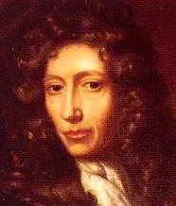
Its principles and explanations are clear and intelligible.

(Even those who accept other theories prefer corpuscular/mechanical accounts where there they are provided.)

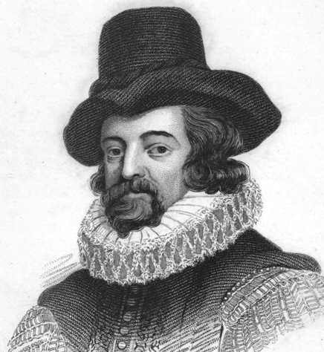
Idol of the tribe.

We can’t assume that nature is simple and easy to understand. Therefore we can’t assume that what is clearest or most intelligible for us is what is correct.

It makes use of the fewest, most primary, and simplest explanatory principles, namely motion and matter (where matter is understood to have only those qualities that result from filling space).

Another idol of the tribe.

It has great explanatory power.

(All the phenomena of nature can be explained as consequences of the motion and collision of small particles, producing different “textures” of visible bodies.)

Idol of the theatre.

(We can’t assume that all the processes of nature can be demonstrated from just a few principles.)

[The corpuscular/mechanical philosophy is not as extensive as Boyle thought. It cannot deal easily with gravitation, magnetism, electrical attraction, solidity, hardness, brittleness, burning, rusting, exploding, elasticity, animal and vegetable life and motion. Indeed, in some cases, such as hardness, no non-circular account is possible.]

These are the very things that drive machines!

We have good empirical evidence of its correctness as an account of the operations of visible bodies, starting with human artefacts and moving up to planetary motions and down to particles observable with microscopes. So we can infer that it applies to all phenomena whatsoever.

Idol of the tribe.

We can’t assume that all the operations of nature are analogous.

[And the claim is false, considering life, vegetation, animal motion, electricity, magnetism, gravitation, & chemical phenomena.]
Rival theories only go so far as to name the agent responsible for the change, not explain how the agent brings about the alteration in the thing that changes. As a consequence, they limit our prospects for gaining power over nature.

Idol of the cave.

It is wishful thinking to presume that we can do any more than identify what “actives” bring about what changes in what “passives.” And supposing we can, there may be other ways of accounting for the generation of motion than by appeal to collision.

Even were change brought about by the presence of certain kinds of agents, those agents would bring about no change were they to remain inert or quiescent. They would have to act somehow. That means they would have to move or make something else move. Change is only conceivable as a consequence of motion of something, and hence of collision with the patient and some alteration in the internal arrangement of parts in the patient.

Idol of the tribe.

Just because you can’t conceive any other possible cause of change, that doesn’t mean there is none. And as a matter of fact, your claim is not justified by experience. Motion does not explain cohesion, hardness, brittleness, solidity, etc

Developing a theory from a purely empirical base (i.e., just from observation and experiment) is so impractical as to be impossible. The number of experiments to be performed and observations to be made is infinite. We must start off by formulating a working hypothesis regarding what is responsible for change in nature, and allow our choice of experiments to be guided by the project of confirming or applying that hypothesis.

Idol of the cave: why should that hypothesis be yours? No good reasons have yet been given.

What is at stake in this debate

Rationalism vrs. empiricism in scientific methodology and epistemology.

– do we arrive at general principles by induction from experience or formulate them in advance?

– do we allow considerations like simplicity, explanatory power, and analogy to influence theory choice?

The feasibility of a purely mechanical account of nature.

